

**附 件1**

ICS 65.110

G 25

**食品安全国家标准**

**植物源性食品中331种农药及其代谢物**

**残留量的测定**

**液相色谱-质谱联用法**

**National food safety standard—**

**Determination of 331 pesticides and metabolites**

**Residues in foods of plant origin**

**Liquid chromatography-tandem mass spectrometry method**

**（征求意见稿）**

中华人民共和国国家卫生健康委员会

中华人民共和国农业农村部 发布

国家市场监督管理总局

××××--××发布

中华人民共和国国家标准

GB ××××—××××

××××-××实施

食品安全国家标准

植物源性食品中331种农药及其代谢物残留量的测定

液相色谱-质谱联用法

**1 范围**

本标准规定了植物源性食品中331种农药及其代谢物(参见附录A）残留量的液相色谱-质谱联用测定方法。

本标准适用于植物源性食品中331种农药及其代谢物残留量的测定。

**2 规范性引用文件**

下列文件对于本文件的应用是必不可少的。凡是注日期的应用文件，仅注日期的版本适用于本文件。凡是不注日期的引用文件，其最新版本（包括所有的修改单）适用于本文件。

GB 2763 食品安全国家标准 食品中农药最大残留限量

GB/T 6682 分析实验室用水规格和试验方法

**3 原理**

试样用乙腈提取，提取液经分散固相萃取净化，液相色谱-质谱联用仪检测，外标法定量。

**4 试剂和材料**

除非另有说明，在分析中仅使用分析纯的试剂，水为GB/T 6682规定的一级水。

4.1 试剂

4.1.1乙腈（CH3CN,CAS号：75-05-8）。

4.1.2 氯化钠（NaCl,CAS号：7647-14-5）。

4.1.3 醋酸钠（CH3COONa,CAS号：6131-90-4）。

4.1.4 醋酸（CH3COOH,CAS号：55896-93-0）。

4.1.5 无水硫酸镁（MgSO4,CAS号：7487-88-9）。

4.1.6柠檬酸钠（Na3C6H5O7,CAS号：6132-04-3）。

4.1.7柠檬酸氢二钠（C6H6Na2O7,CAS号：6132-05-4）。

4.1.8 甲酸（HCOOH，CSA号：64-18-6）：色谱纯。

4.1.9 甲酸铵（HCOONH4，CSA号：540-69-2）。

4.2 溶液配制

4.2.1乙腈-醋酸溶液（99+1）：量取10 mL醋酸加入990mL乙腈中，混匀。

4.3 标准品

331种农药及其代谢物标准品，参见附录A，纯度≥95%。

4.4 标准溶液配制

4.4.1标准储备溶液（1000 mg/L）：准确称取10 mg（精确至0.1mg）各农药标准品，根据标准品的溶解性和测定的需要选甲醇或乙腈等溶剂溶解并定容至10 mL，避光-18 ℃保存，有效期1年。

4.4.2混合标准溶液：吸取一定量的农药标准储备溶液于250 mL容量瓶中，用乙腈定容至刻度。混合标准溶液避光0℃～4℃保存，有效期1个月。

4.5 材料

4.5.1乙二胺-N-丙基硅烷化硅胶（PSA）：40～60 μm。

4.5.2十八烷基硅烷键合硅胶（C18）：40～60 μm。

4.5.3 石墨化炭黑（GCB）：40～120 μm。

4.5.4陶瓷均质子：2 cm（长）×1cm（外径）。

4.5.5微孔滤膜（有机相）：13 mm×0.22 μm。

**5 仪器**

5.1液相色谱-三重四极杆质谱联用仪：配有电喷雾离子源（ESI）。

5.2分析天平：感量0.1 mg和0.01 g。

5.3离心机：转速不低于4200 r/min。

5.4组织捣碎机。

5.5涡旋混合器。

**6 试样制备**

6.1 试样制备

蔬菜和水果的取样量按照相关标准的规定执行，食用菌样品随机取样1 kg。样品取样部位按照GB 2763的规定执行。对于个体较小的样品，取样后全部处理；对于个体较大的基本均匀样品，可在对称轴或对称面上分割或切成小块后处理；对于细长、扁平或组分含量在各部分有差异的样品，可在不同部位切取小片或截成小段后处理；取后的样品将其切碎，充分混匀，用四分法取样或直接放入组织捣碎机中捣碎成匀浆，放入聚乙烯瓶中。

取谷类样品500 g，粉碎后使其全部可通过425 μm的标准网筛，放入聚乙烯瓶或袋中。取油料、茶叶、坚果和香辛料各500 g，粉碎后充分混匀，放入聚乙烯瓶或袋中。

植物油类搅拌均匀，放入聚乙烯瓶中。

6.2 试样贮存

将试样按照测试和备用分别存放。于-18 ℃条件下保存。

**7 分析步骤**

7.1 蔬菜、水果、食用菌和糖料

称取10 g试样（精确至0.01 g）于50 mL塑料离心管中，加入10 mL乙腈、4 g硫酸镁、1 g氯化钠、1 g柠檬酸钠、0.5 g柠檬酸氢二钠及1颗陶瓷均质子，盖上离心管盖，剧烈震荡1 min后4200 r/min离心5 min。吸取一定量上清液至内含除水剂和净化材料的塑料离心管中（每毫升提取液使用150 mg无水硫酸镁、25 mg PSA）；对于颜色较深的试样，离心管中另加入GCB（每毫升提取液使用2.5 mg），涡旋混匀1 min。4200 r/min离心5 min，吸取上清液过微孔滤膜（4.5.5），用于测定。

7.2 谷物、油料和坚果

称取5 g试样（精确至0.01 g）于50 mL塑料离心管中，加10 mL水涡旋混匀，静置30 min。 加入15 mL 乙腈-醋酸溶液（4.2.1）、6 g无水硫酸镁、1.5 g醋酸钠及1颗陶瓷均质子，盖上离心管盖，剧烈震荡1 min后4200 r/min离心5 min。吸取一定量上清液至内含除水剂和净化材料的塑料离心管中（每毫升提取液使用150 mg无水硫酸镁、50 mg C18和50 mg PSA），涡旋混匀1 min。4200 r/min离心5 min，吸取上清液过微孔滤膜（4.5.5），用于测定。

7.3 茶叶和香辛料

称取2 g试样（精确至0.01 g）于50 mL塑料离心管中，加10 mL水涡旋混匀，静置30 min。加入15 mL 乙腈-醋酸溶液（4.2.1）、6 g无水硫酸镁、1.5 g醋酸钠及1颗陶瓷均质子，盖上离心管盖，剧烈震荡1 min后4200 r/min离心5 min。吸取一定量上清液至内含除水剂和净化材料的塑料离心管中（每毫升提取液使用150 mg无水硫酸镁、50 mg C18、50 mg PSA 和25 mg GCB），涡旋混匀1 min。4200 r/min离心5 min，吸取上清液过微孔滤膜（4.5.5），用于测定。

7.4 植物油

称取2 g试样（精确至0.01 g）于50 mL塑料离心管中，加入5 mL水。加入10 mL 乙腈、4 g硫酸镁、1 g氯化钠、1 g柠檬酸钠、0.5 g柠檬酸氢二钠及1颗陶瓷均质子，盖上离心管盖，剧烈震荡1 min后4200 r/min离心5 min。吸取一定量上清液至内含除水剂和净化材料的塑料离心管中（每毫升提取液使用150 mg无水硫酸镁、50 mg C18和50 mg PSA），涡旋混匀1 min。4200 r/min离心5 min，吸取上清液过微孔滤膜（4.5.5），用于测定。

注：测定磺酰脲类除草剂、环己烯酮类除草剂（烯草酮、烯草酮砜、烯草酮亚砜、噻草酮、三甲苯草酮、烯禾啶）、三唑并嘧啶磺酰胺类除草剂（双氟磺草胺、唑嘧磺草胺、五氟磺草胺）、氟啶胺、螺虫乙酯及其代谢物、甲磺草胺、苯嘧磺草胺、苯噻隆、氰霜唑代谢物CCIM和异噁唑草酮-二酮腈时，PSA的用量降低至每毫升提取液5 mg（蔬菜、水果、食用菌、糖料、植物油）和10 mg（谷物、油料、坚果）。

7.5测定

* + 1. 液相色谱参考条件

（1） 色谱柱： C18 （2.1 × 100 mm, 1.8 µm, 100 Å）；

（2）流动相：A相为水（含2 mM甲酸铵和0.01%甲酸），B相为甲醇（含2 mM甲酸铵和0.01%甲酸）。流动相梯度条件见表1；

（3）流速：0.3 mL/min

（4）柱温：40 ℃

（5）进样量：2 µL

表1 流动相及其梯度条件（*V*A+*V*B）

|  |  |  |
| --- | --- | --- |
| 时间min | 流动相*V*A | 流动相*V*B |
| 0 | 97 | 3 |
| 1 | 97 | 3 |
| 1.5 | 85 | 15 |
| 2.5 | 50 | 50 |
| 18 | 30 | 70 |
| 23 | 2 | 98 |
| 27 | 2 | 98 |
| 27.1 | 97 | 3 |
| 30 | 97 | 3 |

* + 1. 质谱参考条件

（1）离子源类型：电喷雾离子源

（2）扫描方式：正源和负源同时扫描

（4）电喷雾电压：正源5500V，负源-4500 V

（5）离子源温度：350 ℃

（6）雾化气：50 psi

（7）辅助加热气：50 psi

（8）气帘气：35 psi

（9）多反应监测：每种农药分别选择一对定量离子，一对定性离子。每组所有需要检测离子对按照出峰顺序，分时段分别检测。每种农药的保留时间、定量离子对、定性离子对和离子对质谱参数，参见附录B。

7.5.3 基质标准工作曲线

精确吸取一定量的混合标准溶液，逐级用空白基质溶液释成质量浓度为0.005 mg/L、0.01 mg/L、0.05 mg/L、0.1 mg/L和0.5 mg/L的标准工作溶液，供液相色谱-质谱联用仪测定。以农药定量离子峰面积为纵坐标，农药标准溶液质量浓度为横坐标，绘制标准曲线。

7.5.4 定性及定量

7.5.4.1保留时间

被测试样中目标农药色谱峰的保留时间与相应标准色谱峰的保留时间相比较，相对误差应在±2.5%之内。

7.5.4.2 定量离子、定性离子及子离子丰度比

在相同实验条件下进行样品测定时，如果检出的色谱峰的保留时间与标准样品相一致，并且在扣除背景后的样品质谱图中，目标化合物的质谱定量和定性离子均出现，而且同一检测批次，对同一化合物，样品中目标化合物的定性离子和定量离子的相对丰度比与质量浓度相当的基质标准溶液相比，其允许偏差不超过表1规定的范围，则可判断样品中存在目标农药。

表1 定性时相对离子丰度的最大允许偏差

|  |  |  |  |  |
| --- | --- | --- | --- | --- |
| 相对离子丰度 | ＞50% | ＞20%至50% | ＞10%至20% | ≤10% |
| 允许相对偏差 | ±20% | ±25% | ±30% | ±50% |

本方法的标准物质多反应监测UPLC-MS/MS图参见附录C。

7.5.4.3 定量

外标法定量。

7.6试样溶液的测定

将基质混合标准工作溶液和试样溶液依次注入液相色谱-质谱联用仪中，保留时间和定性离子定性，测得定量离子峰面积，待测样液中农药的响应值应在仪器检测的定量测定线性范围之内，超过线性范围时应根据测定浓度进行适当倍数稀释后再进行分析。

7.7平行试验

按以上步骤对同一试样进行平行试验测定。

7.8空白试验

除不加试料外，采用完全相同的测定步骤进行平行操作。

**8 结果计算**

试样中各农药残留量以质量分数*ω*计，数值以毫克每千克（mg/kg）表示，按公式（1）计算。

|  |  |
| --- | --- |
| $$ω=\frac{ρ×A×V}{A_{S}×m}×\frac{1000}{1000}$$ | （1） |

式中：

*ω*———试样中被测物残留量，单位为毫克每千克（mg/kg）；

*ρ*———基质标准工作溶液中被测物的质量浓度，单位为毫克每升（mg/L）；

*A*——试样溶液中被测物的色谱峰面积；

*A*s——基质标准工作溶液中被测物的色谱峰面积；

*V*——提取液体积，单位为毫升（mL）；

*m*——试样的质量，单位为克（g）。

计算结果应扣除空白值，计算结果以重复性条件下获得的两次独立测定结果的算术平均值表示，保留两位有效数字，含量超1 mg/kg时保留三位有效数字。

**9 精密度**

在重复性条件下，获得的两次独立测试结果的绝对差值不得超过重复性限（*r*），参见附录D。

在再现性条件下，获得的两次独立测试结果的绝对差值不得超过再现性限（*R*），参见附录D。

**10 其他**

本标准方法的定量限为0.002 mg/kg～0.5 mg/kg （参见附录A）。

附　录　A

(资料性附录）

331种农药及其代谢物中英文名称和定量限

331种农药及其代谢物中文与英文名称和各类基质中的定量限，见表A.1。

表A.1 331种农药及其代谢物中英文名称和方法定量限

| 序号 | 农药中文名 | 农药英文名 | 定量限 mg/kg | | |
| --- | --- | --- | --- | --- | --- |
| 蔬菜、水果、食用菌和糖料 | 谷物、油料、植物油和坚果 | 茶叶和香辛料 |
| 1 | 乙酰甲胺磷 | acephate | 0.01 | 0.02 | 0.05 |
| 2 | 啶虫脒 | acetamiprid | 0.01 | 0.02 | 0.05 |
| 3 | 乙草胺 | acetochlor | 0.01 | 0.02 | 0.05 |
| 4 | 甲草胺 | alachlor | 0.01 | 0.02 | 0.05 |
| 5 | 丙硫多菌灵 | albendazole | 0.01 | 0.02 | 0.05 |
| 6 | 涕灭威 | aldicarb | 0.01 | 0.01 | 0.02 |
| 6 | 涕灭威砜 | aldicarb sulfone | 0.01 | 0.01 | 0.02 |
| 6 | 涕灭威亚砜 | aldicarb sulfoxide | 0.01 | 0.01 | 0.02 |
| 7 | 唑嘧菌胺 | ametoctradin | 0.01 | 0.02 | 0.05 |
| 8 | 莠灭净 | ametryn | 0.01 | 0.02 | 0.05 |
| 9 | 酰嘧磺隆 | amidosulfuron | 0.01 | 0.02 | 0.05 |
| 10 | 吲唑磺菌胺 | amisulbrom | 0.01 | 0.02 | 0.05 |
| 11 | 莎稗磷 | anilofos | 0.01 | 0.02 | 0.05 |
| 12 | 莠去津 | atrazine | 0.01 | 0.02 | 0.05 |
| 13 | 阿维菌素 | avermectin B1a | 0.01 | 0.01 | 0.05 |
| 14 | 保棉磷 | azinphos-methyl | 0.01 | 0.02 | 0.05 |
| 15 | 嘧菌酯 | azoxystrobin | 0.01 | 0.01 | 0.02 |
| 16 | 苯霜灵 | benalaxyl | 0.01 | 0.02 | 0.05 |
| 17 | 草除灵 | benazolin-ethyl | 0.01 | 0.02 | 0.05 |
| 18 | 恶虫威 | bendiocarb | 0.01 | 0.02 | 0.05 |
| 19 | 苄嘧磺隆 | bensulfuron-methyl | 0.01 | 0.02 | 0.05 |
| 20 | 苯并烯氟菌唑 | benzovindiflupyr | 0.01 | 0.02 | 0.05 |
| 21 | 苯螨特 | benzoximate | 0.01 | 0.02 | 0.05 |
| 22 | 甲羧除草醚 | bifenox | 0.01 | 0.02 | 0.05 |
| 23 | 联苯菊酯 | bifenthrin | 0.01 | 0.02 | 0.02 |
| 24 | 生物苄呋菊酯 | bioresmethrin | 0.01 | 0.02 | 0.05 |
| 25 | 联苯三唑醇 | bitertanol | 0.01 | 0.02 | 0.05 |
| 26 | 啶酰菌胺 | boscalid | 0.01 | 0.02 | 0.05 |
| 27 | 糠菌唑 | bromuconazole | 0.01 | 0.02 | 0.05 |
| 28 | 乙嘧酚磺酸酯 | bupirimate | 0.01 | 0.02 | 0.05 |
| 29 | 噻嗪酮 | buprofezin | 0.01 | 0.02 | 0.05 |
| 30 | 丁草胺 | butachlor | 0.01 | 0.02 | 0.05 |
| 31 | 仲丁灵 | butralin | 0.01 | 0.02 | 0.05 |
| 32 | 硫线磷 | cadusafos | 0.005 | 0.02 | 0.05 |
| 33 | 甲萘威 | carbaryl | 0.01 | 0.02 | 0.05 |
| 34 | 多菌灵 | carbendazim | 0.01 | 0.02 | 0.05 |
| 35 | 克百威 | carbofuran | 0.01 | 0.02 | 0.05 |
| 35 | 3-羟基克百威 | 3-hydroxy carbofuran | 0.01 | 0.02 | 0.05 |
| 36 | 萎锈灵 | carboxin | 0.01 | 0.02 | 0.05 |
| 37 | 唑草酮 | carfentrazone-ethyl | 0.01 | 0.02 | 0.05 |
| 38 | 氯虫苯甲酰胺 | chlorantraniliprole | 0.01 | 0.02 | 0.05 |
| 39 | 灭幼脲 | chlorbenzuron | 0.01 | 0.02 | 0.05 |
| 40 | 杀虫脒 | chlordimeform | 0.01 | 0.01 | 0.05 |
| 41 | 毒虫畏 | chlorfenvinphos | 0.01 | 0.02 | 0.05 |
| 42 | 氟啶脲 | chlorfluazuron | 0.01 | 0.02 | 0.05 |
| 43 | 杀草敏 | chloridazon | 0.01 | 0.02 | 0.05 |
| 44 | 氯嘧磺隆 | chlorimuron-ethyl | 0.01 | 0.02 | 0.05 |
| 45 | 氯苯胺灵 | chlorpropham | 0.01 | 0.02 | 0.05 |
| 46 | 毒死蜱 | chlorpyrifos | 0.01 | 0.02 | 0.05 |
| 47 | 甲基毒死蜱 | chlorpyrifos-methyl | 0.01 | 0.02 | 0.05 |
| 48 | 氯磺隆 | chlorsulfuron | 0.01 | 0.02 | 0.05 |
| 49 | 绿麦隆 | chlortoluron | 0.01 | 0.02 | 0.05 |
| 50 | 环虫酰肼 | chromafenozide | 0.01 | 0.02 | 0.05 |
| 51 | 醚磺隆 | cinosulfuron | 0.01 | 0.02 | 0.05 |
| 52 | 烯草酮 | clethodim | 0.01 | 0.02 | 0.05 |
| 52 | 烯草酮砜 | clethodim sulfone | 0.01 | 0.02 | 0.05 |
| 52 | 烯草酮亚砜 | clethodim sulfoxide | 0.01 | 0.02 | 0.05 |
| 53 | 四螨嗪 | clofentezine | 0.01 | 0.02 | 0.05 |
| 54 | 异噁草酮 | clomazone | 0.01 | 0.02 | 0.05 |
| 55 | 噻虫胺 | clothianidin | 0.01 | 0.01 | 0.02 |
| 56 | 蝇毒磷 | coumaphos | 0.01 | 0.02 | 0.05 |
| 57 | 丁香菌酯 | coumoxystrobin | 0.01 | 0.02 | 0.05 |
| 58 | 氰草津 | cyanazine | 0.01 | 0.02 | 0.05 |
| 59 | 溴氰虫酰胺 | cyantraniliprole | 0.01 | 0.02 | 0.02 |
| 60 | 氰霜唑 | cyazofamid | 0.01 | 0.02 | 0.05 |
| 60 | 氰霜唑代谢物 | cyazofamid metabolite CCIM | 0.01 | 0.02 | 0.05 |
| 61 | 环丙嘧磺隆 | cyclosulfamuron | 0.01 | 0.02 | 0.05 |
| 62 | 噻草酮 | cycloxydim | 0.01 | 0.02 | 0.05 |
| 63 | 环氟菌胺 | cyflufenamid | 0.01 | 0.02 | 0.05 |
| 64 | 丁氟螨酯 | cyflumetofen | 0.01 | 0.02 | 0.05 |
| 65 | 霜脲氰 | cymoxanil | 0.01 | 0.02 | 0.05 |
| 66 | 环丙唑醇 | cyproconazole | 0.01 | 0.02 | 0.05 |
| 67 | 嘧菌环胺 | cyprodinil | 0.01 | 0.02 | 0.05 |
| 68 | 溴氰菊酯 | deltamethrin | 0.01 | 0.01 | 0.02 |
| 69 | 内吸磷 | demeton | 0.01 | 0.02 | 0.05 |
| 70 | 二嗪磷 | diazinon | 0.01 | 0.02 | 0.05 |
| 71 | 敌敌畏 | dichlorvos | 0.01 | 0.02 | 0.05 |
| 72 | 苄氯三唑醇 | diclobutrazol | 0.01 | 0.02 | 0.05 |
| 73 | 禾草灵 | diclofop-methyl | 0.01 | 0.02 | 0.05 |
| 74 | 百治磷 | dicrotophos | 0.01 | 0.02 | 0.05 |
| 75 | 乙霉威 | diethofencarb | 0.01 | 0.02 | 0.05 |
| 76 | 胺鲜酯 | diethyl aminoethyl hexanoate | 0.01 | 0.02 | 0.05 |
| 77 | 苯醚甲环唑 | difenoconazole | 0.01 | 0.02 | 0.05 |
| 78 | 除虫脲 | diflubenzuron | 0.01 | 0.01 | 0.05 |
| 79 | 吡氟酰草胺 | diflufenican | 0.01 | 0.02 | 0.05 |
| 80 | 哌草丹 | dimepiperate | 0.01 | 0.02 | 0.05 |
| 81 | 精二甲吩草胺 | dimethenamid-P | 0.01 | 0.01 | 0.05 |
| 82 | 乐果 | dimethoate | 0.01 | 0.02 | 0.05 |
| 83 | 烯酰吗啉 | dimethomorph | 0.01 | 0.02 | 0.05 |
| 84 | 醚菌胺 | dimoxystrobin | 0.01 | 0.02 | 0.05 |
| 85 | 烯唑醇 | diniconazole | 0.01 | 0.02 | 0.05 |
| 86 | 敌螨普 | dinocap | 0.01 | 0.02 | 0.05 |
| 87 | 呋虫胺 | dinotefuran | 0.01 | 0.02 | 0.05 |
| 88 | 乙拌磷氧磷 | demeton-S-sulfone | 0.01 | 0.02 | 0.05 |
| 88 | 砜吸磷-S-亚砜 | demeton-S-sulfoxide | 0.01 | 0.02 | 0.05 |
| 88 | 乙拌磷 | disulfoton | 0.01 | 0.02 | 0.05 |
| 88 | 乙拌磷砜 | disulfoton sulfone | 0.01 | 0.02 | 0.05 |
| 88 | 乙拌磷亚砜 | disulfoton sulfoxide | 0.01 | 0.02 | 0.05 |
| 89 | 敌草隆 | diuron | 0.01 | 0.02 | 0.05 |
| 90 | 敌瘟磷 | edifenphos | 0.01 | 0.02 | 0.05 |
| 91 | 甲氨基阿维菌素苯甲酸盐 | emamectin B1a | 0.01 | 0.005 | 0.05 |
| 92 | 烯肟菌酯 | enestroburin | 0.01 | 0.02 | 0.05 |
| 93 | 苯硫磷 | EPN | 0.01 | 0.02 | 0.05 |
| 94 | 氟环唑 | epoxiconazole | 0.01 | 0.02 | 0.05 |
| 95 | 乙硫磷 | ethion | 0.01 | 0.02 | 0.05 |
| 96 | 乙虫腈 | ethiprole | 0.01 | 0.02 | 0.05 |
| 97 | 乙嘧酚 | ethirimol | 0.01 | 0.02 | 0.05 |
| 98 | 乙氧呋草黄 | ethofumesate | 0.01 | 0.02 | 0.05 |
| 99 | 灭线磷 | ethoprophos | 0.01 | 0.02 | 0.05 |
| 100 | 乙氧磺隆 | ethoxysulfuron | 0.01 | 0.02 | 0.05 |
| 101 | 醚菊酯 | etofenprox | 0.01 | 0.01 | 0.05 |
| 102 | 乙螨唑 | etoxazole | 0.01 | 0.02 | 0.05 |
| 103 | 乙嘧硫磷 | etrimfos | 0.01 | 0.02 | 0.05 |
| 104 | 噁唑菌酮 | famoxadone | 0.01 | 0.02 | 0.05 |
| 105 | 咪唑菌酮 | fenamidone | 0.01 | 0.02 | 0.05 |
| 106 | 烯肟菌胺 | fenaminstrobin | 0.01 | 0.02 | 0.05 |
| 107 | 苯线磷 | fenamiphos | 0.01 | 0.02 | 0.05 |
| 107 | 苯线磷砜 | fenamiphos sulfone | 0.01 | 0.02 | 0.05 |
| 107 | 苯线磷亚砜 | fenamiphos sulfoxide | 0.01 | 0.02 | 0.05 |
| 108 | 氯苯嘧啶醇 | fenarimol | 0.01 | 0.02 | 0.05 |
| 109 | 喹螨醚 | fenazaquin | 0.01 | 0.02 | 0.05 |
| 110 | 腈苯唑 | fenbuconazole | 0.01 | 0.02 | 0.05 |
| 111 | 环酰菌胺 | fenhexamid | 0.01 | 0.02 | 0.05 |
| 112 | 仲丁威 | fenobucarb | 0.01 | 0.02 | 0.05 |
| 113 | 苯硫威 | fenothiocarb | 0.01 | 0.02 | 0.05 |
| 114 | 稻瘟酰胺 | fenoxanil | 0.01 | 0.02 | 0.05 |
| 115 | 精噁唑禾草灵 | fenoxaprop-P-ethyl | 0.01 | 0.02 | 0.05 |
| 116 | 苯氧威 | Fenoxycarb | 0.01 | 0.02 | 0.05 |
| 117 | 甲氰菊酯 | fenpropathrin | 0.01 | 0.02 | 0.02 |
| 118 | 苯锈啶 | fenpropidin | 0.01 | 0.02 | 0.05 |
| 119 | 丁苯吗啉 | fenpropimorph | 0.01 | 0.02 | 0.05 |
| 120 | 胺苯吡菌酮 | fenpyrazamine | 0.01 | 0.02 | 0.05 |
| 121 | 唑螨酯 | fenpyroximate | 0.01 | 0.02 | 0.05 |
| 122 | 丰索磷 | fensulfothion | 0.01 | 0.02 | 0.05 |
| 122 | 氧丰索磷 | fensulfothion oxon | 0.01 | 0.02 | 0.05 |
| 122 | 氧丰索磷砜 | fensulfothion oxon sulfone | 0.01 | 0.02 | 0.05 |
| 122 | 丰索磷砜 | fensulfothion sulfone | 0.01 | 0.02 | 0.05 |
| 123 | 倍硫磷 | fenthion | 0.01 | 0.01 | 0.05 |
| 123 | 倍硫磷砜 | fenthion sulfone | 0.01 | 0.01 | 0.05 |
| 123 | 倍硫磷亚砜 | fenthion sulfoxide | 0.01 | 0.01 | 0.05 |
| 124 | 氰戊菊酯 | fenvalerate | 0.01 | 0.02 | 0.02 |
| 125 | 氟虫腈 | fipronil | 0.005 | 0.002 | 0.05 |
| 125 | 氟甲腈 | fipronil desulfinyl | 0.005 | 0.002 | 0.05 |
| 125 | 氟虫腈硫化物 | fipronil sulfide | 0.005 | 0.002 | 0.05 |
| 125 | 氟虫腈砜 | fipronil sulfone | 0.005 | 0.002 | 0.05 |
| 126 | 氟啶虫酰胺 | flonicamid | 0.01 | 0.02 | 0.05 |
| 127 | 双氟磺草胺 | florasulam | 0.01 | 0.01 | 0.05 |
| 128 | 吡氟禾草灵 | fluazifop | 0.01 | 0.02 | 0.05 |
| 129 | 氟啶胺 | fluazinam | 0.01 | 0.02 | 0.05 |
| 130 | 氟苯虫酰胺 | flubendiamide | 0.01 | 0.02 | 0.05 |
| 131 | 氟吡磺隆 | flucetosulfuron | 0.01 | 0.02 | 0.05 |
| 132 | 氟氰戊菊酯 | flucythrinate | 0.01 | 0.02 | 0.05 |
| 133 | 咯菌腈 | fludioxonil | 0.01 | 0.02 | 0.05 |
| 134 | 氟噻草胺 | flufenacet | 0.01 | 0.02 | 0.05 |
| 135 | 氟虫脲 | flufenoxuron | 0.01 | 0.02 | 0.05 |
| 136 | 氟节胺 | flumetralin | 0.01 | 0.02 | 0.05 |
| 137 | 唑嘧磺草胺 | flumetsulam | 0.01 | 0.02 | 0.05 |
| 138 | 氟吗啉 | flumorph | 0.01 | 0.02 | 0.05 |
| 139 | 氟吡菌胺 | fluopicolide | 0.01 | 0.02 | 0.05 |
| 140 | 氟吡菌酰胺 | fluopyram | 0.01 | 0.01 | 0.05 |
| 141 | 乙羧氟草醚 | fluoroglycofen-ethyl | 0.01 | 0.02 | 0.05 |
| 142 | 呋草酮 | flurtamone | 0.01 | 0.02 | 0.05 |
| 143 | 氟硅唑 | flusilazole | 0.01 | 0.02 | 0.05 |
| 144 | 嗪草酸甲酯 | fluthiacet-methyl | 0.01 | 0.02 | 0.05 |
| 145 | 氟酰胺 | flutolanil | 0.01 | 0.02 | 0.05 |
| 146 | 粉唑醇 | flutriafol | 0.01 | 0.02 | 0.05 |
| 147 | 氟唑菌酰胺 | fluxapyroxad | 0.01 | 0.01 | 0.05 |
| 148 | 地虫硫磷 | fonofos | 0.01 | 0.02 | 0.05 |
| 149 | 氯吡脲 | forchlorfenuron | 0.01 | 0.02 | 0.05 |
| 150 | 安硫磷 | formothion | 0.01 | 0.02 | 0.05 |
| 151 | 噻唑磷 | fosthiazate | 0.01 | 0.02 | 0.05 |
| 152 | 呋线威 | furathiocarb | 0.01 | 0.02 | 0.05 |
| 153 | 氯吡嘧磺隆 | halosulfuron-methyl | 0.01 | 0.02 | 0.05 |
| 154 | 庚烯磷 | heptenophos | 0.01 | 0.02 | 0.05 |
| 155 | 己唑醇 | hexaconazole | 0.01 | 0.02 | 0.05 |
| 156 | 氟铃脲 | hexaflumuron | 0.01 | 0.02 | 0.05 |
| 157 | 环嗪酮 | hexazinone | 0.01 | 0.02 | 0.05 |
| 158 | 噻螨酮 | hexythiazox | 0.01 | 0.02 | 0.05 |
| 159 | 抑霉唑 | imazalil | 0.01 | 0.01 | 0.05 |
| 160 | 亚胺唑 | imibenconazole | 0.01 | 0.02 | 0.05 |
| 161 | 吡虫啉 | imidacloprid | 0.01 | 0.02 | 0.05 |
| 162 | 氯噻啉 | imidaclothiz | 0.01 | 0.02 | 0.05 |
| 163 | 茚虫威 | indoxacarb | 0.01 | 0.02 | 0.05 |
| 164 | 甲基碘磺隆钠盐 | iodosulfuron-methyl-sodium | 0.01 | 0.02 | 0.05 |
| 165 | 种菌唑 | ipconazole | 0.01 | 0.01 | 0.05 |
| 166 | 异稻瘟净 | iprobenfos | 0.01 | 0.02 | 0.05 |
| 167 | 异菌脲 | iprodione | 0.01 | 0.02 | 0.05 |
| 168 | 缬霉威 | iprovalicarb | 0.01 | 0.02 | 0.05 |
| 169 | 氯唑磷 | isazofos | 0.01 | 0.02 | 0.01 |
| 170 | 水胺硫磷 | isocarbophos | 0.01 | 0.02 | 0.05 |
| 171 | 甲基异柳磷 | isofenphos-methyl | 0.01 | 0.02 | 0.05 |
| 172 | 异丙威 | isoprocarb | 0.01 | 0.02 | 0.05 |
| 173 | 稻瘟灵 | isoprothiolane | 0.01 | 0.02 | 0.05 |
| 174 | 异丙隆 | isoproturon | 0.01 | 0.02 | 0.05 |
| 175 | 吡唑萘菌胺 | isopyrazam | 0.01 | 0.02 | 0.05 |
| 176 | 异噁唑草酮 | isoxaflutole | 0.01 | 0.01 | 0.05 |
| 176 | 异噁唑草酮-二酮腈 | isoxaflutole-diketonitrile | 0.01 | 0.01 | 0.05 |
| 177 | 依维菌素 | ivermectin B1a | 0.01 | 0.02 | 0.05 |
| 178 | 醚菌酯 | kresoxim-methyl | 0.01 | 0.02 | 0.05 |
| 179 | 乳氟禾草灵 | lactofen | 0.01 | 0.02 | 0.05 |
| 180 | 利谷隆 | linuron | 0.01 | 0.02 | 0.05 |
| 181 | 虱螨脲 | lufenuron | 0.01 | 0.02 | 0.05 |
| 182 | 马拉氧磷 | malaoxon | 0.01 | 0.02 | 0.05 |
| 182 | 马拉硫磷 | malathion | 0.01 | 0.02 | 0.01 |
| 183 | 双炔酰菌胺 | mandipropamid | 0.01 | 0.02 | 0.05 |
| 184 | 苯噻酰草胺 | mefenacet | 0.01 | 0.02 | 0.05 |
| 185 | 灭锈胺 | mepronil | 0.01 | 0.02 | 0.05 |
| 186 | 甲基二磺隆 | mesosulfuron-methyl | 0.01 | 0.02 | 0.05 |
| 187 | 氰氟虫腙 | metaflumizone | 0.01 | 0.02 | 0.05 |
| 188 | 甲霜灵 | metalaxyl | 0.01 | 0.02 | 0.05 |
| 189 | 噁唑酰草胺 | metamifop | 0.01 | 0.02 | 0.05 |
| 190 | 苯嗪草酮 | metamitron | 0.01 | 0.02 | 0.05 |
| 191 | 吡唑草胺 | metazachlor | 0.01 | 0.02 | 0.05 |
| 192 | 嗪吡嘧磺隆 | metazosulfuron | 0.01 | 0.02 | 0.05 |
| 193 | 叶菌唑 | metconazole | 0.01 | 0.02 | 0.05 |
| 194 | 虫螨畏 | methacrifos | 0.01 | 0.02 | 0.05 |
| 195 | 甲胺磷 | methamidophos | 0.01 | 0.02 | 0.05 |
| 196 | 杀扑磷 | methidathion | 0.01 | 0.02 | 0.05 |
| 197 | 甲硫威 | methiocarb | 0.01 | 0.02 | 0.05 |
| 197 | 甲硫威砜 | methiocarb sulfone | 0.01 | 0.02 | 0.05 |
| 197 | 甲硫威亚砜 | methiocarb sulfoxide | 0.01 | 0.02 | 0.05 |
| 198 | 灭多威 | methomyl | 0.01 | 0.02 | 0.05 |
| 199 | 烯虫酯 | methoprene | 0.01 | 0.02 | 0.05 |
| 200 | 甲氧虫酰肼 | methoxyfenozide | 0.01 | 0.02 | 0.05 |
| 201 | 异丙甲草胺 | metolachlor | 0.01 | 0.02 | 0.05 |
| 202 | 速灭威 | metolcarb | 0.01 | 0.02 | 0.05 |
| 203 | 苯菌酮 | metrafenone | 0.01 | 0.02 | 0.05 |
| 204 | 嗪草酮 | metribuzin | 0.01 | 0.02 | 0.05 |
| 205 | 甲磺隆 | metsulfuron-methyl | 0.01 | 0.02 | 0.05 |
| 206 | 速灭磷 | mevinphos | 0.01 | 0.02 | 0.05 |
| 207 | 禾草敌 | molinate | 0.01 | 0.02 | 0.05 |
| 208 | 久效磷 | monocrotophos | 0.01 | 0.02 | 0.05 |
| 209 | 腈菌唑 | myclobutanil | 0.01 | 0.02 | 0.05 |
| 210 | 敌草胺 | napropamide | 0.01 | 0.02 | 0.05 |
| 211 | 烯啶虫胺 | nitenpyram | 0.01 | 0.02 | 0.05 |
| 212 | 氟酰脲 | novaluron | 0.01 | 0.02 | 0.05 |
| 213 | 氧乐果 | omethoate | 0.01 | 0.02 | 0.01 |
| 214 | 嘧苯胺磺隆 | orthosulfamuron | 0.01 | 0.02 | 0.05 |
| 215 | 丙炔噁草酮 | oxadiargyl | 0.01 | 0.02 | 0.05 |
| 216 | 噁草酮 | oxadiazon | 0.01 | 0.02 | 0.05 |
| 217 | 噁霜灵 | oxadixyl | 0.01 | 0.02 | 0.05 |
| 218 | 杀线威 | oxamyl | 0.01 | 0.02 | 0.05 |
| 218 | 杀线威肟 | oxamyl oxime | 0.01 | 0.02 | 0.05 |
| 219 | 噁嗪草酮 | oxaziclomefone | 0.01 | 0.02 | 0.05 |
| 220 | 甲基内吸磷 | demeton-S-methyl | 0.01 | 0.02 | 0.05 |
| 220 | 甲基砜内吸磷 | demeton-S-methyl-sulfone | 0.01 | 0.02 | 0.05 |
| 220 | 亚砜磷 | oxydemeton-methyl | 0.01 | 0.02 | 0.05 |
| 221 | 乙氧氟草醚 | oxyfluorfen | 0.01 | 0.02 | 0.05 |
| 222 | 多效唑 | paclobutrazol | 0.01 | 0.02 | 0.05 |
| 223 | 对硫磷 | parathion | 0.01 | 0.02 | 0.05 |
| 224 | 戊菌唑 | penconazole | 0.01 | 0.02 | 0.05 |
| 225 | 戊菌隆 | pencycuron | 0.01 | 0.02 | 0.05 |
| 226 | 二甲戊灵 | pendimethalin | 0.01 | 0.02 | 0.05 |
| 227 | 氟唑菌苯胺 | Penflufen | 0.01 | 0.02 | 0.05 |
| 228 | 五氟磺草胺 | penoxsulam | 0.01 | 0.02 | 0.05 |
| 229 | 吡噻菌胺 | penthiopyrad | 0.01 | 0.01 | 0.05 |
| 230 | 氯菊酯 | permethrin | 0.01 | 0.02 | 0.05 |
| 231 | 氰烯菌酯 | phenamacril | 0.01 | 0.02 | 0.05 |
| 232 | 甜菜宁 | phenmedipham | 0.01 | 0.02 | 0.05 |
| 233 | 稻丰散 | phenthoate | 0.01 | 0.02 | 0.05 |
| 234 | 甲拌磷 | phorate | 0.01 | 0.02 | 0.01 |
| 234 | 甲拌磷砜 | phorate sulfone | 0.01 | 0.02 | 0.01 |
| 234 | 甲拌磷亚砜 | phorate sulfoxide | 0.01 | 0.02 | 0.01 |
| 235 | 伏杀硫磷 | phosalone | 0.01 | 0.02 | 0.05 |
| 236 | 硫环磷 | phosfolan | 0.01 | 0.02 | 0.02 |
| 237 | 甲基硫环磷 | phosfolan-methyl | 0.01 | 0.02 | 0.02 |
| 238 | 亚胺硫磷 | phosmet | 0.01 | 0.02 | 0.05 |
| 238 | 氧亚胺硫磷 | phosmet oxon | 0.01 | 0.02 | 0.05 |
| 239 | 磷胺 | phosphamidon | 0.01 | 0.02 | 0.05 |
| 240 | 辛硫磷 | phoxim | 0.01 | 0.02 | 0.05 |
| 241 | 氟吡酰草胺 | Picolinafen | 0.01 | 0.02 | 0.05 |
| 242 | 啶氧菌酯 | picoxystrobin | 0.01 | 0.02 | 0.05 |
| 243 | 增效醚 | piperonyl butoxide | 0.01 | 0.02 | 0.05 |
| 244 | 抗蚜威 | pirimicarb | 0.01 | 0.02 | 0.05 |
| 244 | 脱甲基抗蚜威 | pirimicarb-desmethyl | 0.01 | 0.02 | 0.05 |
| 244 | 脱甲基甲酰胺基抗蚜威 | pirimicarb-desmethyl-formamido | 0.01 | 0.02 | 0.05 |
| 245 | 甲基嘧啶磷 | pirimiphos-methyl | 0.01 | 0.02 | 0.05 |
| 246 | 丙草胺 | pretilachlor | 0.01 | 0.02 | 0.05 |
| 247 | 烯丙苯噻唑 | probenazole | 0.01 | 0.02 | 0.05 |
| 248 | 咪鲜胺 | prochloraz | 0.01 | 0.02 | 0.05 |
| 248 | 咪鲜胺-脱氨基咪唑 | prochloraz metabolite BTS44595 | 0.01 | 0.02 | 0.05 |
| 248 | 咪鲜胺-脱咪唑甲酰胺基 | prochloraz metabolite BTS44596 | 0.01 | 0.02 | 0.05 |
| 249 | 腐霉利 | procymidone | 0.10 | 0.20 | 0.50 |
| 250 | 丙溴磷 | profenofos | 0.01 | 0.02 | 0.05 |
| 251 | 猛杀威 | promecarb | 0.01 | 0.02 | 0.05 |
| 252 | 扑草净 | prometryn | 0.01 | 0.02 | 0.05 |
| 253 | 毒草胺 | propachlor | 0.01 | 0.02 | 0.05 |
| 254 | 霜霉威 | propamocarb | 0.01 | 0.02 | 0.05 |
| 255 | 敌稗 | propanil | 0.01 | 0.02 | 0.05 |
| 256 | 喔草酯 | propaquizafop | 0.01 | 0.02 | 0.05 |
| 257 | 炔螨特 | propargite | 0.01 | 0.02 | 0.05 |
| 258 | 丙环唑 | propiconazole | 0.01 | 0.02 | 0.02 |
| 259 | 异丙草胺 | propisochlor | 0.01 | 0.02 | 0.05 |
| 260 | 残杀威 | propoxur | 0.01 | 0.02 | 0.05 |
| 261 | 丙嗪嘧磺隆 | propyrisulfuron | 0.01 | 0.02 | 0.05 |
| 262 | 炔苯酰草胺 | propyzamide | 0.01 | 0.02 | 0.05 |
| 263 | 丙氧喹啉 | Proquinazid | 0.01 | 0.02 | 0.05 |
| 264 | 苄草丹 | prosulfocarb | 0.01 | 0.02 | 0.05 |
| 265 | 吡唑醚菌酯 | pyraclostrobin | 0.01 | 0.02 | 0.05 |
| 266 | 吡草醚 | pyraflufen-ethyl | 0.01 | 0.02 | 0.05 |
| 267 | 唑胺菌酯 | pyrametostrobin | 0.01 | 0.02 | 0.05 |
| 268 | 唑菌酯 | pyraoxystrobin | 0.01 | 0.02 | 0.05 |
| 269 | 吡嘧磺隆 | pyrazosulfuron-ethyl | 0.01 | 0.02 | 0.05 |
| 270 | 除虫菊素 I | pyrethrins I | 0.01 | 0.02 | 0.05 |
| 270 | 除虫菊素 II | pyrethrins II | 0.01 | 0.02 | 0.05 |
| 271 | 嘧啶肟草醚 | pyribenzoxim | 0.01 | 0.02 | 0.05 |
| 272 | 哒螨灵 | pyridaben | 0.01 | 0.02 | 0.05 |
| 273 | 三氟甲吡醚 | pyridalyl | 0.01 | 0.02 | 0.05 |
| 274 | 哒嗪硫磷 | pyridaphenthion | 0.01 | 0.02 | 0.05 |
| 275 | 环酯草醚 | pyriftalid | 0.01 | 0.02 | 0.05 |
| 276 | 嘧霉胺 | pyrimethanil | 0.01 | 0.02 | 0.05 |
| 277 | 丁吡吗啉 | pyrimorph | 0.01 | 0.02 | 0.05 |
| 278 | 吡丙醚 | pyriproxyfen | 0.01 | 0.01 | 0.05 |
| 279 | 啶菌噁唑 | pyrisoxazole | 0.01 | 0.02 | 0.05 |
| 280 | 喹硫磷 | quinalphos | 0.01 | 0.02 | 0.05 |
| 281 | 喹禾灵 | quizalofop-ethyl | 0.01 | 0.02 | 0.05 |
| 282 | 鱼藤酮 | rotenone | 0.01 | 0.02 | 0.05 |
| 283 | 苯嘧磺草胺 | saflufenacil | 0.01 | 0.01 | 0.01 |
| 284 | 氟唑环菌胺 | sedaxane | 0.01 | 0.01 | 0.05 |
| 285 | 烯禾啶 | sethoxydim | 0.01 | 0.02 | 0.05 |
| 286 | 硅噻菌胺 | silthiofam | 0.01 | 0.01 | 0.05 |
| 287 | 西玛津 | simazine | 0.01 | 0.02 | 0.05 |
| 288 | 西草净 | simetryn | 0.01 | 0.02 | 0.05 |
| 289 | 乙基多杀菌素 J | spinetoram J | 0.01 | 0.02 | 0.05 |
| 289 | 乙基多杀菌素 L | spinetoram L | 0.01 | 0.02 | 0.05 |
| 290 | 多杀霉素 A | spinosad A | 0.01 | 0.01 | 0.05 |
| 290 | 多杀霉素 D | spinosad D | 0.01 | 0.01 | 0.05 |
| 291 | 螺螨酯 | spirodiclofen | 0.01 | 0.02 | 0.02 |
| 292 | 螺甲螨酯 | spiromesifen | 0.01 | 0.02 | 0.05 |
| 293 | 螺虫乙酯 | spirotetramat | 0.01 | 0.02 | 0.05 |
| 293 | 螺虫乙酯-烯醇 | spirotetramat-enol | 0.01 | 0.02 | 0.05 |
| 293 | 螺虫乙酯-烯醇-葡萄糖苷 | spirotetramat-enol-glucoside | 0.01 | 0.02 | 0.05 |
| 293 | 螺虫乙酯-酮基-羟基 | spirotetramat-keto-hydroxy | 0.01 | 0.02 | 0.05 |
| 293 | 螺虫乙酯-单-羟基 | spirotetramat-mono-hydroxy | 0.01 | 0.02 | 0.05 |
| 294 | 甲磺草胺 | sulfentrazone | 0.01 | 0.02 | 0.05 |
| 295 | 治螟磷 | sulfotep | 0.01 | 0.02 | 0.05 |
| 296 | 氟啶虫胺腈 | sulfoxaflor | 0.01 | 0.02 | 0.05 |
| 297 | 氟胺氰菊酯 | tau-fluvalinate | 0.01 | 0.02 | 0.05 |
| 298 | 戊唑醇 | tebuconazole | 0.01 | 0.02 | 0.05 |
| 299 | 虫酰肼 | tebufenozide | 0.01 | 0.02 | 0.05 |
| 300 | 丁噻隆 | tebuthiuron | 0.01 | 0.02 | 0.05 |
| 301 | 氟苯脲 | teflubenzuron | 0.01 | 0.02 | 0.05 |
| 302 | 特丁硫磷 | terbufos | 0.01 | 0.01 | 0.01 |
| 302 | 特丁硫磷砜 | terbufos sulfone | 0.01 | 0.01 | 0.01 |
| 302 | 特丁硫磷亚砜 | terbufos sulfoxide | 0.01 | 0.01 | 0.01 |
| 303 | 特丁津 | terbuthylazine | 0.01 | 0.02 | 0.05 |
| 304 | 四氟醚唑 | tetraconazole | 0.01 | 0.02 | 0.05 |
| 305 | 噻菌灵 | thiabendazole | 0.01 | 0.02 | 0.05 |
| 306 | 噻虫啉 | thiacloprid | 0.01 | 0.02 | 0.05 |
| 307 | 噻虫嗪 | thiamethoxam | 0.01 | 0.02 | 0.02 |
| 308 | 噻苯隆 | thidiazuron | 0.01 | 0.02 | 0.05 |
| 309 | 噻吩磺隆 | thifensulfuron-methyl | 0.01 | 0.02 | 0.05 |
| 310 | 噻氟菌胺 | thifluzamide | 0.01 | 0.02 | 0.05 |
| 311 | 甲基硫菌灵 | thiophanate-methyl | 0.01 | 0.02 | 0.05 |
| 312 | 甲基立枯磷 | tolclofos-methyl | 0.01 | 0.02 | 0.05 |
| 313 | 唑虫酰胺 | tolfenpyrad | 0.01 | 0.02 | 0.05 |
| 314 | 三甲苯草酮 | tralkoxydim | 0.01 | 0.02 | 0.05 |
| 315 | 三唑酮 | triadimefon | 0.01 | 0.02 | 0.05 |
| 316 | 三唑醇 | triadimenol | 0.01 | 0.02 | 0.05 |
| 317 | 野麦畏 | triallate | 0.01 | 0.02 | 0.05 |
| 318 | 醚苯磺隆 | triasulfuron | 0.01 | 0.02 | 0.05 |
| 319 | 三唑磷 | triazophos | 0.01 | 0.02 | 0.05 |
| 320 | 苯磺隆 | tribenuron-methyl | 0.01 | 0.02 | 0.05 |
| 321 | 敌百虫 | trichlorfon | 0.01 | 0.02 | 0.05 |
| 322 | 三环唑 | tricyclazole | 0.01 | 0.02 | 0.05 |
| 323 | 肟菌酯 | trifloxystrobin | 0.01 | 0.02 | 0.05 |
| 324 | 氟菌唑 | triflumizole | 0.01 | 0.02 | 0.05 |
| 324 | 氟菌唑代谢物FM-6-1 | triflumizole metabolite FM-6-1 | 0.01 | 0.02 | 0.05 |
| 325 | 杀铃脲 | triflumuron | 0.01 | 0.02 | 0.05 |
| 326 | 氟胺磺隆 | triflusulfuron-methyl | 0.01 | 0.02 | 0.05 |
| 327 | 灭菌唑 | triticonazole | 0.01 | 0.02 | 0.05 |
| 328 | 三氟甲磺隆 | tritosulfuron | 0.01 | 0.02 | 0.05 |
| 329 | 烯效唑 | uniconazole | 0.01 | 0.02 | 0.05 |
| 330 | 蚜灭磷 | vamidothion | 0.01 | 0.02 | 0.05 |
| 331 | 苯酰菌胺 | zoxamide | 0.01 | 0.02 | 0.05 |

附 录 B  
(资料性附录）

331种农药及其代谢物的保留时间、定量离子对、定性离子对331种农药及其代谢物的保留时间、定量离子对、定性离子对，见表B.1。

表B.1 331种农药及其代谢物的保留时间、定量离子对、定性离子对

| 序号 | 农药中文名 | 农药英文名 | 电离方式 | 保留时间 (min) | 去簇电压(V) | 定量离子对 | 碰撞能（V） | 定性离子对 | 碰撞能（V） |
| --- | --- | --- | --- | --- | --- | --- | --- | --- | --- |
| 1 | 乙酰甲胺磷 | acephate | 正 | 3.03 | 50 | 184-143 | 12 | 184-125 | 25 |
| 2 | 啶虫脒 | acetamiprid | 正 | 4.06 | 65 | 223-126 | 28 | 223-99 | 60 |
| 3 | 乙草胺 | acetochlor | 正 | 13.93 | 20 | 270.1-224.1 | 15 | 270.1-148.1 | 22 |
| 4 | 甲草胺 | alachlor | 正 | 14.02 | 50 | 270-238 | 13 | 270-162 | 28 |
| 5 | 丙硫多菌灵 | albendazole | 正 | 9.96 | 30 | 266-234 | 28 | 266-191.9 | 38 |
| 6 | 涕灭威 | aldicarb | 正 | 4.87 | 20 | 208-116 | 11 | 208-89 | 25 |
| 6 | 涕灭威砜 | aldicarb sulfone | 正 | 3.40 | 30 | 240.1-148 | 17 | 240.1-166 | 16 |
| 6 | 涕灭威亚砜 | aldicarb sulfoxide | 正 | 3.29 | 55 | 207-132 | 9 | 207-89 | 20 |
| 7 | 唑嘧菌胺 | ametoctradin | 正 | 19.24 | 40 | 276.2-176.1 | 51 | 276.2-149 | 50 |
| 8 | 莠灭净 | ametryn | 正 | 9.62 | 90 | 228.1-186.2 | 25 | 228.1-96 | 35 |
| 9 | 酰嘧磺隆 | amidosulfuron | 正 | 6.04 | 40 | 370-261 | 20 | 370-218 | 33 |
| 10 | 吲唑磺菌胺 | amisulbrom | 正 | 20.50 | 70 | 466-227 | 27 | 466-148 | 64 |
| 11 | 莎稗磷 | anilofos | 正 | 16.99 | 80 | 368-199 | 19 | 368-125 | 45 |
| 12 | 莠去津 | atrazine | 正 | 7.69 | 85 | 216.1-174 | 23 | 216.1-104 | 39 |
| 13 | 阿维菌素 | abamectin | 正 | 23.44 | 195 | 895.5-751.5 | 57 | 895.5-449 | 64 |
| 14 | 保棉磷 | azinphos-methyl | 正 | 9.19 | 58 | 318-132 | 22 | 318-125 | 33 |
| 15 | 嘧菌酯 | azoxystrobin | 正 | 10.60 | 80 | 404.1-372 | 20 | 404.1-344.1 | 34 |
| 16 | 苯霜灵 | benalaxyl | 正 | 17.50 | 80 | 326-148.1 | 28 | 326-91 | 55 |
| 17 | 草除灵 | benazolin-ethyl | 正 | 9.90 | 65 | 272-198 | 20 | 272-170 | 33 |
| 18 | 恶虫威 | bendiocarb | 正 | 5.70 | 64 | 224.1-167 | 12 | 224.1-109 | 23 |
| 19 | 苄嘧磺隆 | bensulfuron-methyl | 正 | 9.61 | 40 | 411.1-149 | 26 | 411.1-182 | 26 |
| 20 | 苯并烯氟菌唑 | benzovindiflupyr | 负 | 16.78 | -112 | 396-368 | -30 | 396-91 | -60 |
| 21 | 苯螨特 | benzoximate | 正 | 18.60 | 20 | 364.1-199 | 12 | 364.1-105 | 36 |
| 22 | 甲羧除草醚 | bifenox | 正 | 18.89 | 20 | 359-310 | 15 | 359-342 | 10 |
| 23 | 联苯菊酯 | bifenthrin | 正 | 23.69 | 40 | 440.3-181.1 | 22 | 440.3-166.2 | 58 |
| 24 | 生物苄呋菊酯 | bioresmethrin | 正 | 23.17 | 70 | 339.2-171 | 21 | 339.2-128 | 57 |
| 25 | 联苯三唑醇 | bitertanol | 正 | 18.34/18.62 | 20 | 338.2-269 | 13 | 338.2-251 | 16 |
| 26 | 啶酰菌胺 | boscalid | 正 | 11.20 | 100 | 343-307 | 28 | 343-140 | 27 |
| 27 | 糠菌唑 | bromuconazole | 正 | 12.56/15.03 | 90 | 378-159 | 31 | 378-161 | 35 |
| 28 | 乙嘧酚磺酸酯 | bupirimate | 正 | 15.07 | 90 | 317-166 | 31 | 317-210 | 33 |
| 29 | 噻嗪酮 | buprofezin | 正 | 21.43 | 60 | 306.2-201.1 | 17 | 306.2-116.2 | 22 |
| 30 | 丁草胺 | butachlor | 正 | 21.61 | 20 | 312.1-238 | 15 | 312.1-162 | 32 |
| 31 | 仲丁灵 | butralin | 正 | 22.37 | 40 | 296.1-240.1 | 18 | 296.1-222.1 | 28 |
| 32 | 硫线磷 | cadusafos | 正 | 19.60 | 40 | 271-159 | 19 | 271-131 | 31 |
| 33 | 甲萘威 | carbaryl | 正 | 6.25 | 56 | 202.1-145 | 15 | 202.1-127 | 40 |
| 34 | 多菌灵 | carbendazim | 正 | 4.10 | 80 | 192-160 | 25 | 192-132 | 41 |
| 35 | 克百威 | carbofuran | 正 | 5.83 | 70 | 222.1-165 | 16 | 222.1-123.1 | 29 |
| 35 | 3-羟基克百威 | 3-hydroxy carbofuran | 正 | 4.05 | 70 | 238-181 | 16 | 238-163 | 18 |
| 36 | 萎锈灵 | carboxin | 正 | 6.36 | 60 | 236.1-143 | 19 | 236.1-87 | 31 |
| 37 | 唑草酮 | carfentrazone-ethyl | 正 | 16.37 | 95 | 412-346.1 | 32 | 412-366 | 24 |
| 38 | 氯虫苯甲酰胺 | chlorantraniliprole | 正 | 9.49 | 45 | 483.9-452.9 | 25 | 483.9-285.9 | 19 |
| 39 | 灭幼脲 | chlorbenzuron | 正 | 15.90 | 50 | 309-156 | 18 | 309-139 | 40 |
| 40 | 杀虫脒 | chlordimeform | 正 | 3.66 | 60 | 197.1-117 | 35 | 197.1-89 | 67 |
| 41 | 毒虫畏 | chlorfenvinphos | 正 | 17.53/18.42 | 80 | 359-155 | 17 | 359-127 | 22 |
| 42 | 氟啶脲 | chlorfluazuron | 正 | 22.66 | 70 | 540-383 | 30 | 542-385 | 30 |
| 43 | 杀草敏 | chloridazon | 正 | 4.21 | 90 | 222-104 | 28 | 222-92 | 35 |
| 44 | 氯嘧磺隆 | chlorimuron-ethyl | 正 | 11.58 | 40 | 415-186 | 25 | 415-121 | 54 |
| 45 | 氯苯胺灵 | chlorpropham | 正 | 11.54 | 55 | 214-172 | 12 | 214-154 | 23 |
| 46 | 毒死蜱 | chlorpyrifos | 正 | 21.77 | 75 | 350-198 | 28 | 350-97 | 45 |
| 47 | 甲基毒死蜱 | chlorpyrifos-methyl | 正 | 18.65 | 65 | 322-125.1 | 28 | 324-125.1 | 28 |
| 48 | 氯磺隆 | chlorsulfuron | 正 | 5.87 | 30 | 358-167 | 22 | 358-141 | 25 |
| 49 | 绿麦隆 | chlortoluron | 正 | 7.18 | 60 | 213.1-72.1 | 36 | 213.1-46.1 | 33 |
| 50 | 环虫酰肼 | chromafenozide | 正 | 14.18 | 80 | 395.2-175 | 18 | 395.2-339 | 9 |
| 51 | 醚磺隆 | cinosulfuron | 正 | 5.14 | 30 | 414.1-183 | 23 | 414.1-157 | 25 |
| 52 | 烯草酮 | clethodim | 正 | 20.57 | 55 | 360-164 | 25 | 360-268.1 | 16 |
| 52 | 烯草酮砜 | clethodim sulfone | 正 | 8.56 | 60 | 392.1-300 | 20 | 392.1-164 | 37 |
| 52 | 烯草酮亚砜 | clethodim sulfoxide | 正 | 8.79/8.98 | 60 | 376.1-206 | 21 | 376.1-164.1 | 29 |
| 53 | 四螨嗪 | clofentezine | 正 | 17.87 | 51 | 303-138 | 21 | 303-102 | 47 |
| 54 | 异噁草酮 | clomazone | 正 | 9.26 | 73 | 240.1-125 | 28 | 240.1-89.1 | 65 |
| 55 | 噻虫胺 | clothianidin | 正 | 3.91 | 35 | 250-169.1 | 17 | 250-132 | 21 |
| 56 | 蝇毒磷 | coumaphos | 正 | 11.57 | 100 | 363-227 | 35 | 363-307 | 23 |
| 57 | 丁香菌酯 | coumoxystrobin | 正 | 21.72 | 65 | 437.1-145.1 | 34 | 437.1-205.1 | 12 |
| 58 | 氰草津 | cyanazine | 正 | 5.31 | 60 | 241.1-214.1 | 24 | 241.1-104.1 | 40 |
| 59 | 溴氰虫酰胺 | cyantraniliprole | 正 | 6.77 | 30 | 475-286 | 18 | 475-444 | 27 |
| 60 | 氰霜唑 | cyazofamid | 正 | 14.36 | 70 | 325-108 | 20 | 325-261 | 15 |
| 60 | 氰霜唑代谢物 | cyazofamid metabolite CCIM | 负 | 11.98 | -80 | 216-216 | -21 | 218-218 | -15 |
| 61 | 环丙嘧磺隆 | cyclosulfamuron | 正 | 13.43 | 40 | 422.1-261 | 23 | 422.1-218 | 37 |
| 62 | 噻草酮 | cycloxydim | 正 | 20.41 | 90 | 326.2-280.2 | 18 | 326.2-180.2 | 26 |
| 63 | 环氟菌胺 | cyflufenamid | 正 | 19.17 | 70 | 413-295 | 20 | 413-241 | 31 |
| 64 | 丁氟螨酯 | cyflumetofen | 正 | 21.18 | 40 | 465.2-173 | 30 | 465.2-249.1 | 19 |
| 65 | 霜脲氰 | cymoxanil | 正 | 4.39 | 53 | 199.1-128 | 12 | 199.1-111 | 24 |
| 66 | 环丙唑醇 | cyproconazole | 正 | 12.72 | 80 | 292.2-125.2 | 48 | 292.2-70.2 | 46 |
| 67 | 嘧菌环胺 | cyprodinil | 正 | 15.28 | 96 | 226.1-93 | 50 | 226.1-108.1 | 35 |
| 68 | 溴氰菊酯 | deltamethrin | 正 | 22.81 | 55 | 523-281 | 23 | 523-506 | 16 |
| 69 | 内吸磷 | demeton | 正 | 9.60 | 48 | 259-89 | 22 | 259-61 | 45 |
| 70 | 二嗪磷 | diazinon | 正 | 17.36 | 90 | 305-169 | 28 | 305-153 | 28 |
| 71 | 敌敌畏 | dichlorvos | 正 | 5.57 | 70 | 221-109 | 23 | 221-127 | 27 |
| 72 | 苄氯三唑醇 | diclobutrazol | 正 | 15.93 | 80 | 328-70 | 50 | 330-70 | 50 |
| 73 | 禾草灵 | diclofop-methyl | 正 | 21.08 | 35 | 358-281 | 20 | 358-341 | 11 |
| 74 | 百治磷 | dicrotophos | 正 | 3.72 | 60 | 238.1-112 | 16 | 238.1-193 | 12 |
| 75 | 乙霉威 | diethofencarb | 正 | 10.29 | 66 | 268-226 | 14 | 268-180 | 25 |
| 76 | 胺鲜酯 | diethyl aminoethyl hexanoate | 正 | 4.05 | 60 | 216.1-143 | 23 | 216.1-100 | 20 |
| 77 | 苯醚甲环唑 | difenoconazole | 正 | 19.28/19.49 | 105 | 406.1-251 | 35 | 406.1-337 | 24 |
| 78 | 除虫脲 | diflubenzuron | 正 | 14.64 | 45 | 311-158 | 20 | 311-141.2 | 49 |
| 79 | 吡氟酰草胺 | diflufenican | 正 | 20.11 | 30 | 395.1-266 | 34 | 395.1-246 | 46 |
| 80 | 哌草丹 | dimepiperate | 正 | 19.63 | 20 | 264.1-146 | 11 | 264.1-119.1 | 23 |
| 81 | 精二甲吩草胺 | dimethenamid-P | 正 | 10.82 | 60 | 276.1-244.1 | 20 | 276.1-168.1 | 33 |
| 82 | 乐果 | dimethoate | 正 | 4.13 | 56 | 230-199 | 13 | 230-125 | 29 |
| 83 | 烯酰吗啉 | dimethomorph | 正 | 10.75/11.68 | 105 | 388.1-301 | 29 | 388.1-165 | 43 |
| 84 | 醚菌胺 | Dimoxystrobin | 正 | 15.58 | 64 | 327.2-205 | 14 | 327.2-238.1 | 15 |
| 85 | 烯唑醇 | diniconazole | 正 | 18.57 | 105 | 326-70 | 60 | 326-159 | 40 |
| 86 | 敌螨普 | dinocap | 负 | 21.01/21.40/22.16/22.31/22.60/22.83 | -90 | 295.1-209 | -41 | 295.1-134 | -70 |
| 87 | 呋虫胺 | dinotefuran | 正 | 3.31 | 35 | 203.1-129 | 16 | 203.1-157 | 11 |
| 88 | 乙拌磷氧磷 | demeton-S-sulfone | 正 | 4.28 | 70 | 291-234.8 | 21 | 291-263 | 16 |
| 88 | 砜吸磷-S-亚砜 | demeton-S-sulfoxide | 正 | 4.17 | 70 | 275.1-197 | 16 | 275.1-141 | 29 |
| 88 | 乙拌磷 | disulfoton | 正 | 18.56 | 20 | 275.1-89 | 17 | 275.1-61 | 46 |
| 88 | 乙拌磷砜 | disulfoton sulfone | 正 | 7.45 | 70 | 307-153 | 15 | 307-125 | 22 |
| 88 | 乙拌磷亚砜 | disulfoton sulfoxide | 正 | 7.16 | 60 | 291-185 | 17 | 291-213 | 12 |
| 89 | 敌草隆 | diuron | 正 | 8.12 | 50 | 233.1-72 | 37 | 233.1-46 | 34 |
| 90 | 敌瘟磷 | edifenphos | 正 | 16.77 | 73 | 311-283 | 19 | 311-109 | 46 |
| 91 | 甲氨基阿维菌素苯甲酸盐 | emamectin benzoate | 正 | 21.62 | 50 | 886.5-82 | 110 | 886.5-158.1 | 41 |
| 92 | 烯肟菌酯 | enestroburin | 正 | 21.24 | 45 | 400.1-178 | 20 | 400.1-137 | 38 |
| 93 | 苯硫磷 | EPN | 正 | 19.58 | 75 | 324.1-157 | 28 | 324.1-296 | 17 |
| 94 | 氟环唑 | epoxiconazole | 正 | 14.22 | 85 | 330-121 | 55 | 330-101 | 70 |
| 95 | 乙硫磷 | ethion | 正 | 21.73 | 68 | 385-199.1 | 15 | 385-171 | 17 |
| 96 | 乙虫腈 | ethiprole | 正 | 11.06 | 90 | 397-351 | 28 | 397-255 | 47 |
| 97 | 乙嘧酚 | ethirimol | 正 | 6.32 | 100 | 210-140 | 29 | 210-98 | 33 |
| 98 | 乙氧呋草黄 | ethofumesate | 正 | 10.22 | 80 | 287.1-259 | 12 | 287.1-121 | 20 |
| 99 | 灭线磷 | ethoprophos | 正 | 13.78 | 67 | 243-97 | 43 | 243-131 | 26 |
| 100 | 乙氧磺隆 | ethoxysulfuron | 正 | 12.00 | 40 | 399.1-261 | 20 | 399.1-218 | 32 |
| 101 | 醚菊酯 | etofenprox | 正 | 23.64 | 30 | 394.2-177.1 | 19 | 394.2-107.1 | 59 |
| 102 | 乙螨唑 | etoxazole | 正 | 22.35 | 80 | 360.2-141 | 42 | 360.2-304 | 25 |
| 103 | 乙嘧硫磷 | etrimfos | 正 | 16.19 | 80 | 293.1-265 | 23 | 293.1-125 | 34 |
| 104 | 噁唑菌酮 | famoxadone | 正 | 17.84 | 45 | 392-331 | 12 | 392-238 | 24 |
| 105 | 咪唑菌酮 | fenamidone | 正 | 10.79 | 77 | 312.1-92 | 38 | 312.1-65 | 71 |
| 106 | 烯肟菌胺 | fenaminstrobin | 正 | 20.64 | 60 | 434.1-171 | 36 | 434.1-212 | 21 |
| 107 | 苯线磷 | fenamiphos | 正 | 15.20 | 90 | 304.2-217.1 | 31 | 304.2-202 | 47 |
| 107 | 苯线磷砜 | fenamiphos sulfone | 正 | 6.16 | 90 | 336-308 | 21 | 336-266 | 29 |
| 107 | 苯线磷亚砜 | fenamiphos sulfoxide | 正 | 5.88 | 100 | 320.1-233 | 32 | 320.1-171 | 30 |
| 108 | 氯苯嘧啶醇 | fenarimol | 正 | 13.34 | 90 | 331-268 | 31 | 331-259 | 34 |
| 109 | 喹螨醚 | fenazaquin | 正 | 22.97 | 30 | 307.2-161 | 22 | 307.2-131.1 | 60 |
| 110 | 腈苯唑 | fenbuconazole | 正 | 14.66 | 95 | 337.1-124.9 | 42 | 337.1-70 | 43 |
| 111 | 环酰菌胺 | fenhexamid | 正 | 13.38 | 101 | 302-97 | 30 | 302-55 | 63 |
| 112 | 仲丁威 | fenobucarb | 正 | 9.72 | 65 | 208.1-95 | 21 | 208.1-152 | 13 |
| 113 | 苯硫威 | fenothiocarb | 正 | 14.89 | 61 | 254.1-72.1 | 35 | 254.1-160.2 | 14 |
| 114 | 稻瘟酰胺 | fenoxanil | 正 | 15.09/15.48 | 78 | 329.1-302 | 16 | 329.1-86 | 25 |
| 115 | 精噁唑禾草灵 | fenoxaprop-P-ethyl | 正 | 20.89 | 60 | 362-288 | 24 | 362-244 | 32 |
| 116 | 苯氧威 | fenoxycarb | 正 | 15.15 | 65 | 302.2-116 | 15 | 302.2-256.1 | 17 |
| 117 | 甲氰菊酯 | fenpropathrin | 正 | 22.43 | 85 | 350.3-125.2 | 23 | 350.3-97.2 | 46 |
| 118 | 苯锈啶 | fenpropidin | 正 | 8.28 | 40 | 274.3-147.1 | 39 | 274.3-117.1 | 69 |
| 119 | 丁苯吗啉 | fenpropimorph | 正 | 12.39 | 50 | 304.1-147.1 | 36 | 304.1-117.1 | 75 |
| 120 | 胺苯吡菌酮 | Fenpyrazamine | 正 | 12.89 | 80 | 332-304 | 18 | 332-272 | 19 |
| 121 | 唑螨酯 | fenpyroximate | 正 | 22.64 | 90 | 422-366.1 | 23 | 422-135.1 | 43 |
| 122 | 丰索磷 | fensulfothion | 正 | 8.02 | 80 | 309-281 | 18 | 309-253 | 25 |
| 122 | 氧丰索磷 | fensulfothion oxon | 正 | 4.54 | 80 | 293.1-237 | 25 | 293.1-265 | 19 |
| 122 | 氧丰索磷砜 | fensulfothion oxon sulfone | 正 | 4.67 | 85 | 309.1-253 | 23 | 309.1-175 | 33 |
| 122 | 丰索磷砜 | fensulfothion sulfone | 正 | 8.49 | 90 | 325-269 | 21 | 325-297 | 15 |
| 123 | 倍硫磷 | fenthion | 正 | 16.14 | 78 | 279.1-169 | 23 | 279.1-247 | 18 |
| 123 | 倍硫磷砜 | fenthion sulfone | 正 | 6.53 | 100 | 311-124.8 | 25 | 311-278.9 | 23 |
| 123 | 倍硫磷亚砜 | fenthion sulfoxide | 正 | 6.10 | 90 | 295-280 | 25 | 295-109 | 45 |
| 124 | 氰戊菊酯 | fenvalerate | 正 | 22.96 | 30 | 437-167 | 19 | 437-125 | 59 |
| 125 | 氟虫腈 | fipronil | 负 | 15.76 | -25 | 435-330 | -24 | 435-250 | -38 |
| 125 | 氟甲腈 | fipronil desulfinyl | 负 | 14.78 | -30 | 387-351 | -19 | 387-282 | -47 |
| 125 | 氟虫腈硫化物 | fipronil sulfide | 负 | 16.61 | -20 | 419-262 | -35 | 419-383 | -22 |
| 125 | 氟虫腈砜 | fipronil sulfone | 负 | 17.83 | -28 | 451-415 | -26 | 451-282 | -38 |
| 126 | 氟啶虫酰胺 | flonicamid | 正 | 3.60 | 80 | 230-203 | 22 | 230-148 | 35 |
| 127 | 双氟磺草胺 | florasulam | 正 | 4.55 | 72 | 360-129 | 41 | 360-109 | 78 |
| 128 | 吡氟禾草灵 | fluazifop | 正 | 21.31 | 105 | 384-282 | 29 | 384-328 | 24 |
| 129 | 氟啶胺 | fluazinam | 负 | 21.55 | -20 | 463-416 | -31 | 463-398 | -23 |
| 130 | 氟苯虫酰胺 | flubendiamide | 正 | 17.34 | 150 | 705.1-531.1 | 55 | 705.1-571.1 | 45 |
| 131 | 氟吡磺隆 | flucetosulfuron | 正 | 9.26/9.92 | 20 | 488.1-156.2 | 25 | 488.1-273.2 | 35 |
| 132 | 氟氰戊菊酯 | flucythrinate | 正 | 22.27 | 30 | 469-412 | 17 | 469-181 | 50 |
| 133 | 咯菌腈 | fludioxonil | 正 | 10.71 | 30 | 266.1-229 | 17 | 266.1-158 | 46 |
| 134 | 氟噻草胺 | flufenacet | 正 | 13.91 | 70 | 364-194 | 16 | 364-152 | 27 |
| 135 | 氟虫脲 | flufenoxuron | 正 | 22.28 | 71 | 489-158.1 | 27 | 489-141.2 | 65 |
| 136 | 氟节胺 | flumetralin | 正 | 22.33 | 20 | 422.1-143 | 20 | 422.1-107 | 96 |
| 137 | 唑嘧磺草胺 | flumetsulam | 正 | 3.87 | 30 | 326.1-129.1 | 35 | 326.1-109 | 75 |
| 138 | 氟吗啉 | flumorph | 正 | 8.78 | 50 | 372.1-285 | 27 | 372.1-165 | 40 |
| 139 | 氟吡菌胺 | fluopicolide | 正 | 11.87 | 50 | 382.9-172.9 | 35 | 382.9-364.9 | 23 |
| 140 | 氟吡菌酰胺 | fluopyram | 正 | 13.37 | 60 | 397-207.9 | 30 | 397-172.9 | 40 |
| 141 | 乙羧氟草醚 | fluoroglycofen-ethyl | 正 | 20.66 | 40 | 465.1-344 | 19 | 465.1-223 | 43 |
| 142 | 呋草酮 | flurtamone | 正 | 10.51 | 50 | 334.1-247.1 | 30 | 334.1-303 | 20 |
| 143 | 氟硅唑 | flusilazole | 正 | 15.14 | 50 | 316-247.1 | 26 | 316-165 | 37 |
| 144 | 嗪草酸甲酯 | fluthiacet-methyl | 正 | 15.95 | 40 | 404-274 | 39 | 404-344 | 31 |
| 145 | 氟酰胺 | flutolanil | 正 | 11.85 | 84 | 324.1-262.1 | 25 | 324.1-282.1 | 17 |
| 146 | 粉唑醇 | flutriafol | 正 | 7.58 | 69 | 302.1-123 | 39 | 302.1-109 | 43 |
| 147 | 氟唑菌酰胺 | fluxapyroxad | 正 | 11.91 | 90 | 382.1-362 | 20 | 382.1-342.1 | 28 |
| 148 | 地虫硫磷 | fonofos | 正 | 16.43 | 50 | 247.1-109 | 25 | 247.1-137 | 14 |
| 149 | 氯吡脲 | forchlorfenuron | 正 | 8.24 | 50 | 248.1-129 | 23 | 248.1-93 | 47 |
| 150 | 安硫磷 | formothion | 正 | 5.05 | 20 | 258-199 | 12 | 258-125 | 32 |
| 151 | 噻唑磷 | fosthiazate | 正 | 7.02 | 65 | 284-228 | 14 | 284-104 | 30 |
| 152 | 呋线威 | furathiocarb | 正 | 21.36 | 85 | 383.2-195 | 25 | 383.2-252 | 17 |
| 153 | 氯吡嘧磺隆 | halosulfuron-methyl | 正 | 10.98 | 40 | 435-182 | 24 | 435-139 | 62 |
| 154 | 庚烯磷 | heptenophos | 正 | 8.29 | 65 | 251-127 | 20 | 251-125 | 18 |
| 155 | 己唑醇 | hexaconazole | 正 | 17.10 | 85 | 314.1-70.1 | 45 | 314.1-159 | 40 |
| 156 | 氟铃脲 | hexaflumuron | 正 | 20.67 | 90 | 460.9-158 | 24 | 460.9-141 | 59 |
| 157 | 环嗪酮 | hexazinone | 正 | 5.89 | 76 | 253.1-171.1 | 23 | 253.1-71.1 | 43 |
| 158 | 噻螨酮 | hexythiazox | 正 | 21.88 | 56 | 353-228 | 21 | 353-168 | 33 |
| 159 | 抑霉唑 | imazalil | 正 | 7.83 | 100 | 297.1-159 | 31 | 297.1-201 | 23 |
| 160 | 亚胺唑 | imibenconazole | 正 | 21.38 | 50 | 411-125.1 | 50 | 411-171.1 | 25 |
| 161 | 吡虫啉 | imidacloprid | 正 | 3.83 | 45 | 256.1-175 | 27 | 256.1-209 | 22 |
| 162 | 氯噻啉 | imidaclothiz | 正 | 3.95 | 57 | 262.1-181.1 | 19 | 262.1-122 | 36 |
| 163 | 茚虫威 | indoxacarb | 正 | 20.33 | 50 | 528-293 | 18 | 528-249 | 23 |
| 164 | 甲基碘磺隆钠盐 | iodosulfuron-methyl-sodium | 正 | 8.23 | 30 | 508-167 | 25 | 508-83 | 65 |
| 165 | 种菌唑 | ipconazole | 正 | 19.78/20.26 | 40 | 334-70 | 57 | 334-125 | 59 |
| 166 | 异稻瘟净 | iprobenfos | 正 | 16.07 | 40 | 289.1-205 | 13 | 289.1-91.2 | 30 |
| 167 | 异菌脲 | iprodione | 正 | 14.56 | 30 | 330.1-245 | 20 | 330.1-288 | 18 |
| 168 | 缬霉威 | iprovalicarb | 正 | 13.63/13.81 | 70 | 321.2-119 | 29 | 321.2-203 | 11 |
| 169 | 氯唑磷 | isazofos | 正 | 12.95 | 70 | 316-164 | 23 | 316-122 | 35 |
| 170 | 水胺硫磷 | isocarbophos | 正 | 8.25 | 100 | 231-121 | 26 | 231-109 | 38 |
| 171 | 甲基异柳磷 | isofenphos-methyl | 正 | 16.67 | 20 | 332-121 | 43 | 332-231 | 19 |
| 172 | 异丙威 | isoprocarb | 正 | 7.48 | 57 | 194-95 | 19 | 194-137 | 12 |
| 173 | 稻瘟灵 | isoprothiolane | 正 | 11.76 | 35 | 291.1-231.1 | 16 | 291.1-189 | 30 |
| 174 | 异丙隆 | isoproturon | 正 | 7.90 | 40 | 207.1-72.1 | 22 | 207.1-165 | 20 |
| 175 | 吡唑萘菌胺 | isopyrazam | 正 | 19.42/19.67 | 110 | 360.2-244 | 30 | 360.2-340.3 | 22 |
| 176 | 异噁唑草酮 | isoxaflutole | 正 | 8.21 | 85 | 360-251 | 21 | 360-144 | 74 |
| 176 | 异噁唑草酮-二酮腈 | isoxaflutole-diketonitrile | 负 | 4.73 | -70 | 358-79 | -37 | 358-64 | -68 |
| 177 | 依维菌素 | ivermectin | 正 | 24.15 | 230 | 897.5-753.2 | 59 | 897.5-329.2 | 68 |
| 178 | 醚菌酯 | kresoxim-methyl | 正 | 15.84 | 60 | 314.1-267 | 9 | 314.1-222 | 20 |
| 179 | 乳氟禾草灵 | lactofen | 正 | 21.48 | 40 | 479.1-344 | 21 | 479.1-223 | 48 |
| 180 | 利谷隆 | linuron | 正 | 9.87 | 70 | 249-160 | 25 | 249-182 | 20 |
| 181 | 虱螨脲 | lufenuron | 正 | 21.89 | 64 | 511-158.2 | 27 | 511-141.2 | 67 |
| 182 | 马拉氧磷 | malaoxon | 正 | 5.93 | 70 | 315-127 | 16 | 315-99 | 31 |
| 182 | 马拉硫磷 | malathion | 正 | 11.98 | 70 | 331-127 | 16 | 331-99 | 32 |
| 183 | 双炔酰菌胺 | mandipropamid | 正 | 11.81 | 90 | 412.1-328 | 20 | 412.1-356 | 15 |
| 184 | 苯噻酰草胺 | mefenacet | 正 | 12.59 | 35 | 299.1-148.1 | 19 | 299.1-120.1 | 35 |
| 185 | 灭锈胺 | mepronil | 正 | 11.99 | 60 | 270.1-228 | 20 | 270.1-119 | 32 |
| 186 | 甲基二磺隆 | mesosulfuron-methyl | 正 | 7.51 | 30 | 504.1-182.1 | 31 | 504.1-139 | 73 |
| 187 | 氰氟虫腙 | metaflumizone | 正 | 21.56 | 30 | 507-178 | 32 | 507-287 | 33 |
| 188 | 甲霜灵 | metalaxyl | 正 | 8.27 | 75 | 280.2-220 | 18 | 280.2-192.3 | 24 |
| 189 | 噁唑酰草胺 | metamifop | 正 | 21.18 | 75 | 441.1-288 | 26 | 441.1-180 | 26 |
| 190 | 苯嗪草酮 | metamitron | 正 | 4.15 | 60 | 203.1-175 | 22 | 203.1-104 | 30 |
| 191 | 吡唑草胺 | metazachlor | 正 | 7.93 | 20 | 278-210 | 14 | 278-134 | 28 |
| 192 | 嗪吡嘧磺隆 | metazosulfuron | 正 | 8.87 | 60 | 476.1-182 | 24 | 476.1-295 | 22 |
| 193 | 叶菌唑 | metconazole | 正 | 17.72 | 75 | 320.2-70 | 62 | 320.2-125 | 56 |
| 194 | 虫螨畏 | Methacrifos | 正 | 7.47/8.83 | 58 | 241-209 | 11 | 241-125 | 25 |
| 195 | 甲胺磷 | methamidophos | 正 | 2.85 | 57 | 142-94 | 19 | 142-125 | 18 |
| 196 | 杀扑磷 | methidathion | 正 | 8.74 | 59 | 303-145 | 13 | 303-85 | 28 |
| 197 | 甲硫威 | methiocarb | 正 | 10.23 | 61 | 226.1-169.2 | 13 | 226.1-121.1 | 23 |
| 197 | 甲硫威砜 | methiocarb sulfone | 正 | 4.12 | 50 | 258-201 | 13 | 258-122 | 20 |
| 197 | 甲硫威亚砜 | methiocarb sulfoxide | 正 | 3.90 | 37 | 242-185 | 18 | 242-122 | 38 |
| 198 | 灭多威 | methomyl | 正 | 3.58 | 38 | 163-88 | 12 | 163-106 | 14 |
| 199 | 烯虫酯 | methoprene | 正 | 23.38 | 80 | 279-191 | 11 | 279-237 | 9 |
| 200 | 甲氧虫酰肼 | methoxyfenozide | 正 | 12.79 | 70 | 369.2-149.1 | 21 | 369.2-133 | 15 |
| 201 | 异丙甲草胺 | metolachlor | 正 | 14.46 | 60 | 284.1-251.9 | 19 | 284.1-176 | 33 |
| 202 | 速灭威 | metolcarb | 正 | 5.18 | 50 | 166.1-109 | 18 | 166.1-94.2 | 40 |
| 203 | 苯菌酮 | metrafenone | 正 | 18.97 | 71 | 409-209.1 | 21 | 409-227.1 | 27 |
| 204 | 嗪草酮 | metribuzin | 正 | 5.88 | 60 | 215.1-187.1 | 24 | 215.1-84.1 | 28 |
| 205 | 甲磺隆 | metsulfuron-methyl | 正 | 5.46 | 40 | 382.1-167 | 22 | 382.1-199 | 32 |
| 206 | 速灭磷 | mevinphos | 正 | 4.05/4.46 | 55 | 225-127 | 21 | 225-193 | 9 |
| 207 | 禾草敌 | molinate | 正 | 11.69 | 61 | 188.1-126.2 | 17 | 188.1-55.1 | 35 |
| 208 | 久效磷 | monocrotophos | 正 | 3.63 | 60 | 224.1-98 | 17 | 224.1-127 | 21 |
| 209 | 腈菌唑 | myclobutanil | 正 | 12.12 | 80 | 289-70 | 35 | 289-125 | 46 |
| 210 | 敌草胺 | napropamide | 正 | 13.90 | 50 | 272.1-129 | 21 | 272.1-171 | 25 |
| 211 | 烯啶虫胺 | nitenpyram | 正 | 3.46 | 40 | 271.1-225 | 16 | 271.1-99 | 22 |
| 212 | 氟酰脲 | novaluron | 正 | 21.03 | 91 | 493-158.1 | 27 | 493-141.1 | 69 |
| 213 | 氧乐果 | omethoate | 正 | 3.22 | 60 | 214-182.9 | 16 | 214-109 | 36 |
| 214 | 嘧苯胺磺隆 | orthosulfamuron | 正 | 8.13 | 20 | 425.1-199 | 16 | 425.1-227 | 21 |
| 215 | 丙炔噁草酮 | oxadiargyl | 正 | 18.18 | 90 | 341-223 | 22 | 341-230 | 21 |
| 216 | 噁草酮 | oxadiazon | 正 | 21.54 | 90 | 345-303 | 18 | 345-220 | 27 |
| 217 | 噁霜灵 | oxadixyl | 正 | 4.98 | 68 | 279.1-219.1 | 17 | 279.1-132.1 | 41 |
| 218 | 杀线威 | oxamyl | 正 | 3.42 | 20 | 237.1-72 | 32 | 237.1-90.1 | 11 |
| 218 | 杀线威肟 | oxamyl oxime | 正 | 3.23 | 35 | 163-72.1 | 15 | 163-90 | 23 |
| 219 | 噁嗪草酮 | oxaziclomefone | 正 | 21.05 | 35 | 376.1-190.1 | 21 | 376.1-133 | 49 |
| 220 | 甲基内吸磷 | demeton-S-methyl | 正 | 5.99 | 42 | 231-89 | 16 | 231-61 | 42 |
| 220 | 甲基砜内吸磷 | demeton-S-methyl-sulfone | 正 | 3.57 | 75 | 263.1-169 | 21 | 263.1-125 | 31 |
| 220 | 亚砜磷 | oxydemeton-methyl | 正 | 3.49 | 61 | 247-169 | 21 | 247-126.9 | 39 |
| 221 | 乙氧氟草醚 | oxyfluorfen | 正 | 20.89 | 85 | 362-316 | 20 | 362-237 | 36 |
| 222 | 多效唑 | paclobutrazol | 正 | 11.54/11.89 | 90 | 294-70 | 40 | 294-125 | 45 |
| 223 | 对硫磷 | parathion | 正 | 15.34 | 73 | 292-236 | 20 | 292-264 | 15 |
| 224 | 戊菌唑 | penconazole | 正 | 15.76 | 81 | 284-159 | 39 | 284-70 | 29 |
| 225 | 戊菌隆 | pencycuron | 正 | 19.09 | 100 | 329-125 | 35 | 329-218 | 21 |
| 226 | 二甲戊灵 | pendimethalin | 正 | 21.85 | 40 | 282.1-212 | 15 | 282.1-194 | 28 |
| 227 | 氟唑菌苯胺 | Penflufen | 正 | 16.07 | 100 | 318-234 | 22 | 318-141 | 37 |
| 228 | 五氟磺草胺 | penoxsulam | 正 | 6.54 | 30 | 484.1-195 | 37 | 484.1-444 | 34 |
| 229 | 吡噻菌胺 | penthiopyrad | 正 | 16.69 | 30 | 360-276 | 20 | 360-256 | 28 |
| 230 | 氯菊酯 | permethrin | 正 | 23.23/24.47 | 50 | 408.2-183.1 | 22 | 408.2-355.2 | 12 |
| 231 | 氰烯菌酯 | phenamacril | 正 | 5.41 | 65 | 217.1-104 | 32 | 217.1-189.1 | 16 |
| 232 | 甜菜宁 | phenmedipham | 正 | 9.26 | 70 | 301.1-168.1 | 11 | 301.1-136 | 29 |
| 233 | 稻丰散 | phenthoate | 正 | 15.89 | 51 | 321-79 | 51 | 321-163.1 | 17 |
| 234 | 甲拌磷 | phorate | 正 | 17.65 | 51 | 261-75 | 21 | 261-47 | 53 |
| 234 | 甲拌磷砜 | phorate sulfone | 正 | 7.50 | 65 | 293-96.9 | 50 | 293-114.7 | 35 |
| 234 | 甲拌磷亚砜 | phorate sulfoxide | 正 | 7.17 | 25 | 277-199 | 13 | 277-153 | 19 |
| 235 | 伏杀硫磷 | phosalone | 正 | 18.41 | 76 | 368-182 | 20 | 368-322 | 13 |
| 236 | 硫环磷 | phosfolan | 正 | 4.67 | 40 | 256.1-140 | 30 | 256.1-228 | 18 |
| 237 | 甲基硫环磷 | phosfolan-methyl | 正 | 3.68 | 30 | 228-168 | 20 | 228-109 | 35 |
| 238 | 亚胺硫磷 | phosmet | 正 | 9.43 | 61 | 318-160 | 17 | 318-133 | 49 |
| 238 | 氧亚胺硫磷 | phosmet oxon | 正 | 4.90 | 70 | 302-160 | 17 | 302-133 | 47 |
| 239 | 磷胺 | phosphamidon | 正 | 5.03/5.22 | 75 | 300.1-174 | 19 | 300.1-127 | 27 |
| 240 | 辛硫磷 | phoxim | 正 | 17.99 | 55 | 299-129 | 18 | 299-153 | 10 |
| 241 | 氟吡酰草胺 | picolinafen | 正 | 21.37 | 90 | 377-238 | 37 | 377-359 | 29 |
| 242 | 啶氧菌酯 | picoxystrobin | 正 | 15.69 | 54 | 368.1-205.1 | 13 | 368.1-145.1 | 27 |
| 243 | 增效醚 | piperonyl butoxide | 正 | 21.63 | 30 | 356.2-177.1 | 20 | 356.2-119 | 48 |
| 244 | 抗蚜威 | pirimicarb | 正 | 6.81 | 76 | 239.2-182 | 21 | 239.2-72 | 36 |
| 244 | 脱甲基抗蚜威 | pirimicarb-desmethyl | 正 | 4.52 | 60 | 225.1-168.1 | 19 | 225.1-180 | 17 |
| 244 | 脱甲基甲酰胺基抗蚜威 | pirimicarb-desmethyl-formamido | 正 | 5.73 | 40 | 253-72 | 30 | 253-225 | 15 |
| 245 | 甲基嘧啶磷 | pirimiphos-methyl | 正 | 18.31 | 90 | 306.1-164.1 | 29 | 306.1-108 | 40 |
| 246 | 丙草胺 | pretilachlor | 正 | 20.42 | 40 | 312.1-252.1 | 23 | 312.1-176.1 | 36 |
| 247 | 烯丙苯噻唑 | probenazole | 正 | 5.24 | 60 | 224-41 | 27 | 224-39 | 58 |
| 248 | 咪鲜胺 | prochloraz | 正 | 17.93 | 20 | 376.2-308 | 15 | 376.2-266 | 22 |
| 248 | 咪鲜胺-脱氨基咪唑 | prochloraz metabolite BTS44595 | 正 | 17.04 | 90 | 325-282 | 21 | 327-284 | 23 |
| 248 | 咪鲜胺-脱咪唑甲酰胺基 | prochloraz metabolite BTS44596 | 正 | 16.72 | 80 | 353-308 | 19 | 355-310 | 20 |
| 249 | 腐霉利 | procymidone | 正 | 12.98 | 90 | 284-256 | 24 | 286-258 | 24 |
| 250 | 丙溴磷 | profenofos | 正 | 20.70 | 80 | 373-302.9 | 25 | 373-345.2 | 18 |
| 251 | 猛杀威 | Promecarb | 正 | 10.90 | 60 | 208.1-151 | 12 | 208.1-109 | 20 |
| 252 | 扑草净 | prometryn | 正 | 12.55 | 95 | 242.1-158 | 31 | 242.1-200.1 | 24 |
| 253 | 毒草胺 | propachlor | 正 | 7.97 | 30 | 212.1-170 | 20 | 212.1-94.1 | 35 |
| 254 | 霜霉威 | propamocarb | 正 | 3.20 | 70 | 189-102 | 24 | 189-74 | 34 |
| 255 | 敌稗 | propanil | 正 | 9.97 | 71 | 218.1-162.1 | 21 | 218.1-127.1 | 37 |
| 256 | 喔草酯 | Propaquizafop | 正 | 21.43 | 100 | 444-371 | 19 | 444-100 | 21 |
| 257 | 炔螨特 | propargite | 正 | 22.28 | 20 | 368-231 | 14 | 368-175 | 21 |
| 258 | 丙环唑 | propiconazole | 正 | 16.92 | 70 | 342.1-159 | 43 | 344.1-161 | 43 |
| 259 | 异丙草胺 | propisochlor | 正 | 16.69 | 20 | 284.1-224 | 14 | 284.1-212 | 20 |
| 260 | 残杀威 | propoxur | 正 | 5.72 | 56 | 210.1-111 | 19 | 210.1-168 | 11 |
| 261 | 丙嗪嘧磺隆 | propyrisulfuron | 正 | 12.41 | 30 | 456.1-196.1 | 21 | 456.1-218.1 | 35 |
| 262 | 炔苯酰草胺 | propyzamide | 正 | 11.45 | 67 | 256-190 | 19 | 256-173.1 | 31 |
| 263 | 丙氧喹啉 | Proquinazid | 正 | 22.62 | 80 | 373-331 | 21 | 373-289 | 31 |
| 264 | 苄草丹 | prosulfocarb | 正 | 20.30 | 75 | 252-128 | 16 | 252-91 | 39 |
| 265 | 吡唑醚菌酯 | pyraclostrobin | 正 | 18.23 | 50 | 388.1-194 | 18 | 388.1-163 | 36 |
| 266 | 吡草醚 | pyraflufen-ethyl | 正 | 17.41 | 40 | 413-339 | 28 | 413-253 | 45 |
| 267 | 唑胺菌酯 | pyrametostrobin | 正 | 16.24 | 30 | 382.1-194.1 | 16 | 382.1-163 | 34 |
| 268 | 唑菌酯 | pyraoxystrobin | 正 | 18.65 | 30 | 413.1-205.1 | 14 | 413.1-145 | 36 |
| 269 | 吡嘧磺隆 | pyrazosulfuron-ethyl | 正 | 12.48 | 30 | 415.1-182 | 25 | 415.1-139 | 59 |
| 270 | 除虫菊素I | pyrethrins I | 正 | 22.46 | 75 | 329.2-161.1 | 13 | 329.2-133.1 | 22 |
| 270 | 除虫菊素II | pyrethrins II | 正 | 20.47 | 75 | 373.2-161.1 | 13 | 373.2-133.1 | 22 |
| 271 | 嘧啶肟草醚 | pyribenzoxim | 正 | 21.75 | 30 | 610.2-413.1 | 17 | 610.2-180.1 | 48 |
| 272 | 哒螨灵 | pyridaben | 正 | 22.98 | 77 | 365-309 | 17 | 365-147 | 34 |
| 273 | 三氟甲吡醚 | pyridalyl | 正 | 24.05 | 40 | 492-109 | 51 | 492-111 | 50 |
| 274 | 哒嗪硫磷 | pyridaphenthion | 正 | 12.71 | 94 | 341-189 | 30 | 341-205 | 30 |
| 275 | 环酯草醚 | pyriftalid | 正 | 9.65 | 30 | 319-139 | 36 | 319-301 | 30 |
| 276 | 嘧霉胺 | pyrimethanil | 正 | 9.83 | 30 | 200-183 | 33 | 200-168 | 40 |
| 277 | 丁吡吗啉 | pyrimorph | 正 | 17.42 | 40 | 385.2-242.1 | 38 | 385.2-272.1 | 46 |
| 278 | 吡丙醚 | pyriproxyfen | 正 | 21.60 | 68 | 322.1-96 | 20 | 322.1-185 | 32 |
| 279 | 啶菌噁唑 | pyrisoxazole | 正 | 10.77/11.83 | 20 | 289.1-151.1 | 20 | 289.1-120 | 30 |
| 280 | 喹硫磷 | quinalphos | 正 | 15.55 | 77 | 299-163 | 31 | 299-147 | 29 |
| 281 | 喹禾灵 | quizalofop-ethyl | 正 | 20.87 | 50 | 373.1-299 | 25 | 373.1-271 | 34 |
| 282 | 鱼藤酮 | rotenone | 正 | 15.05 | 96 | 395-213 | 29 | 395-192 | 31 |
| 283 | 苯嘧磺草胺 | saflufenacil | 正 | 10.30 | 95 | 501.1-459 | 18 | 501.1-349 | 38 |
| 284 | 氟唑环菌胺 | sedaxane | 正 | 12.70/14.17 | 40 | 332-159 | 25 | 332-292.1 | 20 |
| 285 | 烯禾啶 | sethoxydim | 正 | 21.26 | 66 | 328.1-178.1 | 27 | 328.1-282.2 | 17 |
| 286 | 硅噻菌胺 | silthiofam | 正 | 15.78 | 30 | 268.1-252 | 12 | 268.1-139 | 24 |
| 287 | 西玛津 | simazine | 正 | 5.88 | 55 | 202-124 | 24 | 202-104 | 33 |
| 288 | 西草净 | simetryn | 正 | 7.24 | 65 | 214.1-124.2 | 25 | 214.1-96 | 32 |
| 289 | 乙基多杀菌素 J | spinetoram J | 正 | 20.94 | 40 | 748.5-142.1 | 37 | 748.5-203.1 | 42 |
| 289 | 乙基多杀菌素 L | spinetoram L | 正 | 21.95 | 80 | 760.4-142 | 35 | 760.4-98 | 100 |
| 290 | 多杀霉素 A | spinosad A | 正 | 19.57 | 110 | 732.4-142 | 35 | 732.4-98.1 | 95 |
| 290 | 多杀霉素 D | spinosad D | 正 | 20.69 | 110 | 746.4-142 | 34 | 746.4-98 | 101 |
| 291 | 螺螨酯 | spirodiclofen | 正 | 22.75 | 83 | 411.2-313.1 | 15 | 411.2-71.1 | 30 |
| 292 | 螺甲螨酯 | spiromesifen | 正 | 22.37 | 65 | 388-273 | 23 | 388-255 | 38 |
| 293 | 螺虫乙酯 | spirotetramat | 正 | 13.98 | 87 | 374-302 | 24 | 374-330 | 20 |
| 293 | 螺虫乙酯-烯醇 | spirotetramat-enol | 正 | 7.10 | 60 | 302.1-270 | 27 | 302.1-216 | 38 |
| 293 | 螺虫乙酯-烯醇-葡萄糖苷 | spirotetramat-enol-glucoside | 正 | 3.74 | 30 | 464-216 | 61 | 464-302 | 24 |
| 293 | 螺虫乙酯-酮基-羟基 | spirotetramat-keto-hydroxy | 正 | 8.76 | 40 | 318-300 | 18 | 318-214 | 37 |
| 293 | 螺虫乙酯-单-羟基 | spirotetramat-mono-hydroxy | 正 | 5.72 | 60 | 304.1-254.1 | 25 | 304.1-211 | 26 |
| 294 | 甲磺草胺 | sulfentrazone | 正 | 6.19 | 100 | 387-307 | 29 | 387-146 | 57 |
| 295 | 治螟磷 | sulfotep | 正 | 16.52 | 70 | 323-171.1 | 19 | 323-115 | 40 |
| 296 | 氟啶虫胺腈 | sulfoxaflor | 正 | 4.19 | 59 | 278-174 | 12 | 278-154 | 37 |
| 297 | 氟胺氰菊酯 | tau-fluvalinate | 正 | 23.16 | 61 | 503.1-208.1 | 16 | 503.1-181.1 | 38 |
| 298 | 戊唑醇 | tebuconazole | 正 | 16.35 | 95 | 308-70 | 49 | 308-125 | 47 |
| 299 | 虫酰肼 | tebufenozide | 正 | 15.88 | 35 | 353.1-133.1 | 24 | 353.1-297.1 | 11 |
| 300 | 丁噻隆 | tebuthiuron | 正 | 6.15 | 30 | 229.1-172 | 23 | 229.1-116.1 | 35 |
| 301 | 氟苯脲 | teflubenzuron | 正 | 21.26 | 71 | 381.1-158.2 | 23 | 381.1-141.2 | 53 |
| 302 | 特丁硫磷 | terbufos | 正 | 21.15 | 53 | 289.1-103.1 | 13 | 289.1-233.2 | 9 |
| 302 | 特丁硫磷砜 | terbufos sulfone | 正 | 10.16 | 75 | 321-97 | 57 | 321-115 | 39 |
| 302 | 特丁硫磷亚砜 | terbufos sulfoxide | 正 | 10.19 | 57 | 305-187 | 20 | 305-131 | 38 |
| 303 | 特丁津 | terbuthylazine | 正 | 10.80 | 40 | 230.1-174.1 | 23 | 230.1-104.1 | 41 |
| 304 | 四氟醚唑 | tetraconazole | 正 | 13.85 | 98 | 372-159 | 40 | 372-70 | 50 |
| 305 | 噻菌灵 | thiabendazole | 正 | 4.57 | 100 | 202-175 | 34 | 202-131 | 43 |
| 306 | 噻虫啉 | thiacloprid | 正 | 4.33 | 81 | 253.1-126.1 | 29 | 253.1-99.1 | 57 |
| 307 | 噻虫嗪 | thiamethoxam | 正 | 3.58 | 30 | 292-211 | 16 | 292-181 | 30 |
| 308 | 噻苯隆 | thidiazuron | 正 | 5.73 | 30 | 221-102 | 22 | 221-128 | 22 |
| 309 | 噻吩磺隆 | thifensulfuron-methyl | 正 | 5.24 | 30 | 388-167 | 21 | 388-205 | 35 |
| 310 | 噻氟菌胺 | thifluzamide | 正 | 14.83 | 20 | 528.8-148 | 60 | 528.8-488.9 | 38 |
| 311 | 甲基硫菌灵 | thiophanate-methyl | 正 | 5.62 | 60 | 343-151 | 26 | 343-311 | 15 |
| 312 | 甲基立枯磷 | tolclofos-methyl | 正 | 17.81 | 90 | 301-268.9 | 21 | 301-175 | 35 |
| 313 | 唑虫酰胺 | tolfenpyrad | 正 | 21.48 | 40 | 384.1-197 | 35 | 384.1-171 | 33 |
| 314 | 三甲苯草酮 | tralkoxydim | 正 | 21.94 | 40 | 330.1-284.1 | 17 | 330.1-96 | 41 |
| 315 | 三唑酮 | triadimefon | 正 | 12.20 | 70 | 294-197 | 21 | 294-225 | 17 |
| 316 | 三唑醇 | triadimenol | 正 | 12.71 | 15 | 296.1-70 | 40 | 296.1-227 | 11 |
| 317 | 野麦畏 | triallate | 正 | 21.84 | 30 | 304-143 | 36 | 304-83.1 | 68 |
| 318 | 醚苯磺隆 | triasulfuron | 正 | 5.38 | 40 | 402.1-167 | 24 | 402.1-141 | 26 |
| 319 | 三唑磷 | triazophos | 正 | 12.88 | 80 | 314-162 | 24 | 314-119.1 | 50 |
| 320 | 苯磺隆 | tribenuron-methyl | 正 | 7.78 | 30 | 396.1-155 | 18 | 396.1-181 | 27 |
| 321 | 敌百虫 | trichlorfon | 正 | 4.15 | 65 | 256.9-109 | 21 | 256.9-221 | 16 |
| 322 | 三环唑 | tricyclazole | 正 | 4.67 | 70 | 190-163.1 | 32 | 190-136 | 38 |
| 323 | 肟菌酯 | trifloxystrobin | 正 | 20.35 | 40 | 409.1-186 | 23 | 409.1-145 | 63 |
| 324 | 氟菌唑 | triflumizole | 正 | 20.23 | 41 | 346-278 | 14 | 346-73 | 21 |
| 324 | 氟菌唑代谢物FM-6-1 | triflumizole metabolite FM-6-1 | 正 | 5.36 | 90 | 295-215 | 31 | 295-195 | 38 |
| 325 | 杀铃脲 | triflumuron | 正 | 18.44 | 40 | 359.1-139.1 | 44 | 359.1-111.1 | 77 |
| 326 | 氟胺磺隆 | triflusulfuron-methyl | 正 | 12.04 | 40 | 493.1-264 | 30 | 493.1-461 | 18 |
| 327 | 灭菌唑 | triticonazole | 正 | 13.69 | 80 | 318-70 | 46 | 318-125 | 51 |
| 328 | 三氟甲磺隆 | tritosulfuron | 正 | 7.69 | 90 | 446-195 | 26 | 446-221 | 25 |
| 329 | 烯效唑 | uniconazole | 正 | 14.54 | 30 | 292.1-70 | 50 | 292.1-125 | 39 |
| 330 | 蚜灭磷 | vamidothion | 正 | 4.00 | 30 | 288-146 | 17 | 288-118 | 31 |
| 331 | 苯酰菌胺 | zoxamide | 正 | 16.86 | 90 | 336-186.9 | 31 | 336-204 | 23 |

附 录 C  
(资料性附录）

331种农药及其代谢物多反应监测（MRM）色谱图

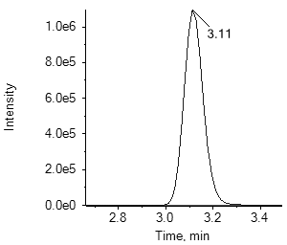1.乙酰甲胺磷

acephate

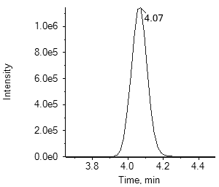2.啶虫脒

acetamiprid

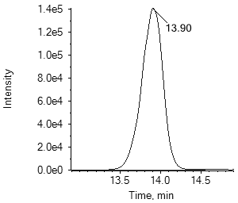3.乙草胺

acetochlor

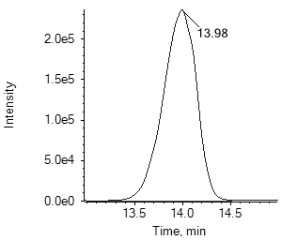4.甲草胺

alachlor

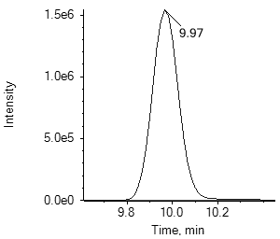5.丙硫多菌灵

albendazole

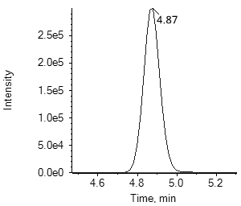6.涕灭威

aldicarb

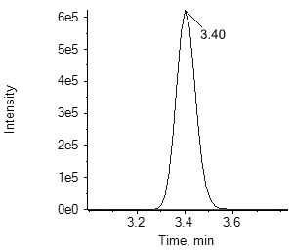6.涕灭威砜

aldicarb Sulfone

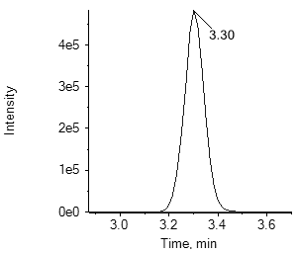6.涕灭威亚砜

aldicarb sulfoxide

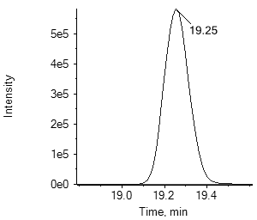7.唑嘧菌胺

ametoctradin

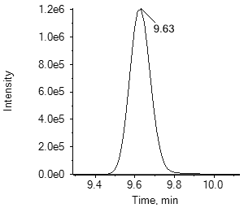8.莠灭净

ametryn

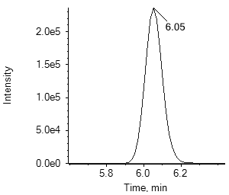9.酰嘧磺隆

amidosulfuron

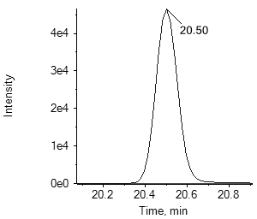10.吲唑磺菌胺

amisulbrom

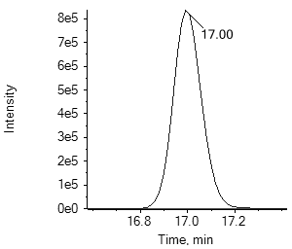11.莎稗磷

anilofos

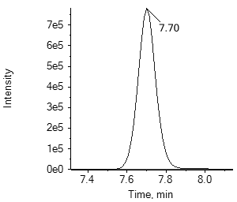12.莠去津

atrazine

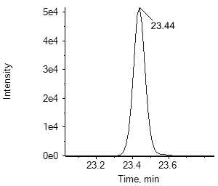13.阿维菌素

avermectin B1a

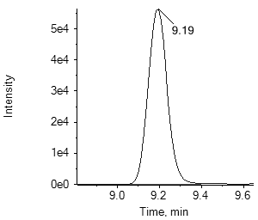14.保棉磷

azinphos-methyl

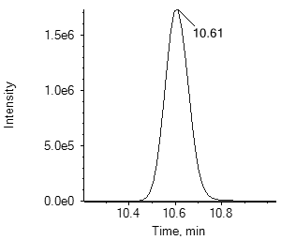15.嘧菌酯

azoxystrobin

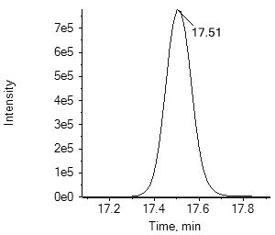16.苯霜灵

benalaxyl

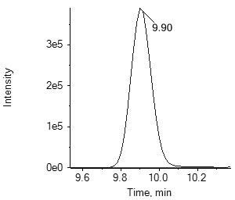17.草除灵

benazolin-ethyl

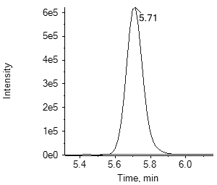18.恶虫威

bendiocarb

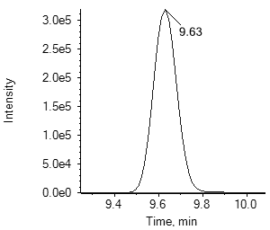19.苄嘧磺隆

bensulfuron-methyl

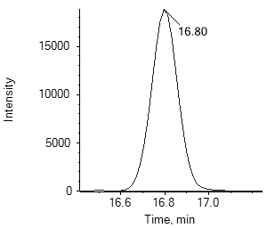20.苯并烯氟菌唑benzovindiflupyr

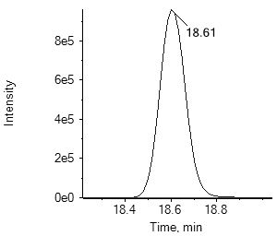21.苯螨特

benzoximate

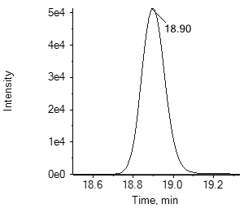22.甲羧除草醚

bifenox

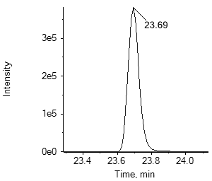23.联苯菊酯

bifenthrin

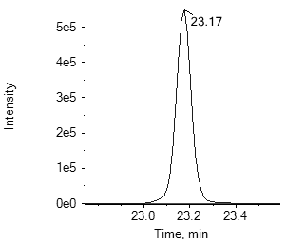24.生物苄呋菊酯bioresmethrin

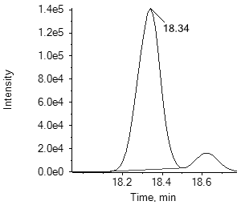25.联苯三唑醇

bitertanol

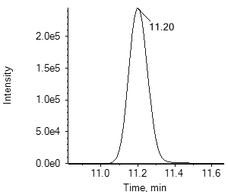26.啶酰菌胺

boscalid

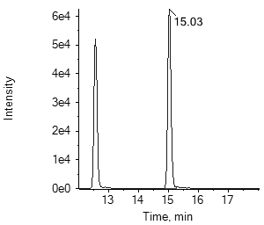27.糠菌唑

bromuconazole

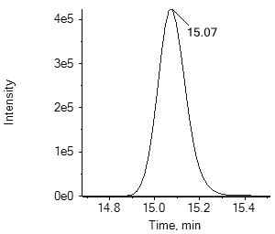28.乙嘧酚磺酸酯bupirimate

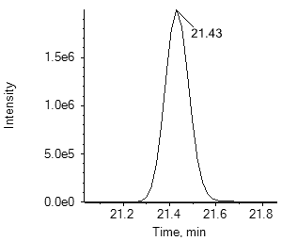29.噻嗪酮

buprofezin

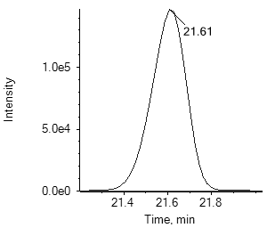30.丁草胺

butachlor

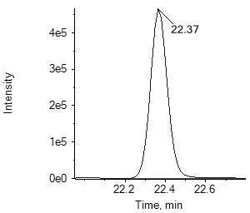31.仲丁灵

butralin

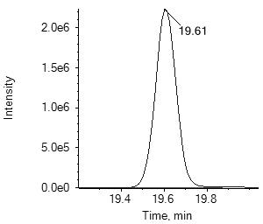32.硫线磷

cadusafos

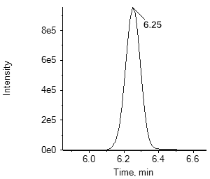33.甲萘威

carbaryl

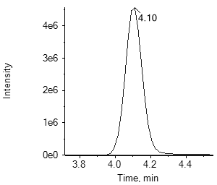34.多菌灵

carbendazim

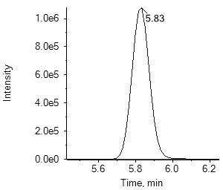35.克百威

carbofuran

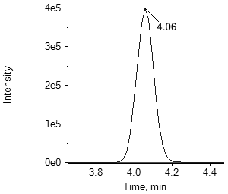35. 3-羟基克百威

3-hydroxy carbofuran

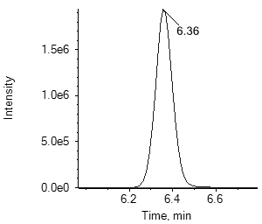36.萎锈灵

carboxin

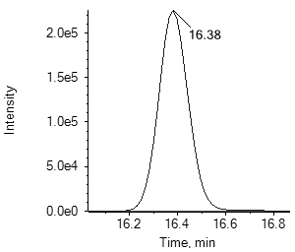37.唑草酮

carfentrazone-ethyl

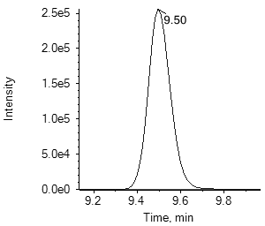38.氯虫苯甲酰胺chlorantraniliprole

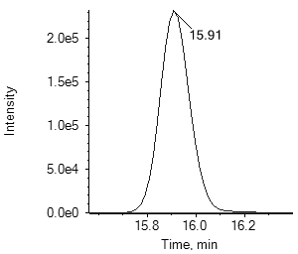39.灭幼脲

chlorbenzuron

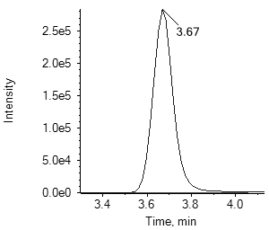40.杀虫脒

chlordimeform

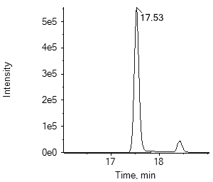41.毒虫畏

chlorfenvinphos

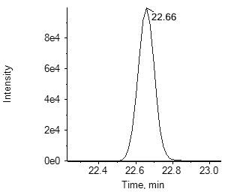42.氟啶脲

chlorfluazuron

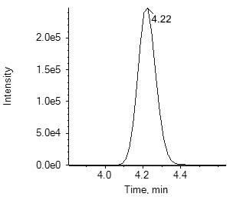43.杀草敏

chloridazon

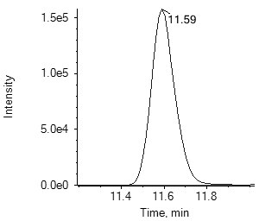44.氯嘧磺隆

chlorimuron-ethyl

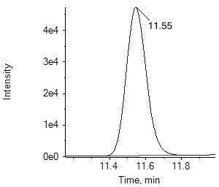45.氯苯胺灵

chlorpropham

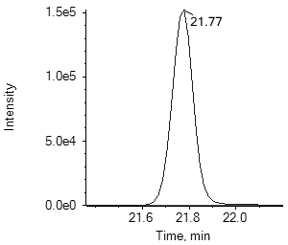46.毒死蜱

chlorpyrifos

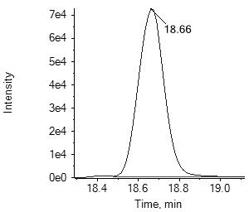47.甲基毒死蜱chlorpyrifos-methyl

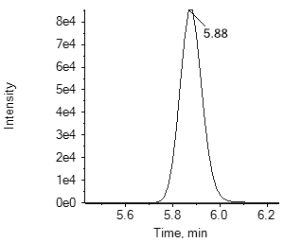48.氯磺隆

chlorsulfuron

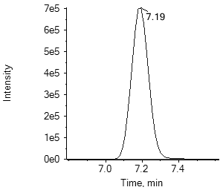49.绿麦隆

chlortoluron

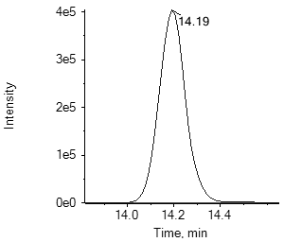50.环虫酰肼chromafenozide

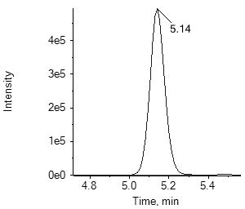51.醚磺隆

cinosulfuron

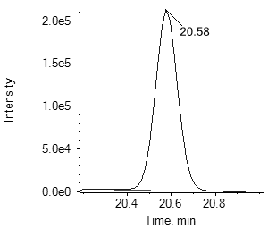52.烯草酮

clethodim

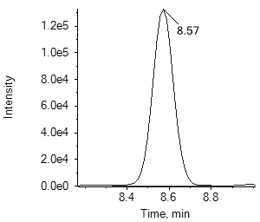52.烯草酮砜

clethodim sulfone

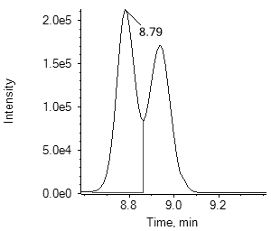52.烯草酮亚砜

clethodim sulfoxide

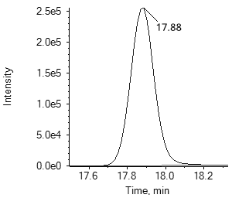53.四螨嗪

clofentezine

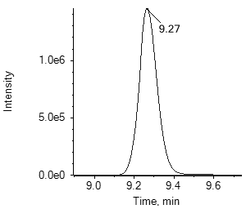54.异噁草酮

clomazone

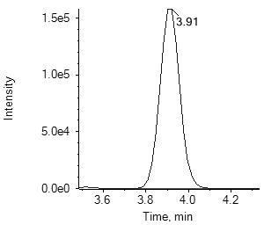55.噻虫胺

clothianidin

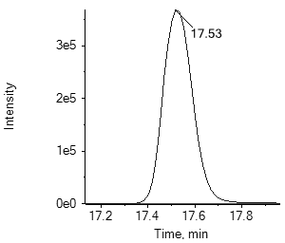56.蝇毒磷

coumaphos

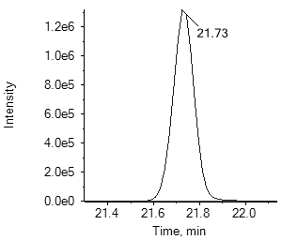57.丁香菌酯coumoxystrobin

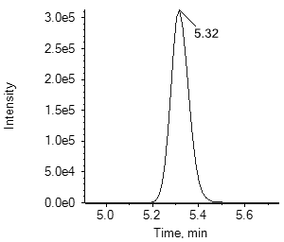58.氰草津

cyanazine

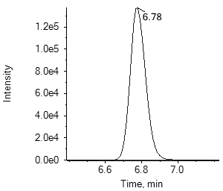59.溴氰虫酰胺cyantraniliprole

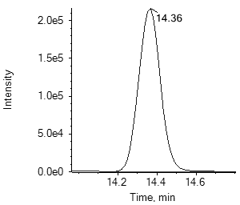60.氰霜唑

cyazofamid

20.苯并烯氟菌唑benzovindiflupyr

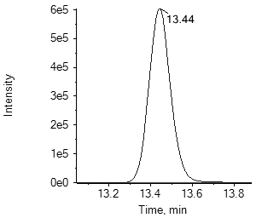61.环丙嘧磺隆cyclosulfamuron

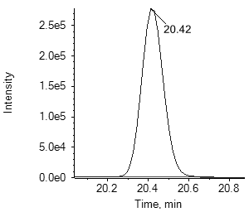62.噻草酮

cycloxydim

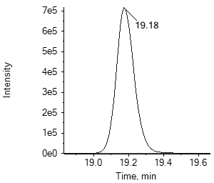63.环氟菌胺

cyflufenamid

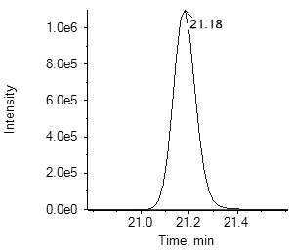64.丁氟螨酯

cyflumetofen

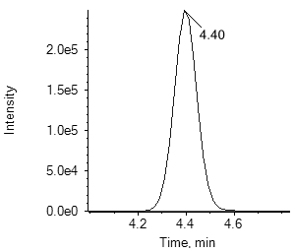65.霜脲氰

cymoxanil

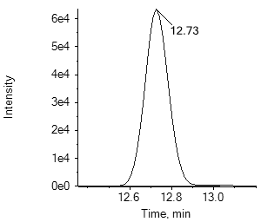66.环丙唑醇

cyproconazole

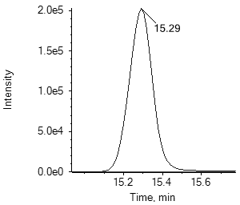67.嘧菌环胺

cyprodinil

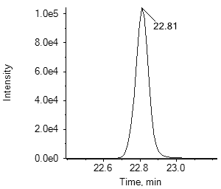68.溴氰菊酯

deltamethrin

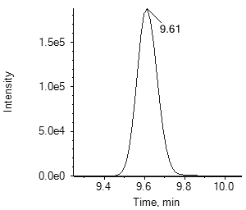69.内吸磷

demeton

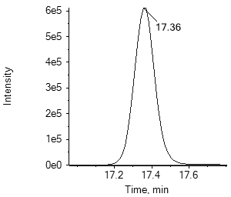70.二嗪磷

diazinon

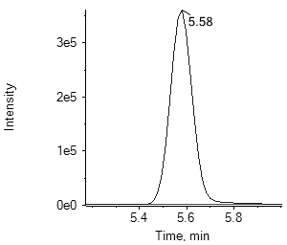71.敌敌畏

dichlorvos

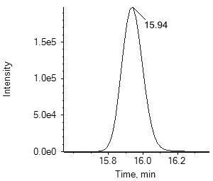72.苄氯三唑醇Diclobutrazol

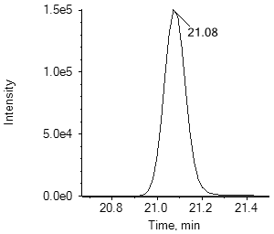73.禾草灵

diclofop-methyl

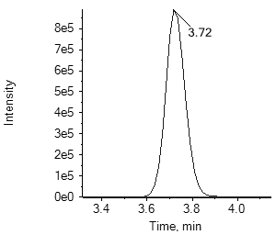74.百治磷

dicrotophos

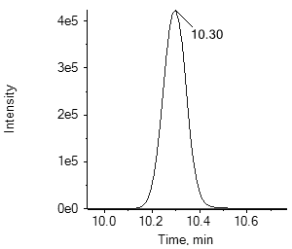75.乙霉威

diethofencarb

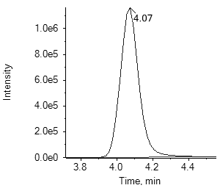76.胺鲜酯

diethyl aminoethyl hexanoate

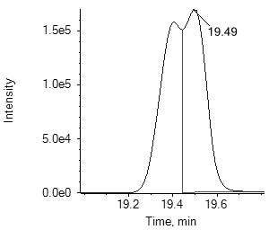77.苯醚甲环唑difenoconazole

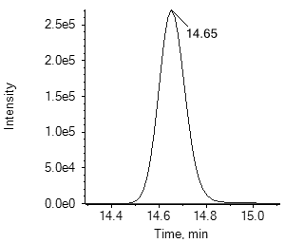78.除虫脲

diflubenzuron

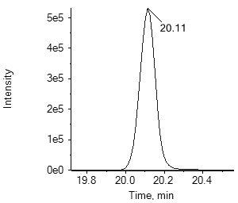79.吡氟酰草胺

diflufenican

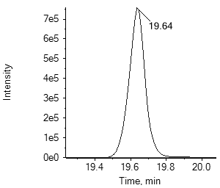80.哌草丹

dimepiperate

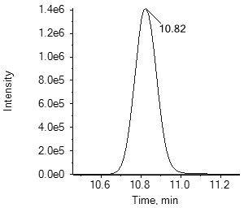81.精二甲吩草胺dimethenamid-P

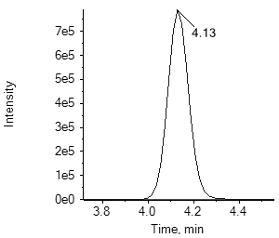82.乐果

dimethoate

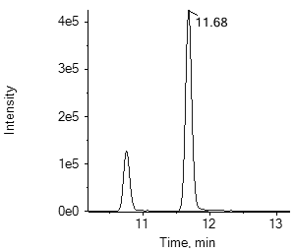83.烯酰吗啉dimethomorph

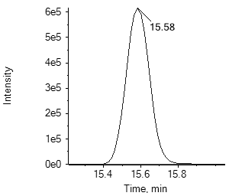84.醚菌胺

dimoxystrobin

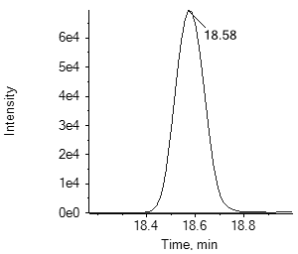85.烯唑醇

diniconazole

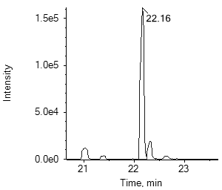86.敌螨普

dinocap

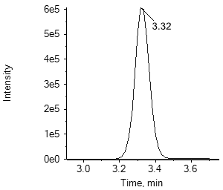87.呋虫胺

dinotefuran

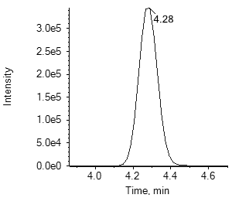88.乙拌磷氧磷

demeton-S-sulfone

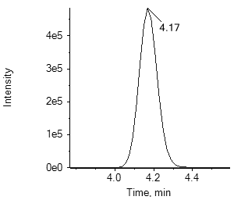88.砜吸磷-S-亚砜demeton-S-sulfoxide

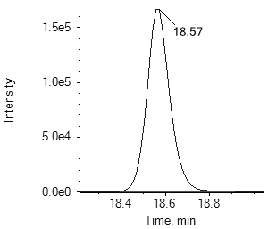88.乙拌磷

disulfoton

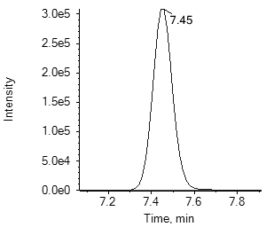88.乙拌磷砜

disulfoton sulfone

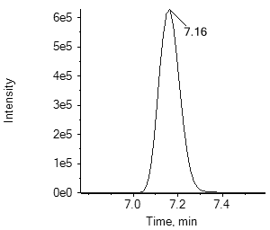88.乙拌磷亚砜

disulfoton sulfoxide

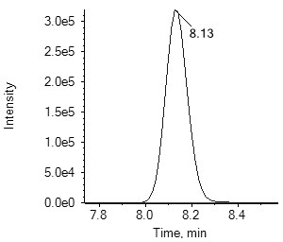89.敌草隆

diuron

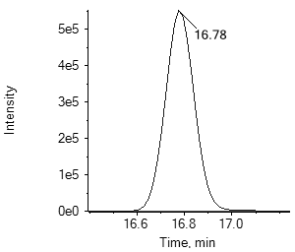90.敌瘟磷

edifenphos

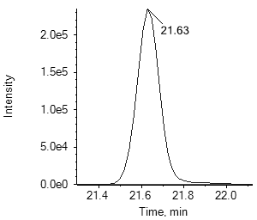91.甲氨基阿维菌素苯甲酸盐emamectin B1a

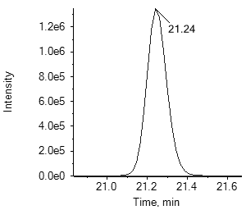92.烯肟菌酯

enestroburin

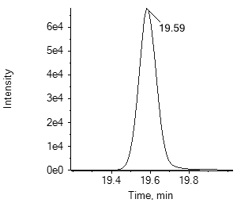93.苯硫磷

EPN

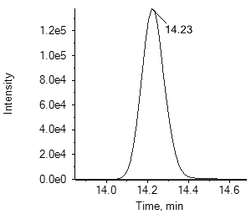94.氟环唑

epoxiconazole

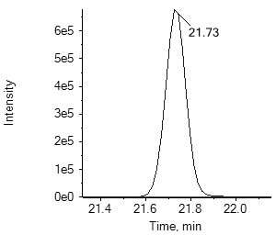95.乙硫磷

ethion

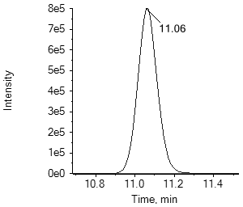96.乙虫腈

ethiprole

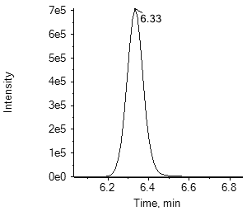97.乙嘧酚

ethirimol

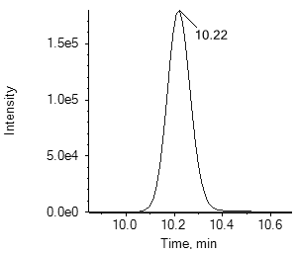98.乙氧呋草黄ethofumesate

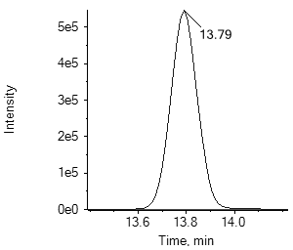99.灭线磷

ethoprophos

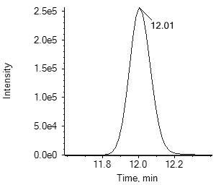100.乙氧磺隆ethoxysulfuron

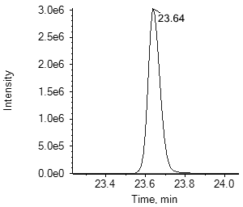101.醚菊酯

etofenprox

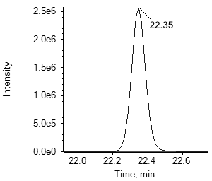102.乙螨唑

etoxazole

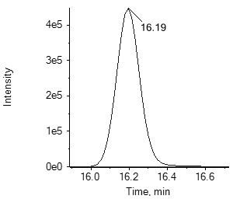103.乙嘧硫磷

etrimfos

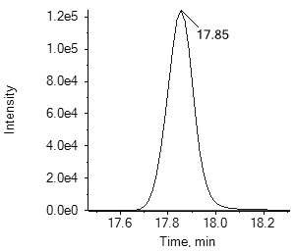104.噁唑菌酮

famoxadone

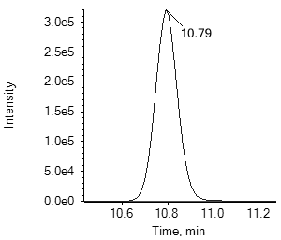105.咪唑菌酮

fenamidone

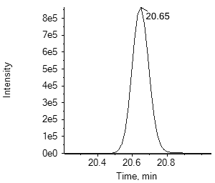106.烯肟菌胺fenaminstrobin

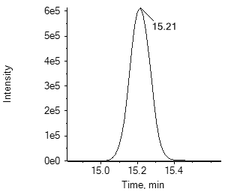107.苯线磷

fenamiphos

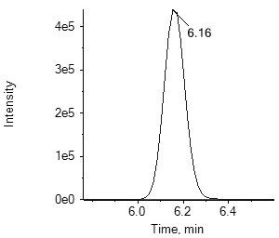107.苯线磷砜

fenamiphos sulfone

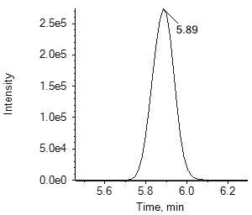107.苯线磷亚砜fenamiphos sulfoxide

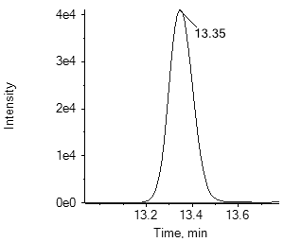108.氯苯嘧啶醇

fenarimol

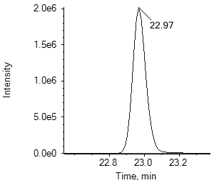109.喹螨醚

fenazaquin

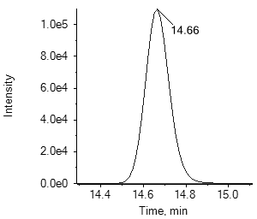110.腈苯唑

fenbuconazole

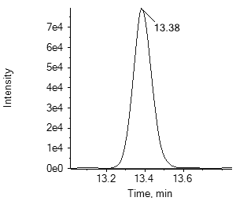111.环酰菌胺

fenhexamid

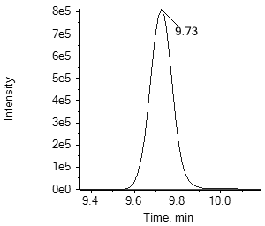112.仲丁威

fenobucarb

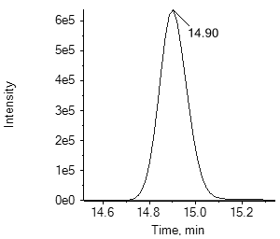113.苯硫威

fenothiocarb

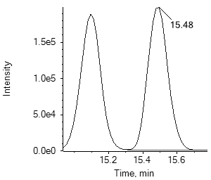114.稻瘟酰胺

fenoxanil

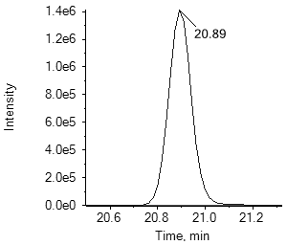115.精噁唑禾草灵fenoxaprop-P-ethyl

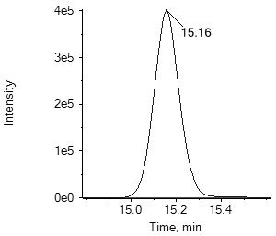116.苯氧威

Fenoxycarb

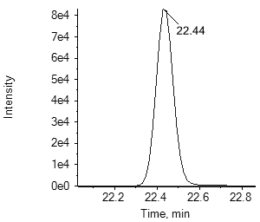117.甲氰菊酯fenpropathrin

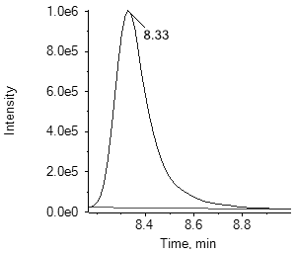118.苯锈啶

fenpropidin

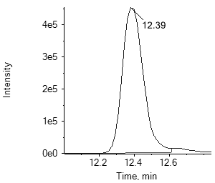119.丁苯吗啉fenpropimorph

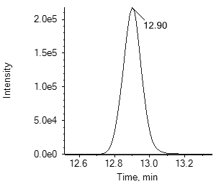120.胺苯吡菌酮fenpyrazamine

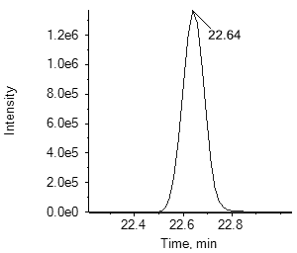121.唑螨酯

fenpyroximate

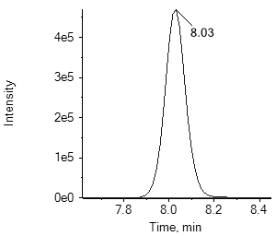122.丰索磷

fensulfothion

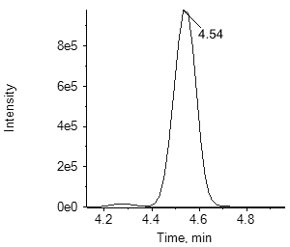122.氧丰索磷

fensulfothion oxon

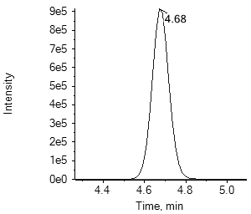122.氧丰索磷砜fensulfothion oxon sulfone

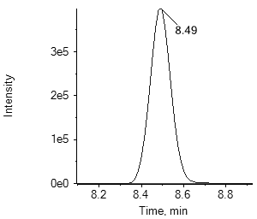122.丰索磷砜

fensulfothion sulfone

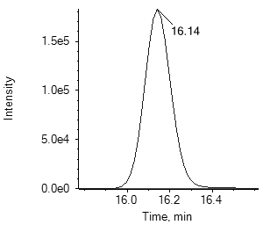123.倍硫磷

fenthion

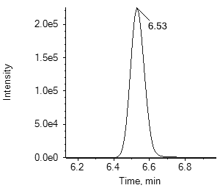123.倍硫磷砜

fenthion sulfone

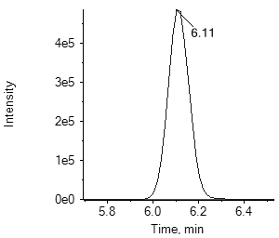123.倍硫磷亚砜

fenthion sulfoxide

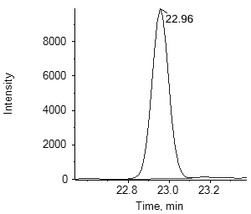124.氰戊菊酯

fenvalerate

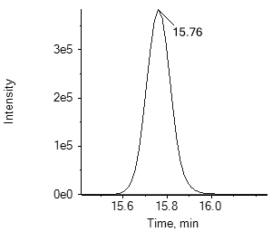125.氟虫腈

fipronil

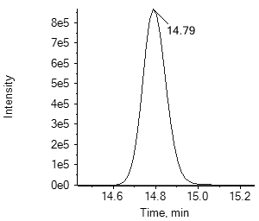125.氟甲腈

fipronil desulfinyl

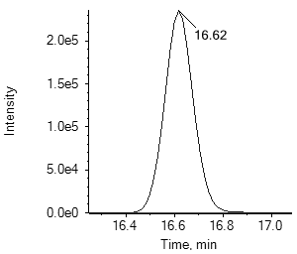125.氟虫腈硫化物

fipronil sulfide

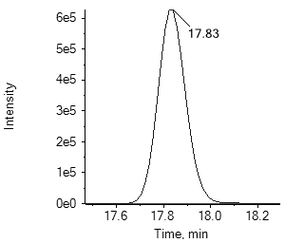125.氟虫腈砜

fipronil sulfone

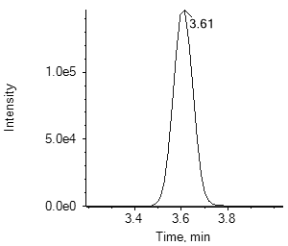126.氟啶虫酰胺

flonicamid

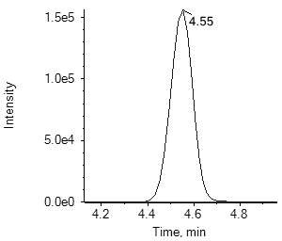127.双氟磺草胺

florasulam

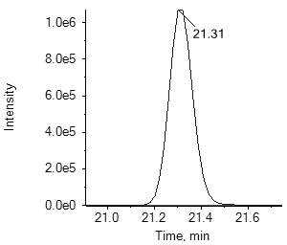128.吡氟禾草灵

fluazifop butyl

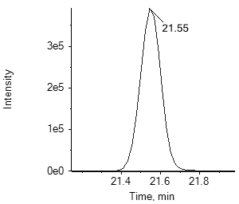129.氟啶胺

fluazinam

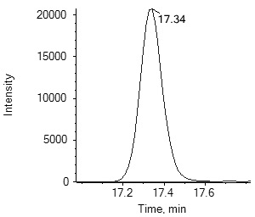130.氟苯虫酰胺flubendiamide

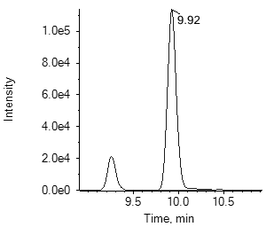131.氟吡磺隆flucetosulfuron

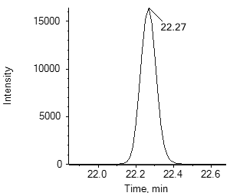132.氟氰戊菊酯flucythrinate

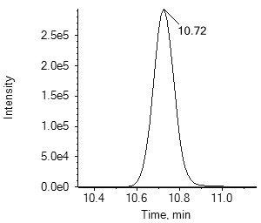133.咯菌腈

fludioxonil

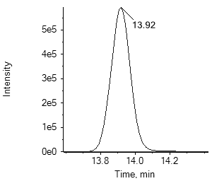134.氟噻草胺

flufenacet

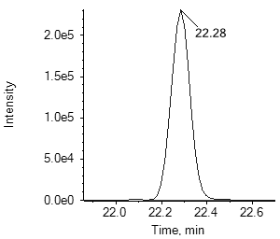135.氟虫脲

flufenoxuron

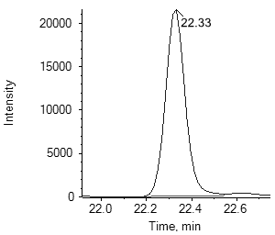136.氟节胺

flumetralin

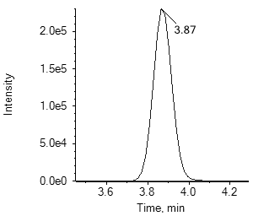137.唑嘧磺草胺flumetsulam

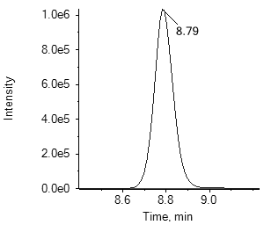138.氟吗啉

flumorph

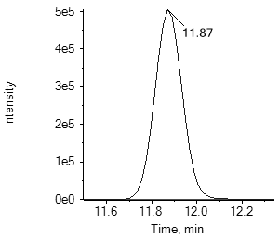139.氟吡菌胺

fluopicolide

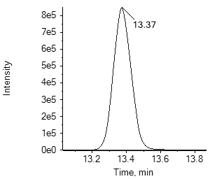140.氟吡菌酰胺

fluopyram

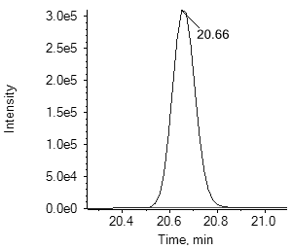141.乙羧氟草醚fluoroglycofen-ethyl

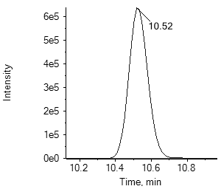142.呋草酮

flurtamone

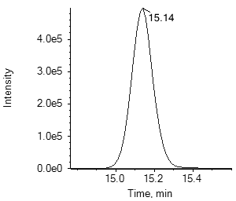143.氟硅唑

flusilazole

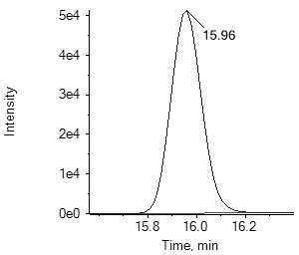144.嗪草酸甲酯

fluthiacet-methyl

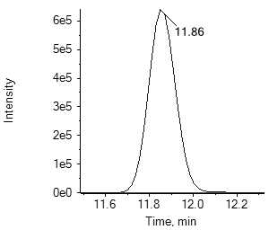145.氟酰胺

flutolanil

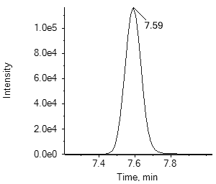146.粉唑醇

flutriafol

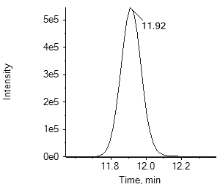147.氟唑菌酰胺fluxapyroxad

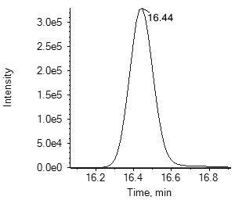148.地虫硫磷

fonofos

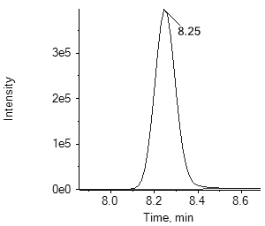149.氯吡脲forchlorfenuron

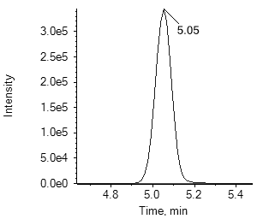150.安硫磷formothion

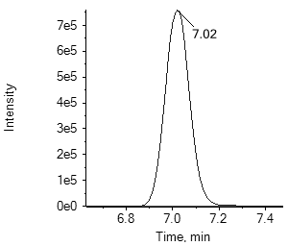151.噻唑磷fosthiazate

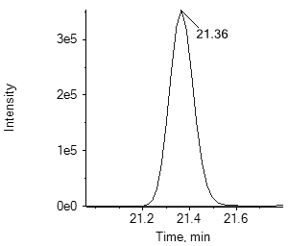152.呋线威furathiocarb

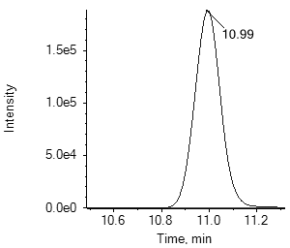153.氯吡嘧磺隆halosulfuron-methyl

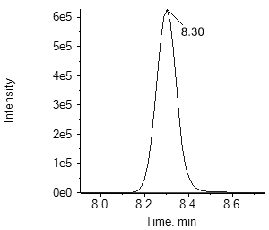154.庚烯磷

heptenophos

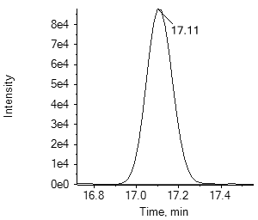155.己唑醇

hexaconazole

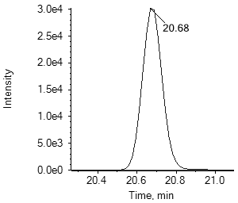156.氟铃脲

hexaflumuron

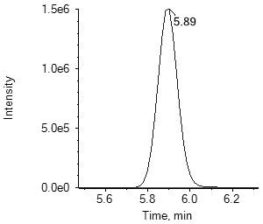157.环嗪酮hexazinone

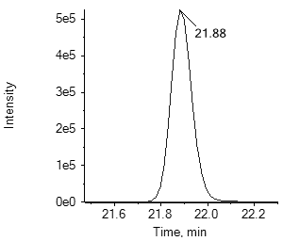158.噻螨酮hexythiazox

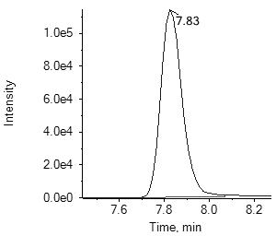159.抑霉唑imazalil

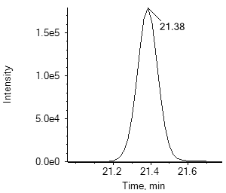160.亚胺唑imibenconazole

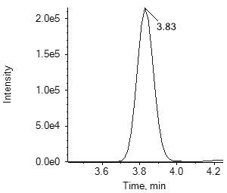161.吡虫啉

imidacloprid

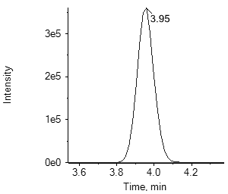162.氯噻啉

imidaclothiz

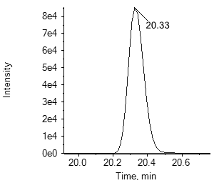163.茚虫威

indoxacarb

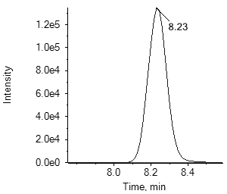164.甲基碘磺隆钠盐iodosulfuron-methyl-sodium

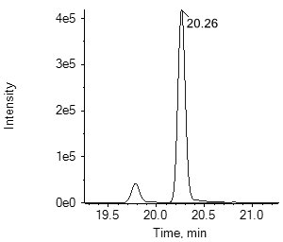165.种菌唑

ipconazole

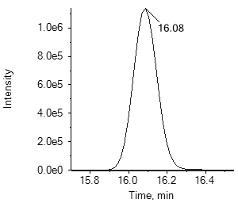166.异稻瘟净

iprobenfos

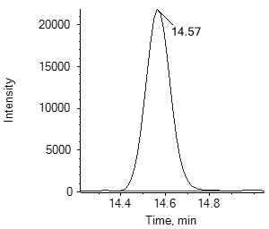167.异菌脲

iprodione

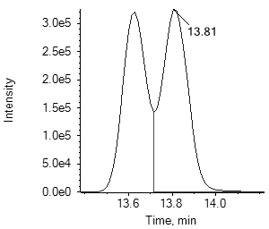168.缬霉威

iprovalicarb

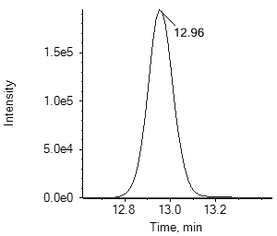169.氯唑磷

isazofos

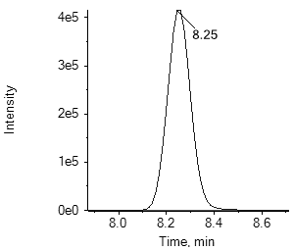170.水胺硫磷

isocarbophos

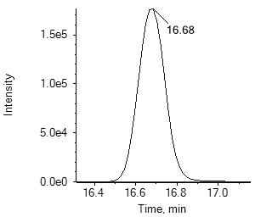171.甲基异柳磷isofenphos-methyl

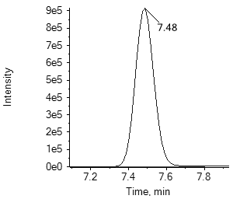172.异丙威

isoprocarb

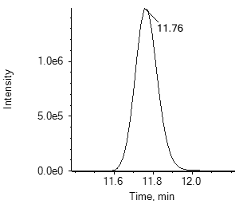173.稻瘟灵

isoprothiolane

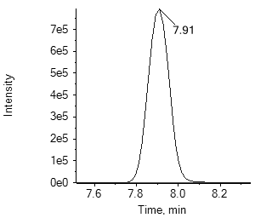174.异丙隆

isoproturon

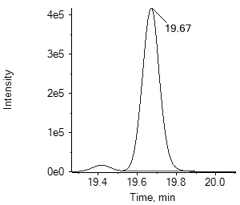175.吡唑萘菌胺isopyrazam

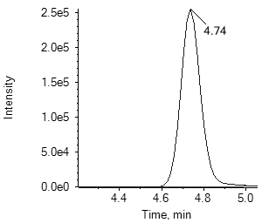176.异噁唑草酮-二酮腈isoxaflutole-diketonitrile

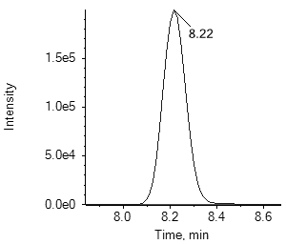176.异噁唑草酮isoxaflutole

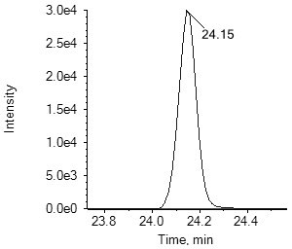177.依维菌素

ivermectin B1a

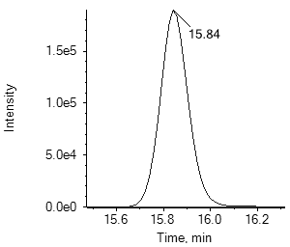178.醚菌酯

kresoxim-methyl

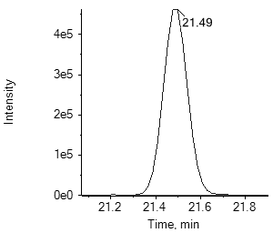179.乳氟禾草灵

lactofen

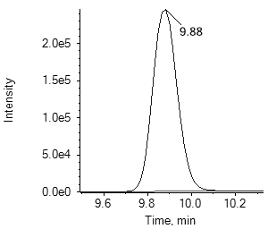180.利谷隆

linuron

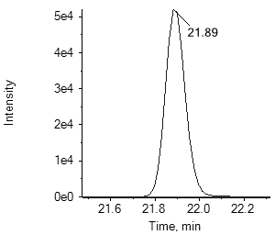181.虱螨脲

lufenuron

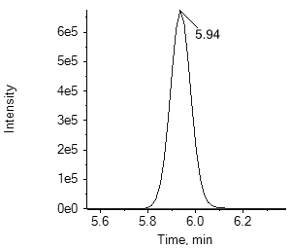182.马拉氧磷

malaoxon

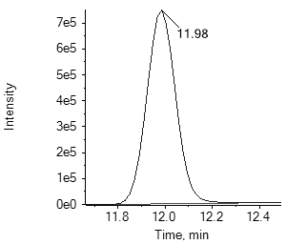182.马拉硫磷

malathion

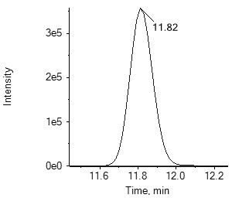183.双炔酰菌胺mandipropamid

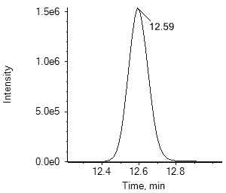184.苯噻酰草胺

mefenacet

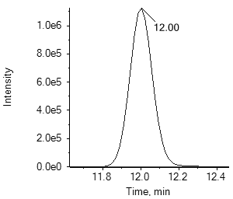185.灭锈胺

mepronil

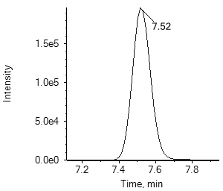186.甲基二磺隆mesosulfuron-methyl

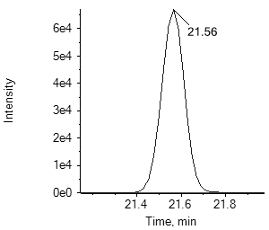187.氰氟虫腙metaflumizone

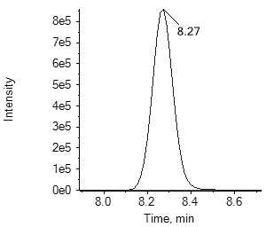188.甲霜灵

metalaxyl

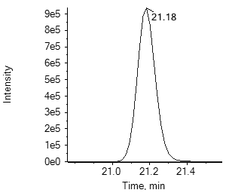189.噁唑酰草胺metamifop

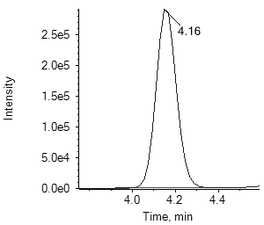190.苯嗪草酮

metamitron

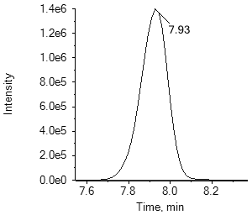191.吡唑草胺

metazachlor

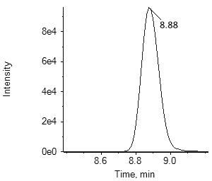192.嗪吡嘧磺隆metazosulfuron

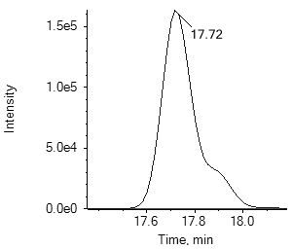193.叶菌唑

metconazole

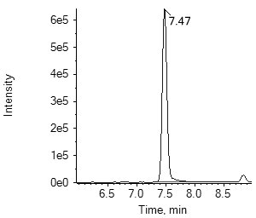194.虫螨畏

methacrifos

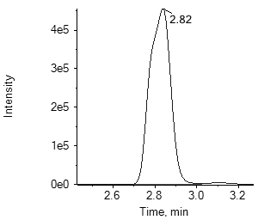195.甲胺磷methamidophos

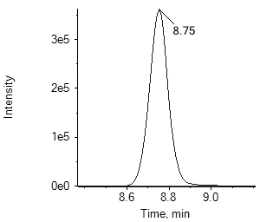196.杀扑磷

methidathion

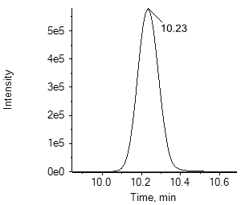197.甲硫威

methiocarb

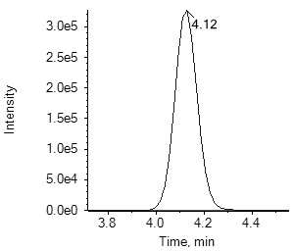197.甲硫威砜

methiocarb sulfone

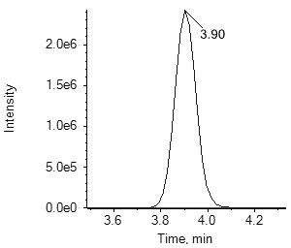197.甲硫威亚砜methiocarb sulfoxide

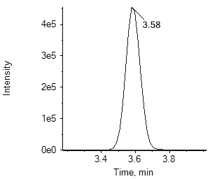198.灭多威

methomyl

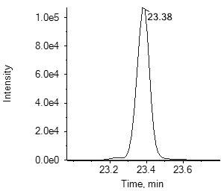199.烯虫酯

methoprene

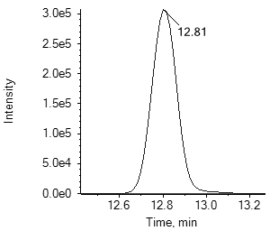200.甲氧虫酰肼methoxyfenozide

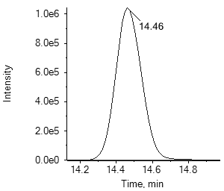201.异丙甲草胺metolachlor

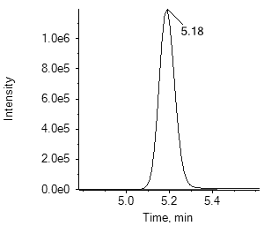202.速灭威

metolcarb

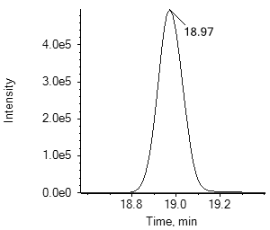203.苯菌酮

metrafenone

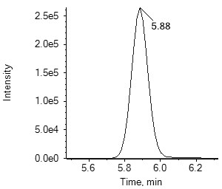204.嗪草酮

metribuzin

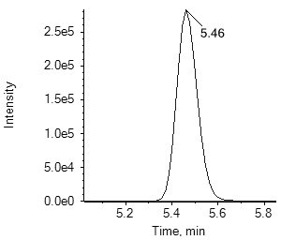205.甲磺隆

metsulfuron-methyl

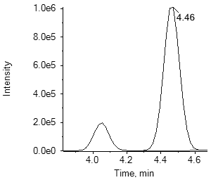206.速灭磷

mevinphos

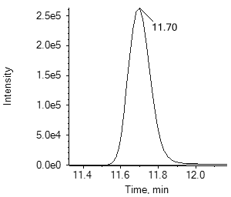207.禾草敌

molinate

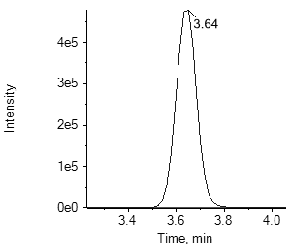208.久效磷monocrotophos

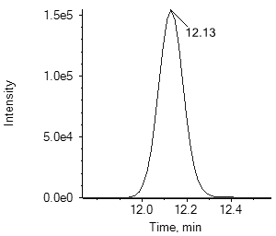209.腈菌唑

myclobutanil

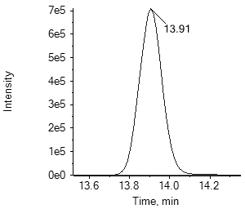210.敌草胺

napropamide

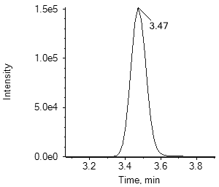211.烯啶虫胺

nitenpyram

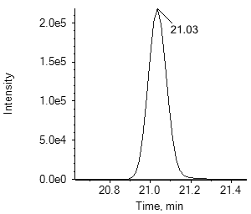212.氟酰脲

novaluron

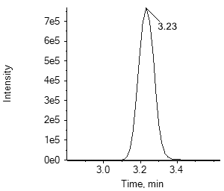213.氧乐果

omethoate

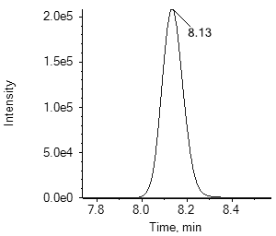214.嘧苯胺磺隆orthosulfamuron

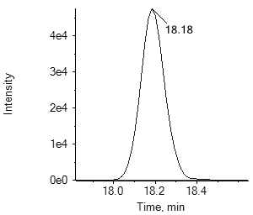215.丙炔噁草酮

oxadiargyl

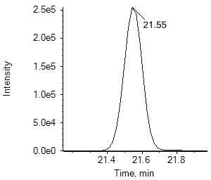216.噁草酮

oxadiazon

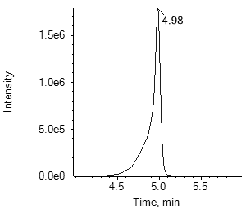217.噁霜灵

oxadixyl

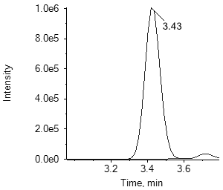218.杀线威

oxamyl

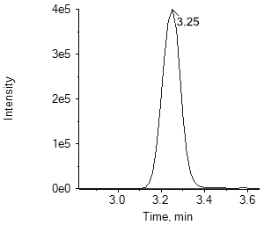218.杀线威肟

oxamyl oxime

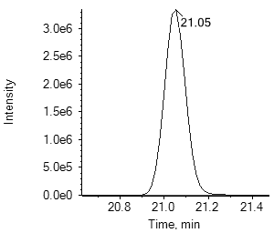219.噁嗪草酮oxaziclomefone

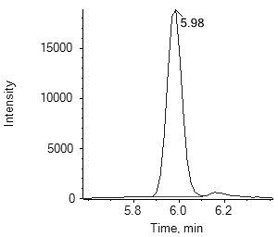220.甲基内吸磷

demeton-S-methyl

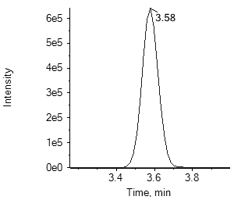220.甲基砜内吸磷demeton-S-methyl-sulfone

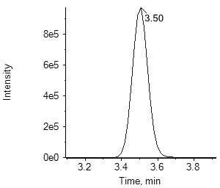220.亚砜磷

oxydemeton-methyl

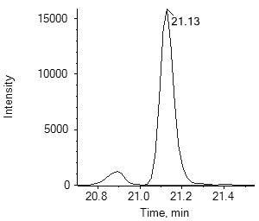221.乙氧氟草醚oxyfluorfen

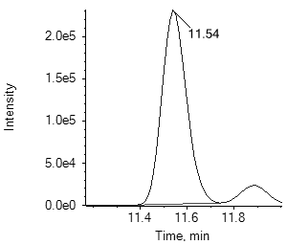222.多效唑

paclobutrazol

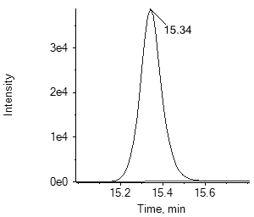223.对硫磷

parathion

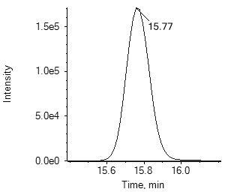224.戊菌唑

penconazole

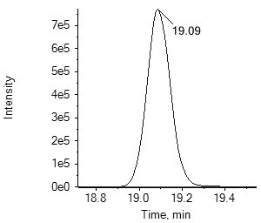225.戊菌隆

pencycuron

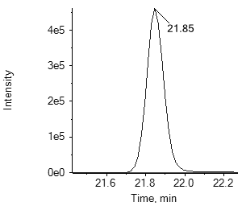226.二甲戊灵pendimethalin

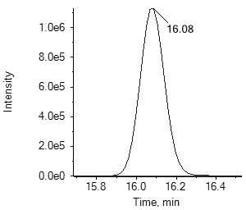227.氟唑菌苯胺

penflufen

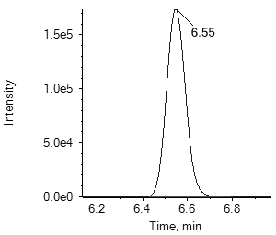228.五氟磺草胺penoxsulam

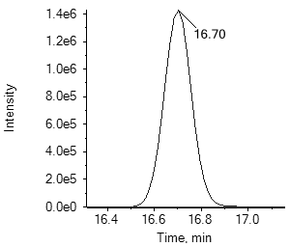229.吡噻菌胺penthiopyrad

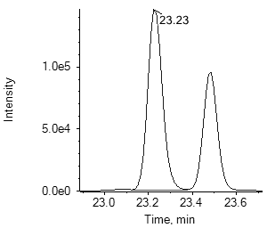230.氯菊酯

permethrin

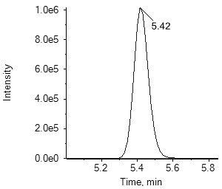231.氰烯菌酯

phenamacril

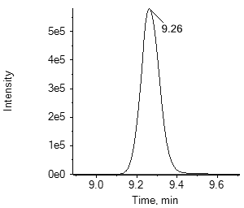232.甜菜宁phenmedipham

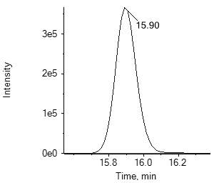233.稻丰散

phenthoate

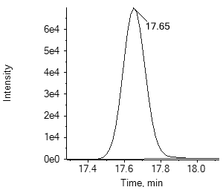234.甲拌磷

phorate

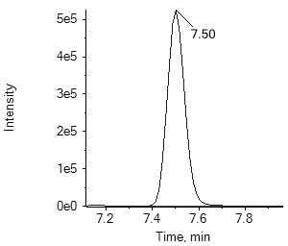234.甲拌磷砜

phorate sulfone

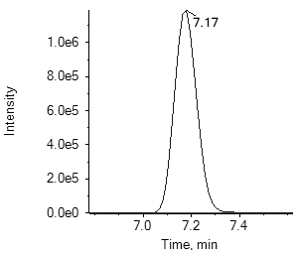234.甲拌磷亚砜

phorate sulfoxide

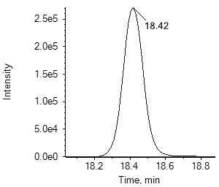235.伏杀硫磷

phosalone

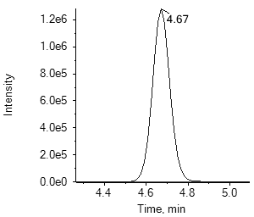236.硫环磷

phosfolan

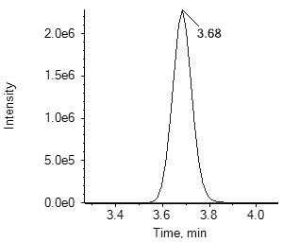237.甲基硫环磷

phosfolan-methyl

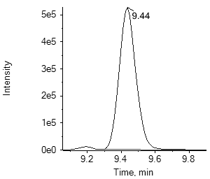238.亚胺硫磷

phosmet

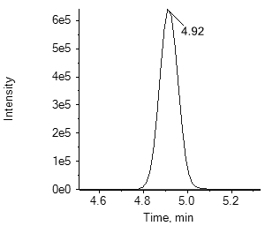238.氧亚胺硫磷

phosmet oxon

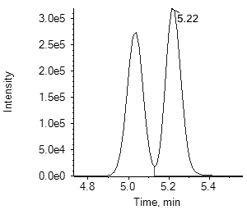239.磷胺

phosphamidon

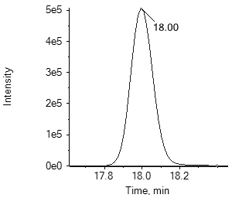240.辛硫磷

phoxim

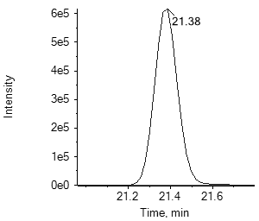241.氟吡酰草胺picolinafen

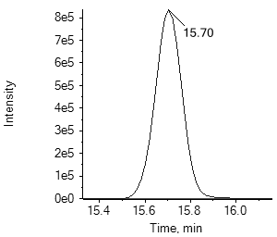242.啶氧菌酯

picoxystrobin

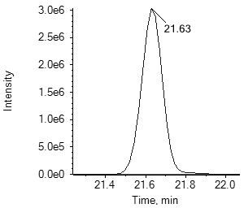243.增效醚

piperonyl butoxide

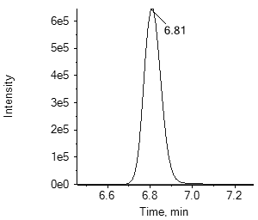244.抗蚜威

pirimicarb

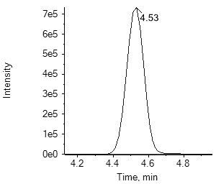244.脱甲基抗蚜威pirimicarb-desmethyl

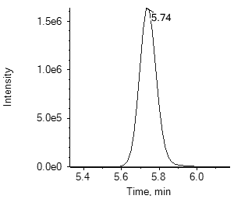244.脱甲基甲酰胺基抗蚜威pirimicarb-desmethyl-formamido

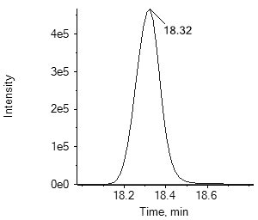245.甲基嘧啶磷pirimiphos-methyl

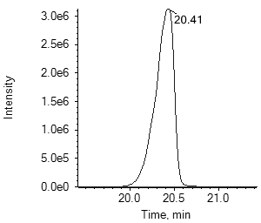246.丙草胺

pretilachlor

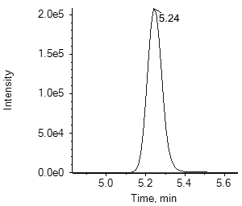247.烯丙苯噻唑probenazole

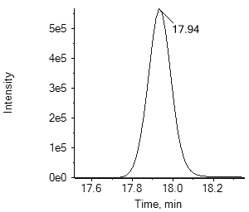248.咪鲜胺

prochloraz

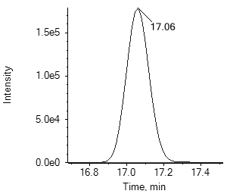248.咪鲜胺-脱氨基咪唑prochloraz metabolite BTS44595

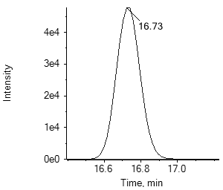248.咪鲜胺-脱咪唑甲酰胺基prochloraz metabolite BTS44596

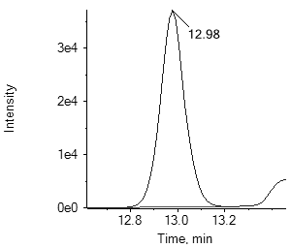249.腐霉利

procymidone

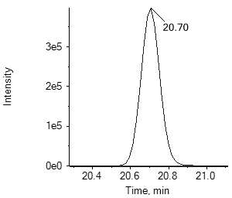250.丙溴磷

profenofos

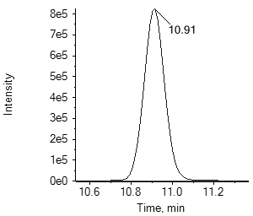251.猛杀威

promecarb

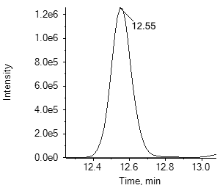252.扑草净

prometryn

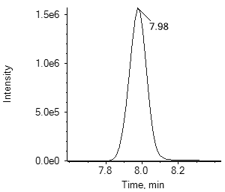253.毒草胺

propachlor

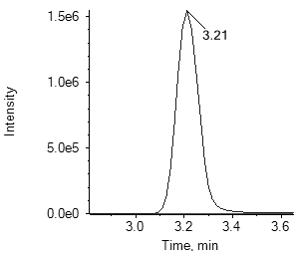254.霜霉威

propamocarb

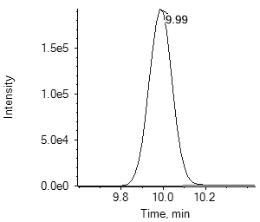255.敌稗

propanil

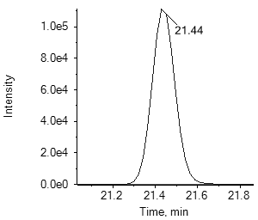256.喔草酯

propaquizafop

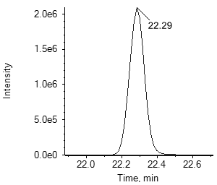257.炔螨特propargite

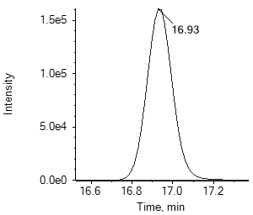258.丙环唑propiconazole

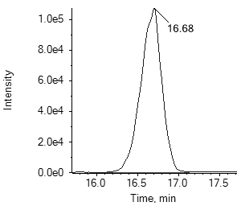259.异丙草胺propisochlor

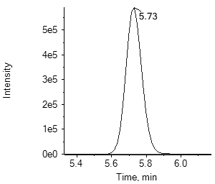260.残杀威

propoxur

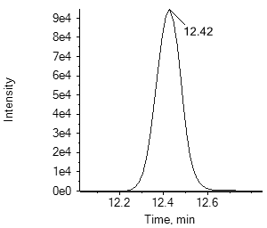261.丙嗪嘧磺隆propyrisulfuron

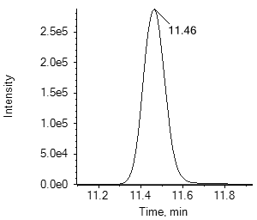262.炔苯酰草胺propyzamide

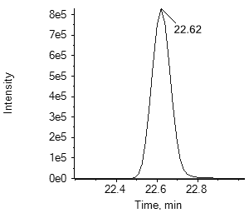263.丙氧喹啉

proquinazid

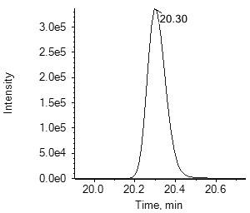264.苄草丹

prosulfocarb

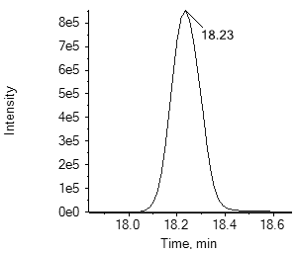265.吡唑醚菌酯pyraclostrobin

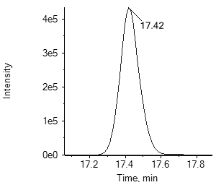266.吡草醚

pyraflufen-ethyl

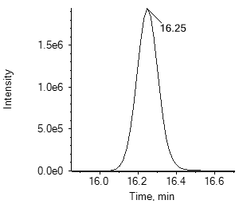267.唑胺菌酯pyrametostrobin

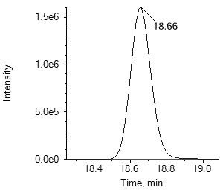268.唑菌酯

pyraoxystrobin

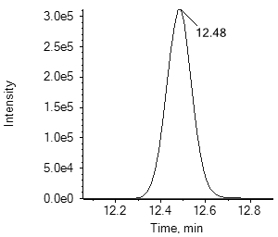269.吡嘧磺隆pyrazosulfuron-ethyl

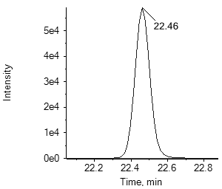270.除虫菊素 I

pyrethrins I

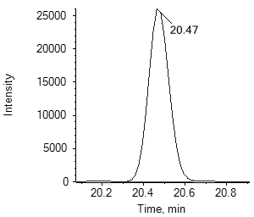270.除虫菊素 II

pyrethrins II

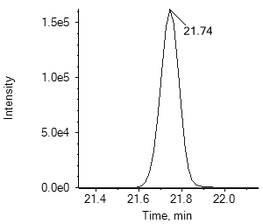271.嘧啶肟草醚pyribenzoxim

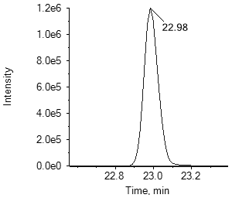272.哒螨灵

pyridaben

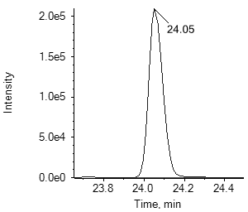273.三氟甲吡醚

pyridalyl

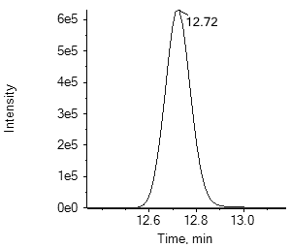274.哒嗪硫磷pyridaphenthion

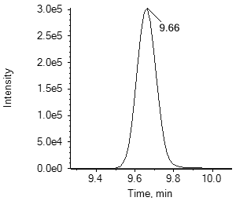275.环酯草醚

pyriftalid

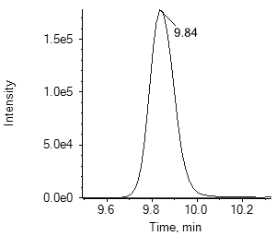276.嘧霉胺

pyrimethanil

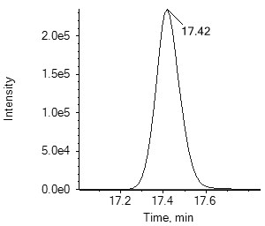277.丁吡吗啉

pyrimorph

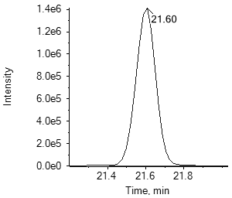278.吡丙醚

pyriproxyfen

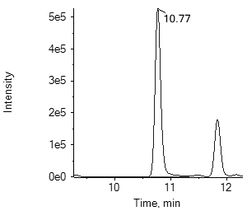279.啶菌噁唑pyrisoxazole

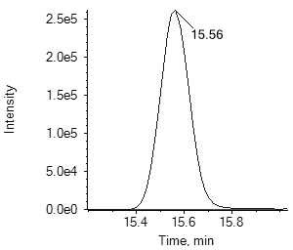280.喹硫磷

quinalphos

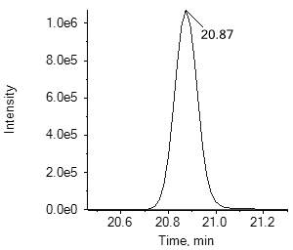281.喹禾灵

quizalofop-ethyl

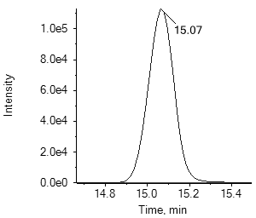282.鱼藤酮

rotenone

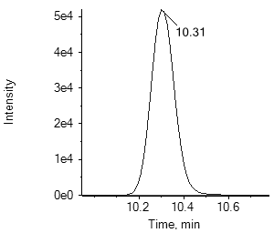283.苯嘧磺草胺saflufenacil

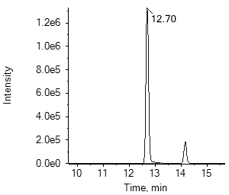284.氟唑环菌胺

sedaxane

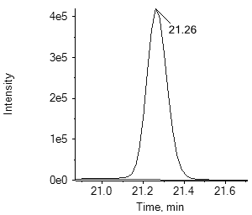285.烯禾啶

sethoxydim

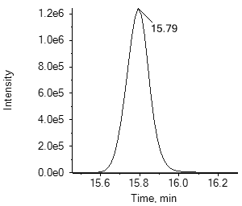286.硅噻菌胺

silthiofam

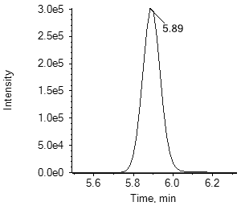287.西玛津

simazine

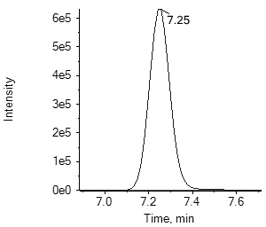288.西草净

simetryn

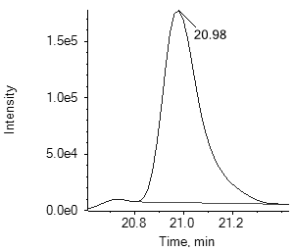289.乙基多杀菌素J spinetoram J

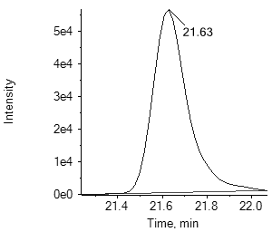289.乙基多杀菌素 L spinetoram L

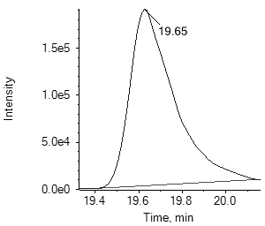290.多杀霉素 A

spinosad A

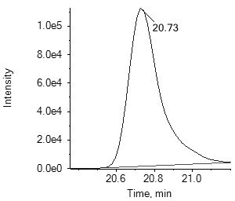290.多杀霉素 D

spinosad D

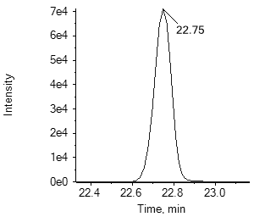291.螺螨酯

spirodiclofen

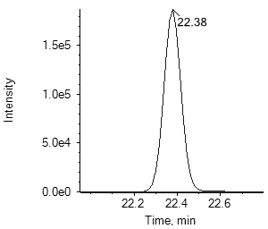292.螺甲螨酯

spiromesifen

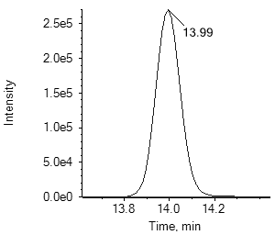293.螺虫乙酯spirotetramat

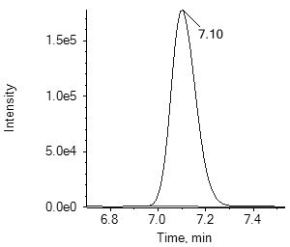293.螺虫乙酯-烯醇spirotetramat-enol

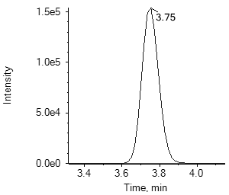293.螺虫乙酯-烯醇-葡萄糖苷spirotetramat-enol-glucoside

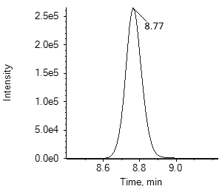293.螺虫乙酯-酮基-羟基spirotetramat-keto-hydroxy

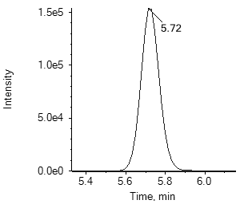293.螺虫乙酯-单-羟基spirotetramat-mono-hydroxy

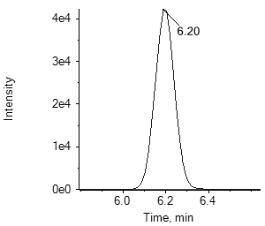294.甲磺草胺sulfentrazone

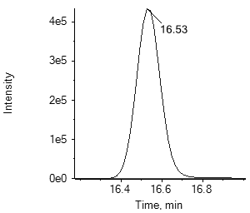295.治螟磷

sulfotep

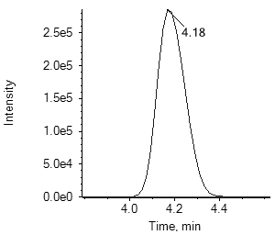296.氟啶虫胺腈

sulfoxaflor

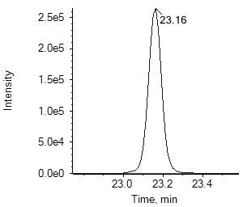297.氟胺氰菊酯

tau-fluvalinate

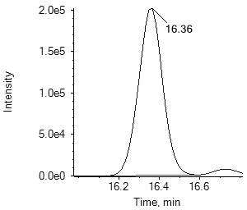298.戊唑醇

tebuconazole

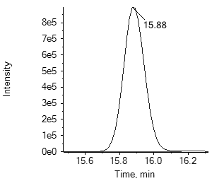299.虫酰肼

tebufenozide

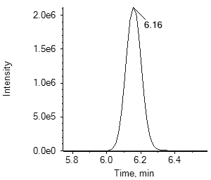300.丁噻隆

tebuthiuron

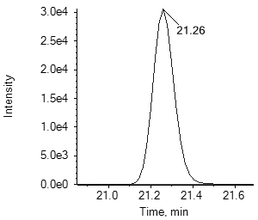301.氟苯脲

teflubenzuron

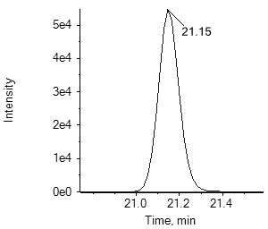302.特丁硫磷

terbufos

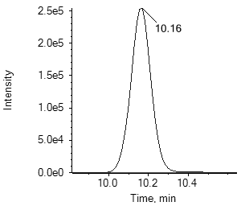302.特丁硫磷砜

terbufos sulfone

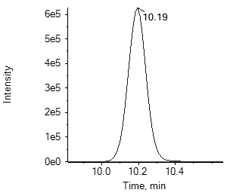302.特丁硫磷亚砜

terbufos sulfoxide

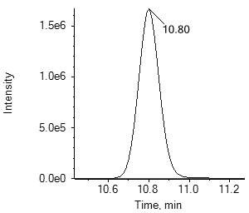303.特丁津

terbuthylazine

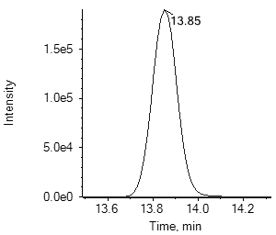304.四氟醚唑tetraconazole

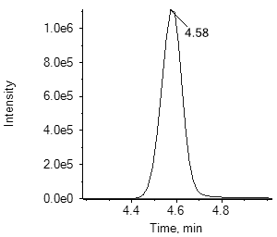305.噻菌灵

thiabendazole

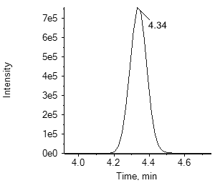306.噻虫啉

thiacloprid

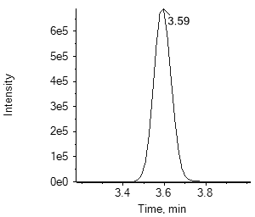307.噻虫嗪

thiamethoxam

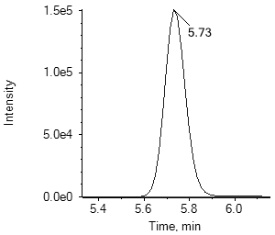308.噻苯隆

thidiazuron

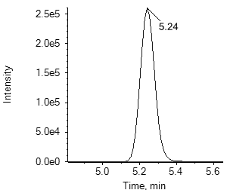309.噻吩磺隆thifensulfuron-methyl

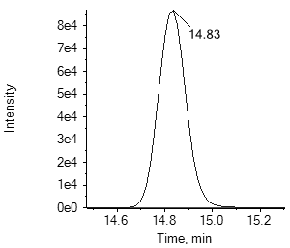310.噻氟菌胺

thifluzamide

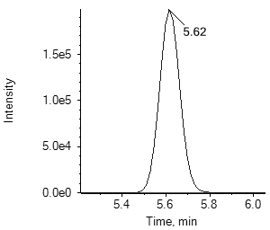311.甲基硫菌灵thiophanate-methyl

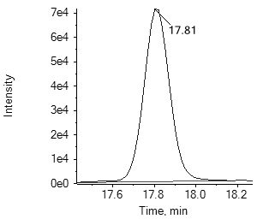312.甲基立枯磷

tolclofos-methyl

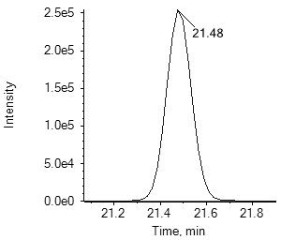313.唑虫酰胺

tolfenpyrad

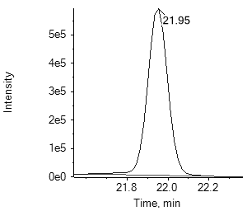314.三甲苯草酮tralkoxydim

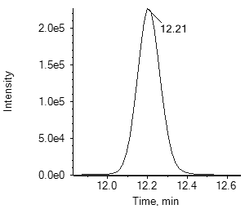315.三唑酮

triadimefon

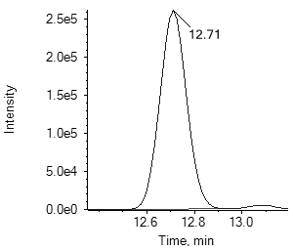316.三唑醇

triadimenol

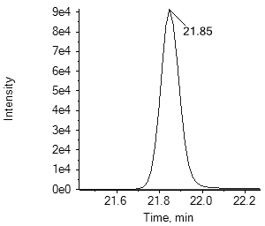317.野麦畏

triallate

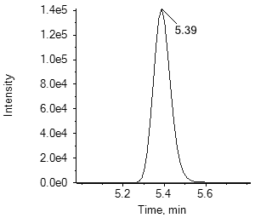318.醚苯磺隆

triasulfuron

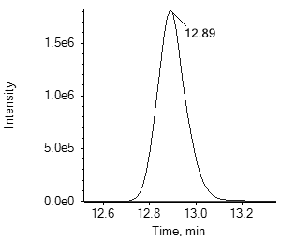319.三唑磷

triazophos

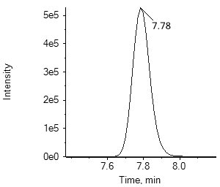320.苯磺隆

tribenuron-methyl

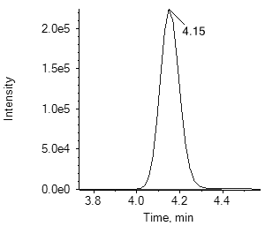321.敌百虫

trichlorfon

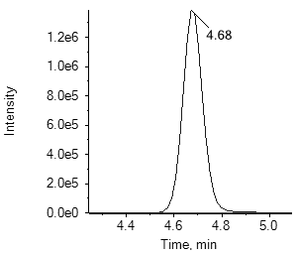322.三环唑

tricyclazole

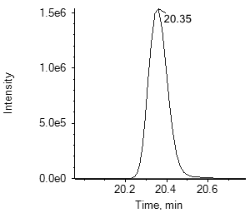323.肟菌酯

trifloxystrobin

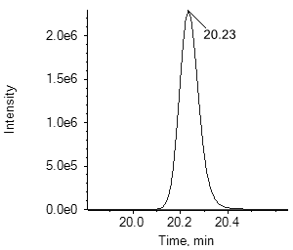324.氟菌唑

triflumizole

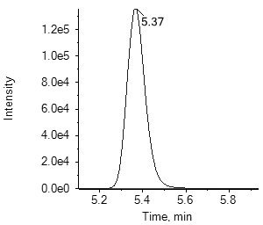324.氟菌唑代谢物FM-6-1 triflumizole metabolite FM-6-1

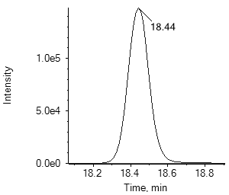325.杀铃脲

triflumuron

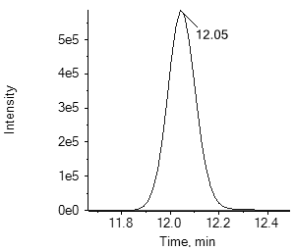326.氟胺磺隆triflusulfuron-methyl

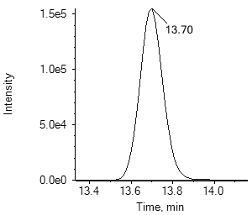327.灭菌唑

triticonazole

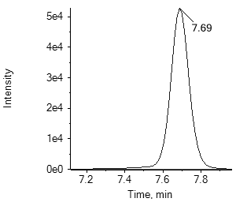328.三氟甲磺隆tritosulfuron

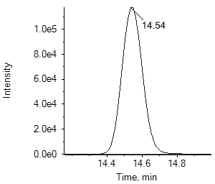329.烯效唑

uniconazole

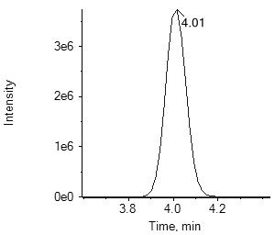330.蚜灭磷

vamidothion

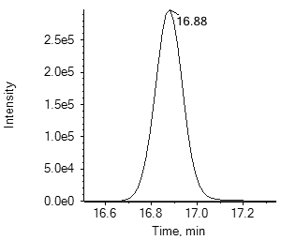331.苯酰菌胺

zoxamide

附 录 D

(资料性附录）

**精密度的表示和计算**

重复性限（*r*）要求见表D.1，再现性限（*R*）要求见表D.2。

**表D.1** 重复性限（*r*）

| 序号 | 农药中文名 | 农药英文名 | 重复性限r | | | | |
| --- | --- | --- | --- | --- | --- | --- | --- |
| a mg/kg | b mg/kg | c mg/kg | 0.1 mg/kg | 0.5 mg/kg |
| 1 | 乙酰甲胺磷 | acephate | 0.0023 | 0.0030 | 0.0081 | 0.0180 | 0.0958 |
| 2 | 啶虫脒 | acetamiprid | 0.0024 | 0.0048 | 0.0077 | 0.0446 | 0.1191 |
| 3 | 乙草胺 | acetochlor | 0.0020 | 0.0047 | 0.0139 | 0.0319 | 0.1164 |
| 4 | 甲草胺 | alachlor | 0.0021 | 0.0055 | 0.0093 | 0.0245 | 0.1438 |
| 5 | 丙硫多菌灵 | albendazole | 0.0011 | 0.0036 | 0.0050 | 0.0160 | 0.0972 |
| 6 | 涕灭威 | aldicarb | 0.0020 | 0.0025 | 0.0020 | 0.0232 | 0.0743 |
| 6 | 涕灭威砜 | aldicarb sulfone | 0.0018 | 0.0024 | 0.0148 | 0.0207 | 0.1306 |
| 6 | 涕灭威亚砜 | aldicarb sulfoxide | 0.0021 | 0.0015 | 0.0074 | 0.0247 | 0.1561 |
| 7 | 唑嘧菌胺 | ametoctradin | 0.0010 | 0.0015 | 0.0027 | 0.0161 | 0.0479 |
| 8 | 莠灭净 | ametryn | 0.0015 | 0.0037 | 0.0037 | 0.0193 | 0.1008 |
| 9 | 酰嘧磺隆 | amidosulfuron | 0.0016 | 0.0051 | 0.0044 | 0.0211 | 0.1065 |
| 10 | 吲唑磺菌胺 | amisulbrom | 0.0017 | 0.0048 | 0.0095 | 0.0219 | 0.0753 |
| 11 | 莎稗磷 | anilofos | 0.0015 | 0.0023 | 0.0062 | 0.0227 | 0.1257 |
| 12 | 莠去津 | atrazine | 0.0019 | 0.0052 | 0.0042 | 0.0292 | 0.0897 |
| 13 | 阿维菌素 | avermectin b1a | 0.0026 | 0.0034 | 0.0108 | 0.0279 | 0.1266 |
| 14 | 保棉磷 | azinphos-methyl | 0.0017 | 0.0029 | 0.0074 | 0.0186 | 0.0676 |
| 15 | 嘧菌酯 | azoxystrobin | 0.0016 | 0.0018 | 0.0062 | 0.0215 | 0.1175 |
| 16 | 苯霜灵 | benalaxyl | 0.0015 | 0.0016 | 0.0051 | 0.0205 | 0.1279 |
| 17 | 草除灵 | benazolin-ethyl | 0.0013 | 0.0005 | 0.0082 | 0.0163 | 0.0950 |
| 18 | 恶虫威 | bendiocarb | 0.0019 | 0.0021 | 0.0133 | 0.0323 | 0.1623 |
| 19 | 苄嘧磺隆 | bensulfuron-methyl | 0.0019 | 0.0019 | 0.0055 | 0.0211 | 0.1416 |
| 20 | 苯并烯氟菌唑 | benzovindiflupyr | 0.0031 | 0.0060 | 0.0210 | 0.0386 | 0.2006 |
| 21 | 苯螨特 | benzoximate | 0.0017 | 0.0025 | 0.0064 | 0.0181 | 0.1175 |
| 22 | 甲羧除草醚 | bifenox | 0.0017 | 0.0030 | 0.0096 | 0.0184 | 0.0596 |
| 23 | 联苯菊酯 | bifenthrin | 0.0027 | 0.0040 | 0.0042 | 0.0193 | 0.1228 |
| 24 | 生物苄呋菊酯 | bioresmethrin | 0.0018 | 0.0026 | 0.0052 | 0.0197 | 0.1485 |
| 25 | 联苯三唑醇 | bitertanol | 0.0016 | 0.0030 | 0.0089 | 0.0112 | 0.0653 |
| 26 | 啶酰菌胺 | boscalid | 0.0017 | 0.0029 | 0.0055 | 0.0174 | 0.1036 |
| 27 | 糠菌唑 | bromuconazole | 0.0018 | 0.0034 | 0.0095 | 0.0204 | 0.1164 |
| 28 | 乙嘧酚磺酸酯 | bupirimate | 0.0017 | 0.0019 | 0.0046 | 0.0253 | 0.1395 |
| 29 | 噻嗪酮 | buprofezin | 0.0018 | 0.0029 | 0.0048 | 0.0316 | 0.1692 |
| 30 | 丁草胺 | butachlor | 0.0015 | 0.0020 | 0.0136 | 0.0176 | 0.1619 |
| 31 | 仲丁灵 | butralin | 0.0013 | 0.0028 | 0.0039 | 0.0128 | 0.0701 |
| 32 | 硫线磷 | cadusafos | 0.0058 | 0.0018 | 0.0036 | 0.0156 | 0.0958 |
| 33 | 甲萘威 | carbaryl | 0.0013 | 0.0028 | 0.0070 | 0.0216 | 0.1275 |
| 34 | 多菌灵 | carbendazim | 0.0015 | 0.0030 | 0.0067 | 0.0163 | 0.1016 |
| 35 | 克百威 | carbofuran | 0.0018 | 0.0021 | 0.0046 | 0.0175 | 0.0694 |
| 35 | 3-羟基克百威 | 3-hydroxy carbofuran | 0.0022 | 0.0030 | 0.0078 | 0.0158 | 0.0901 |
| 36 | 萎锈灵 | carboxin | 0.0012 | 0.0025 | 0.0052 | 0.0136 | 0.0682 |
| 37 | 唑草酮 | carfentrazone-ethyl | 0.0014 | 0.0022 | 0.0055 | 0.0214 | 0.1048 |
| 38 | 氯虫苯甲酰胺 | chlorantraniliprole | 0.0015 | 0.0021 | 0.0059 | 0.0142 | 0.0713 |
| 39 | 灭幼脲 | chlorbenzuron | 0.0015 | 0.0037 | 0.0030 | 0.0243 | 0.1018 |
| 40 | 杀虫脒 | chlordimeform | 0.0018 | 0.0016 | 0.0124 | 0.0329 | 0.1015 |
| 41 | 毒虫畏 | chlorfenvinphos | 0.0016 | 0.0020 | 0.0047 | 0.0201 | 0.1049 |
| 42 | 氟啶脲 | chlorfluazuron | 0.0021 | 0.0030 | 0.0134 | 0.0204 | 0.1287 |
| 43 | 杀草敏 | chloridazon | 0.0027 | 0.0074 | 0.0164 | 0.0327 | 0.1753 |
| 44 | 氯嘧磺隆 | chlorimuron-ethyl | 0.0015 | 0.0024 | 0.0052 | 0.0171 | 0.1185 |
| 45 | 氯苯胺灵 | chlorpropham | 0.0018 | 0.0036 | 0.0105 | 0.0178 | 0.0824 |
| 46 | 毒死蜱 | chlorpyrifos | 0.0019 | 0.0011 | 0.0065 | 0.0225 | 0.1473 |
| 47 | 甲基毒死蜱 | chlorpyrifos-methyl | 0.0013 | 0.0027 | 0.0074 | 0.0215 | 0.1167 |
| 48 | 氯磺隆 | chlorsulfuron | 0.0013 | 0.0030 | 0.0074 | 0.0174 | 0.0872 |
| 49 | 绿麦隆 | chlortoluron | 0.0012 | 0.0026 | 0.0049 | 0.0109 | 0.0674 |
| 50 | 环虫酰肼 | chromafenozide | 0.0015 | 0.0050 | 0.0047 | 0.0200 | 0.1320 |
| 51 | 醚磺隆 | cinosulfuron | 0.0013 | 0.0027 | 0.0078 | 0.0201 | 0.1164 |
| 52 | 烯草酮 | clethodim | 0.0016 | 0.0018 | 0.0048 | 0.0117 | 0.0603 |
| 52 | 烯草酮砜 | clethodim sulfone | 0.0021 | 0.0037 | 0.0073 | 0.0140 | 0.0804 |
| 52 | 烯草酮亚砜 | clethodim sulfoxide | 0.0017 | 0.0038 | 0.0067 | 0.0130 | 0.0668 |
| 53 | 四螨嗪 | clofentezine | 0.0013 | 0.0042 | 0.0053 | 0.0318 | 0.1777 |
| 54 | 异噁草酮 | clomazone | 0.0009 | 0.0016 | 0.0052 | 0.0161 | 0.0748 |
| 55 | 噻虫胺 | clothianidin | 0.0019 | 0.0025 | 0.0020 | 0.0184 | 0.0898 |
| 56 | 蝇毒磷 | coumaphos | 0.0015 | 0.0032 | 0.0070 | 0.0219 | 0.1064 |
| 57 | 丁香菌酯 | coumoxystrobin | 0.0017 | 0.0026 | 0.0107 | 0.0242 | 0.1172 |
| 58 | 氰草津 | cyanazine | 0.0013 | 0.0031 | 0.0088 | 0.0103 | 0.0726 |
| 59 | 溴氰虫酰胺 | cyantraniliprole | 0.0015 | 0.0030 | 0.0045 | 0.0176 | 0.1144 |
| 60 | 氰霜唑 | cyazofamid | 0.0014 | 0.0036 | 0.0045 | 0.0246 | 0.1082 |
| 60 | 氰霜唑代谢物 | cyazofamid metabolite CCIM | 0.0027 | 0.0015 | 0.0113 | 0.0263 | 0.1303 |
| 61 | 环丙嘧磺隆 | cyclosulfamuron | 0.0017 | 0.0022 | 0.0041 | 0.0112 | 0.1029 |
| 62 | 噻草酮 | cycloxydim | 0.0019 | 0.0026 | 0.0054 | 0.0154 | 0.0816 |
| 63 | 环氟菌胺 | cyflufenamid | 0.0015 | 0.0012 | 0.0034 | 0.0160 | 0.1134 |
| 64 | 丁氟螨酯 | cyflumetofen | 0.0019 | 0.0032 | 0.0119 | 0.0206 | 0.0844 |
| 65 | 霜脲氰 | cymoxanil | 0.0021 | 0.0042 | 0.0070 | 0.0258 | 0.1588 |
| 66 | 环丙唑醇 | cyproconazole | 0.0017 | 0.0018 | 0.0085 | 0.0122 | 0.1173 |
| 67 | 嘧菌环胺 | cyprodinil | 0.0012 | 0.0022 | 0.0053 | 0.0146 | 0.0832 |
| 68 | 溴氰菊酯 | deltamethrin | 0.0014 | 0.0020 | 0.0064 | 0.0217 | 0.1062 |
| 69 | 内吸磷 | demeton | 0.0015 | 0.0038 | 0.0075 | 0.0206 | 0.0830 |
| 70 | 二嗪磷 | diazinon | 0.0012 | 0.0018 | 0.0037 | 0.0108 | 0.0700 |
| 71 | 敌敌畏 | dichlorvos | 0.0013 | 0.0032 | 0.0086 | 0.0112 | 0.0682 |
| 72 | 苄氯三唑醇 | diclobutrazol | 0.0023 | 0.0040 | 0.0055 | 0.0203 | 0.1400 |
| 73 | 禾草灵 | diclofop-methyl | 0.0023 | 0.0026 | 0.0084 | 0.0368 | 0.1524 |
| 74 | 百治磷 | dicrotophos | 0.0015 | 0.0039 | 0.0083 | 0.0249 | 0.1329 |
| 75 | 乙霉威 | diethofencarb | 0.0014 | 0.0030 | 0.0050 | 0.0166 | 0.1213 |
| 76 | 胺鲜酯 | diethyl aminoethyl hexanoate | 0.0015 | 0.0040 | 0.0055 | 0.0245 | 0.1216 |
| 77 | 苯醚甲环唑 | difenoconazole | 0.0035 | 0.0016 | 0.0068 | 0.0231 | 0.1572 |
| 78 | 除虫脲 | diflubenzuron | 0.0012 | 0.0010 | 0.0052 | 0.0097 | 0.0574 |
| 79 | 吡氟酰草胺 | diflufenican | 0.0013 | 0.0018 | 0.0087 | 0.0162 | 0.1250 |
| 80 | 哌草丹 | dimepiperate | 0.0020 | 0.0021 | 0.0053 | 0.0172 | 0.1268 |
| 81 | 精二甲吩草胺 | Dimethenamid-P | 0.0011 | 0.0010 | 0.0036 | 0.0114 | 0.0476 |
| 82 | 乐果 | dimethoate | 0.0018 | 0.0021 | 0.0076 | 0.0240 | 0.1193 |
| 83 | 烯酰吗啉 | dimethomorph | 0.0021 | 0.0024 | 0.0069 | 0.0248 | 0.1279 |
| 84 | 醚菌胺 | dimoxystrobin | 0.0021 | 0.0032 | 0.0045 | 0.0250 | 0.1107 |
| 85 | 烯唑醇 | diniconazole | 0.0017 | 0.0033 | 0.0028 | 0.0135 | 0.0603 |
| 86 | 敌螨普 | dinocap | 0.0027 | 0.0024 | 0.0092 | 0.0265 | 0.1459 |
| 87 | 呋虫胺 | dinotefuran | 0.0020 | 0.0032 | 0.0099 | 0.0162 | 0.0701 |
| 88 | 乙拌磷氧磷 | demeton-s-sulfone | 0.0029 | 0.0072 | 0.0149 | 0.0375 | 0.1592 |
| 88 | 砜吸磷-S-亚砜 | demeton-s-sulfoxide | 0.0020 | 0.0039 | 0.0071 | 0.0216 | 0.1746 |
| 88 | 乙拌磷 | disulfoton | 0.0024 | 0.0027 | 0.0078 | 0.0294 | 0.1576 |
| 88 | 乙拌磷砜 | disulfoton sulfone | 0.0019 | 0.0017 | 0.0057 | 0.0233 | 0.1091 |
| 88 | 乙拌磷亚砜 | disulfoton sulfoxide | 0.0014 | 0.0019 | 0.0054 | 0.0173 | 0.0780 |
| 89 | 敌草隆 | diuron | 0.0017 | 0.0025 | 0.0043 | 0.0203 | 0.1090 |
| 90 | 敌瘟磷 | edifenphos | 0.0012 | 0.0022 | 0.0046 | 0.0095 | 0.0506 |
| 91 | 甲氨基阿维菌素苯甲酸盐 | emamectin b1a | 0.0028 | 0.0040 | 0.0055 | 0.0171 | 0.1182 |
| 92 | 烯肟菌酯 | enestroburin | 0.0023 | 0.0018 | 0.0070 | 0.0237 | 0.0654 |
| 93 | 苯硫磷 | EPN | 0.0016 | 0.0032 | 0.0084 | 0.0287 | 0.1067 |
| 94 | 氟环唑 | epoxiconazole | 0.0017 | 0.0024 | 0.0159 | 0.0185 | 0.1398 |
| 95 | 乙硫磷 | ethion | 0.0025 | 0.0019 | 0.0059 | 0.0300 | 0.1481 |
| 96 | 乙虫腈 | ethiprole | 0.0014 | 0.0033 | 0.0094 | 0.0133 | 0.0750 |
| 97 | 乙嘧酚 | ethirimol | 0.0026 | 0.0060 | 0.0050 | 0.0240 | 0.0957 |
| 98 | 乙氧呋草黄 | ethofumesate | 0.0022 | 0.0053 | 0.0048 | 0.0295 | 0.0950 |
| 99 | 灭线磷 | ethoprophos | 0.0011 | 0.0031 | 0.0039 | 0.0116 | 0.0482 |
| 100 | 乙氧磺隆 | ethoxysulfuron | 0.0022 | 0.0023 | 0.0053 | 0.0388 | 0.0828 |
| 101 | 醚菊酯 | etofenprox | 0.0026 | 0.0011 | 0.0036 | 0.0209 | 0.1374 |
| 102 | 乙螨唑 | etoxazole | 0.0019 | 0.0016 | 0.0031 | 0.0093 | 0.0472 |
| 103 | 乙嘧硫磷 | etrimfos | 0.0017 | 0.0028 | 0.0041 | 0.0217 | 0.0879 |
| 104 | 噁唑菌酮 | famoxadone | 0.0014 | 0.0039 | 0.0068 | 0.0253 | 0.1444 |
| 105 | 咪唑菌酮 | fenamidone | 0.0012 | 0.0020 | 0.0064 | 0.0132 | 0.0593 |
| 106 | 烯肟菌胺 | fenaminstrobin | 0.0020 | 0.0026 | 0.0056 | 0.0247 | 0.0988 |
| 107 | 苯线磷 | fenamiphos | 0.0018 | 0.0026 | 0.0045 | 0.0149 | 0.1128 |
| 107 | 苯线磷砜 | fenamiphos sulfone | 0.0015 | 0.0028 | 0.0066 | 0.0168 | 0.0732 |
| 107 | 苯线磷亚砜 | fenamiphos sulfoxide | 0.0023 | 0.0043 | 0.0055 | 0.0234 | 0.1103 |
| 108 | 氯苯嘧啶醇 | fenarimol | 0.0018 | 0.0021 | 0.0052 | 0.0168 | 0.1341 |
| 109 | 喹螨醚 | fenazaquin | 0.0013 | 0.0018 | 0.0090 | 0.0115 | 0.0742 |
| 110 | 腈苯唑 | fenbuconazole | 0.0015 | 0.0037 | 0.0064 | 0.0192 | 0.0959 |
| 111 | 环酰菌胺 | fenhexamid | 0.0018 | 0.0033 | 0.0075 | 0.0172 | 0.1128 |
| 112 | 仲丁威 | fenobucarb | 0.0011 | 0.0025 | 0.0071 | 0.0149 | 0.0626 |
| 113 | 苯硫威 | fenothiocarb | 0.0016 | 0.0025 | 0.0075 | 0.0219 | 0.1259 |
| 114 | 稻瘟酰胺 | fenoxanil | 0.0018 | 0.0028 | 0.0063 | 0.0214 | 0.1074 |
| 115 | 精噁唑禾草灵 | fenoxaprop-P-ethyl | 0.0017 | 0.0018 | 0.0046 | 0.0114 | 0.0656 |
| 116 | 苯氧威 | fenoxycarb | 0.0014 | 0.0015 | 0.0050 | 0.0204 | 0.1009 |
| 117 | 甲氰菊酯 | fenpropathrin | 0.0020 | 0.0043 | 0.0018 | 0.0206 | 0.0838 |
| 118 | 苯锈啶 | fenpropidin | 0.0012 | 0.0025 | 0.0028 | 0.0090 | 0.0588 |
| 119 | 丁苯吗啉 | fenpropimorph | 0.0013 | 0.0020 | 0.0109 | 0.0759 | 0.5171 |
| 120 | 胺苯吡菌酮 | fenpyrazamine | 0.0018 | 0.0040 | 0.0038 | 0.0220 | 0.1165 |
| 121 | 唑螨酯 | fenpyroximate | 0.0015 | 0.0026 | 0.0040 | 0.0123 | 0.0680 |
| 122 | 丰索磷 | fensulfothion | 0.0023 | 0.0025 | 0.0077 | 0.0230 | 0.1207 |
| 122 | 氧丰索磷 | fensulfothion oxon | 0.0015 | 0.0032 | 0.0086 | 0.0293 | 0.1257 |
| 122 | 氧丰索磷砜 | fensulfothion oxon sulfone | 0.0017 | 0.0032 | 0.0064 | 0.0334 | 0.1430 |
| 122 | 丰索磷砜 | fensulfothion sulfone | 0.0017 | 0.0064 | 0.0067 | 0.0240 | 0.1096 |
| 123 | 倍硫磷 | fenthion | 0.0018 | 0.0013 | 0.0061 | 0.0153 | 0.0640 |
| 123 | 倍硫磷砜 | fenthion sulfone | 0.0012 | 0.0013 | 0.0067 | 0.0127 | 0.0567 |
| 123 | 倍硫磷亚砜 | fenthion sulfoxide | 0.0013 | 0.0018 | 0.0046 | 0.0154 | 0.0656 |
| 124 | 氰戊菊酯 | fenvalerate | 0.0028 | 0.0042 | 0.0125 | 0.0217 | 0.1506 |
| 125 | 氟虫腈 | fipronil | 0.0008 | 0.0015 | 0.0055 | 0.0151 | 0.1110 |
| 125 | 氟甲腈 | fipronil desulfinyl | 0.0007 | 0.0026 | 0.0057 | 0.0215 | 0.0832 |
| 125 | 氟虫腈硫化物 | fipronil sulfide | 0.0009 | 0.0034 | 0.0039 | 0.0116 | 0.0772 |
| 125 | 氟虫腈砜 | fipronil sulfone | 0.0007 | 0.0020 | 0.0042 | 0.0128 | 0.1050 |
| 126 | 氟啶虫酰胺 | flonicamid | 0.0030 | 0.0041 | 0.0118 | 0.0390 | 0.1223 |
| 127 | 双氟磺草胺 | florasulam | 0.0026 | 0.0034 | 0.0076 | 0.0219 | 0.1154 |
| 128 | 吡氟禾草灵 | fluazifop | 0.0024 | 0.0037 | 0.0047 | 0.0118 | 0.0523 |
| 129 | 氟啶胺 | fluazinam | 0.0024 | 0.0047 | 0.0123 | 0.0262 | 0.1437 |
| 130 | 氟苯虫酰胺 | flubendiamide | 0.0021 | 0.0089 | 0.0117 | 0.0400 | 0.1216 |
| 131 | 氟吡磺隆 | flucetosulfuron | 0.0017 | 0.0038 | 0.0053 | 0.0222 | 0.1048 |
| 132 | 氟氰戊菊酯 | flucythrinate | 0.0025 | 0.0064 | 0.0132 | 0.0299 | 0.0913 |
| 133 | 咯菌腈 | fludioxonil | 0.0016 | 0.0021 | 0.0066 | 0.0169 | 0.0845 |
| 134 | 氟噻草胺 | flufenacet | 0.0012 | 0.0021 | 0.0048 | 0.0127 | 0.0459 |
| 135 | 氟虫脲 | flufenoxuron | 0.0026 | 0.0029 | 0.0065 | 0.0209 | 0.1386 |
| 136 | 氟节胺 | flumetralin | 0.0020 | 0.0016 | 0.0090 | 0.0291 | 0.1348 |
| 137 | 唑嘧磺草胺 | flumetsulam | 0.0015 | 0.0027 | 0.0048 | 0.0105 | 0.0926 |
| 138 | 氟吗啉 | flumorph | 0.0026 | 0.0029 | 0.0044 | 0.0201 | 0.0951 |
| 139 | 氟吡菌胺 | fluopicolide | 0.0016 | 0.0016 | 0.0084 | 0.0221 | 0.1084 |
| 140 | 氟吡菌酰胺 | fluopyram | 0.0013 | 0.0013 | 0.0052 | 0.0118 | 0.0530 |
| 141 | 乙羧氟草醚 | fluoroglycofen-ethyl | 0.0033 | 0.0019 | 0.0054 | 0.0266 | 0.1103 |
| 142 | 呋草酮 | flurtamone | 0.0015 | 0.0020 | 0.0035 | 0.0215 | 0.1012 |
| 143 | 氟硅唑 | flusilazole | 0.0015 | 0.0023 | 0.0045 | 0.0085 | 0.0573 |
| 144 | 嗪草酸甲酯 | fluthiacet-methyl | 0.0020 | 0.0032 | 0.0046 | 0.0206 | 0.1295 |
| 145 | 氟酰胺 | flutolanil | 0.0015 | 0.0024 | 0.0061 | 0.0229 | 0.0921 |
| 146 | 粉唑醇 | flutriafol | 0.0012 | 0.0021 | 0.0060 | 0.0124 | 0.0639 |
| 147 | 氟唑菌酰胺 | fluxapyroxad | 0.0016 | 0.0021 | 0.0048 | 0.0208 | 0.0885 |
| 148 | 地虫硫磷 | fonofos | 0.0017 | 0.0018 | 0.0079 | 0.0195 | 0.0957 |
| 149 | 氯吡脲 | forchlorfenuron | 0.0011 | 0.0022 | 0.0043 | 0.0146 | 0.0582 |
| 150 | 安硫磷 | formothion | 0.0019 | 0.0039 | 0.0093 | 0.0232 | 0.1228 |
| 151 | 噻唑磷 | fosthiazate | 0.0018 | 0.0026 | 0.0032 | 0.0201 | 0.0893 |
| 152 | 呋线威 | furathiocarb | 0.0018 | 0.0039 | 0.0069 | 0.0240 | 0.1258 |
| 153 | 氯吡嘧磺隆 | halosulfuron-methyl | 0.0016 | 0.0016 | 0.0071 | 0.0189 | 0.0877 |
| 154 | 庚烯磷 | heptenophos | 0.0015 | 0.0048 | 0.0055 | 0.0253 | 0.1033 |
| 155 | 己唑醇 | hexaconazole | 0.0013 | 0.0024 | 0.0045 | 0.0112 | 0.0619 |
| 156 | 氟铃脲 | hexaflumuron | 0.0033 | 0.0049 | 0.0136 | 0.0291 | 0.1741 |
| 157 | 环嗪酮 | hexazinone | 0.0021 | 0.0053 | 0.0055 | 0.0281 | 0.1154 |
| 158 | 噻螨酮 | hexythiazox | 0.0016 | 0.0033 | 0.0089 | 0.0198 | 0.1086 |
| 159 | 抑霉唑 | imazalil | 0.0016 | 0.0031 | 0.0112 | 0.0238 | 0.1017 |
| 160 | 亚胺唑 | imibenconazole | 0.0025 | 0.0046 | 0.0074 | 0.0285 | 0.1262 |
| 161 | 吡虫啉 | imidacloprid | 0.0018 | 0.0032 | 0.0096 | 0.0183 | 0.0763 |
| 162 | 氯噻啉 | imidaclothiz | 0.0022 | 0.0070 | 0.0087 | 0.0272 | 0.2276 |
| 163 | 茚虫威 | indoxacarb | 0.0017 | 0.0057 | 0.0062 | 0.0201 | 0.1179 |
| 164 | 甲基碘磺隆钠盐 | iodosulfuron-methyl-sodium | 0.0014 | 0.0034 | 0.0078 | 0.0119 | 0.0914 |
| 165 | 种菌唑 | ipconazole | 0.0018 | 0.0018 | 0.0097 | 0.0183 | 0.1205 |
| 166 | 异稻瘟净 | iprobenfos | 0.0017 | 0.0025 | 0.0044 | 0.0184 | 0.1065 |
| 167 | 异菌脲 | iprodione | 0.0019 | 0.0056 | 0.0058 | 0.0193 | 0.0911 |
| 168 | 缬霉威 | iprovalicarb | 0.0014 | 0.0027 | 0.0068 | 0.0247 | 0.1331 |
| 169 | 氯唑磷 | isazofos | 0.0016 | 0.0021 | 0.0017 | 0.0114 | 0.0466 |
| 170 | 水胺硫磷 | isocarbophos | 0.0022 | 0.0033 | 0.0056 | 0.0239 | 0.1087 |
| 171 | 甲基异柳磷 | isofenphos-methyl | 0.0027 | 0.0048 | 0.0145 | 0.0304 | 0.1722 |
| 172 | 异丙威 | isoprocarb | 0.0015 | 0.0022 | 0.0077 | 0.0108 | 0.0563 |
| 173 | 稻瘟灵 | isoprothiolane | 0.0015 | 0.0025 | 0.0056 | 0.0172 | 0.1045 |
| 174 | 异丙隆 | isoproturon | 0.0018 | 0.0017 | 0.0048 | 0.0198 | 0.1158 |
| 175 | 吡唑萘菌胺 | isopyrazam | 0.0016 | 0.0019 | 0.0080 | 0.0131 | 0.0595 |
| 176 | 异噁唑草酮 | isoxaflutole | 0.0020 | 0.0025 | 0.0118 | 0.0185 | 0.1181 |
| 176 | 异噁唑草酮-二酮腈 | isoxaflutole-diketonitrile | 0.0013 | 0.0031 | 0.0082 | 0.0282 | 0.1117 |
| 177 | 依维菌素 | ivermectin b1a | 0.0025 | 0.0030 | 0.0107 | 0.0431 | 0.1314 |
| 178 | 醚菌酯 | kresoxim-methyl | 0.0014 | 0.0032 | 0.0048 | 0.0118 | 0.0540 |
| 179 | 乳氟禾草灵 | lactofen | 0.0026 | 0.0073 | 0.0058 | 0.0294 | 0.1454 |
| 180 | 利谷隆 | linuron | 0.0018 | 0.0025 | 0.0062 | 0.0176 | 0.1294 |
| 181 | 虱螨脲 | lufenuron | 0.0022 | 0.0051 | 0.0119 | 0.0211 | 0.0964 |
| 182 | 马拉氧磷 | malaoxon | 0.0022 | 0.0035 | 0.0127 | 0.0256 | 0.1530 |
| 182 | 马拉硫磷 | malathion | 0.0010 | 0.0023 | 0.0018 | 0.0138 | 0.0602 |
| 183 | 双炔酰菌胺 | mandipropamid | 0.0012 | 0.0026 | 0.0045 | 0.0165 | 0.0688 |
| 184 | 苯噻酰草胺 | mefenacet | 0.0011 | 0.0033 | 0.0048 | 0.0164 | 0.1094 |
| 185 | 灭锈胺 | mepronil | 0.0015 | 0.0012 | 0.0059 | 0.0174 | 0.0918 |
| 186 | 甲基二磺隆 | mesosulfuron-methyl | 0.0024 | 0.0028 | 0.0085 | 0.0287 | 0.1287 |
| 187 | 氰氟虫腙 | metaflumizone | 0.0017 | 0.0040 | 0.0086 | 0.0153 | 0.0704 |
| 188 | 甲霜灵 | metalaxyl | 0.0022 | 0.0038 | 0.0031 | 0.0245 | 0.1392 |
| 189 | 噁唑酰草胺 | metamifop | 0.0025 | 0.0028 | 0.0064 | 0.0331 | 0.1270 |
| 190 | 苯嗪草酮 | metamitron | 0.0021 | 0.0036 | 0.0096 | 0.0258 | 0.0633 |
| 191 | 吡唑草胺 | metazachlor | 0.0010 | 0.0023 | 0.0036 | 0.0111 | 0.1046 |
| 192 | 嗪吡嘧磺隆 | metazosulfuron | 0.0020 | 0.0038 | 0.0066 | 0.0256 | 0.0754 |
| 193 | 叶菌唑 | metconazole | 0.0024 | 0.0031 | 0.0143 | 0.0336 | 0.1677 |
| 194 | 虫螨畏 | methacrifos | 0.0016 | 0.0029 | 0.0073 | 0.0209 | 0.0933 |
| 195 | 甲胺磷 | methamidophos | 0.0016 | 0.0013 | 0.0045 | 0.0144 | 0.0689 |
| 196 | 杀扑磷 | methidathion | 0.0015 | 0.0021 | 0.0080 | 0.0131 | 0.0498 |
| 197 | 甲硫威 | methiocarb | 0.0011 | 0.0023 | 0.0044 | 0.0126 | 0.0630 |
| 197 | 甲硫威砜 | methiocarb sulfone | 0.0021 | 0.0040 | 0.0080 | 0.0166 | 0.0920 |
| 197 | 甲硫威亚砜 | methiocarb sulfoxide | 0.0014 | 0.0021 | 0.0083 | 0.0176 | 0.0591 |
| 198 | 灭多威 | methomyl | 0.0025 | 0.0040 | 0.0089 | 0.0207 | 0.1414 |
| 199 | 烯虫酯 | methoprene | 0.0026 | 0.0032 | 0.0178 | 0.0235 | 0.1601 |
| 200 | 甲氧虫酰肼 | methoxyfenozide | 0.0019 | 0.0038 | 0.0065 | 0.0133 | 0.0934 |
| 201 | 异丙甲草胺 | metolachlor | 0.0015 | 0.0019 | 0.0038 | 0.0164 | 0.0926 |
| 202 | 速灭威 | metolcarb | 0.0020 | 0.0026 | 0.0076 | 0.0239 | 0.1072 |
| 203 | 苯菌酮 | metrafenone | 0.0013 | 0.0035 | 0.0062 | 0.0119 | 0.0632 |
| 204 | 嗪草酮 | metribuzin | 0.0020 | 0.0035 | 0.0067 | 0.0255 | 0.1226 |
| 205 | 甲磺隆 | metsulfuron-methyl | 0.0020 | 0.0036 | 0.0066 | 0.0210 | 0.1027 |
| 206 | 速灭磷 | mevinphos | 0.0023 | 0.0037 | 0.0077 | 0.0368 | 0.1479 |
| 207 | 禾草敌 | molinate | 0.0014 | 0.0031 | 0.0076 | 0.0182 | 0.0640 |
| 208 | 久效磷 | monocrotophos | 0.0030 | 0.0031 | 0.0173 | 0.0451 | 0.1852 |
| 209 | 腈菌唑 | myclobutanil | 0.0020 | 0.0021 | 0.0068 | 0.0142 | 0.0880 |
| 210 | 敌草胺 | napropamide | 0.0016 | 0.0028 | 0.0037 | 0.0176 | 0.1095 |
| 211 | 烯啶虫胺 | nitenpyram | 0.0029 | 0.0047 | 0.0071 | 0.0324 | 0.1473 |
| 212 | 氟酰脲 | novaluron | 0.0026 | 0.0042 | 0.0082 | 0.0222 | 0.0858 |
| 213 | 氧乐果 | omethoate | 0.0023 | 0.0028 | 0.0045 | 0.0393 | 0.1228 |
| 214 | 嘧苯胺磺隆 | orthosulfamuron | 0.0015 | 0.0024 | 0.0057 | 0.0383 | 0.1167 |
| 215 | 丙炔噁草酮 | oxadiargyl | 0.0017 | 0.0036 | 0.0077 | 0.0135 | 0.0590 |
| 216 | 噁草酮 | oxadiazon | 0.0025 | 0.0046 | 0.0053 | 0.0223 | 0.1446 |
| 217 | 噁霜灵 | oxadixyl | 0.0021 | 0.0017 | 0.0085 | 0.0361 | 0.1434 |
| 218 | 杀线威 | oxamyl | 0.0018 | 0.0034 | 0.0087 | 0.0158 | 0.1181 |
| 218 | 杀线威肟 | oxamyl oxime | 0.0021 | 0.0029 | 0.0043 | 0.0261 | 0.1148 |
| 219 | 噁嗪草酮 | oxaziclomefone | 0.0015 | 0.0038 | 0.0064 | 0.0278 | 0.1274 |
| 220 | 甲基内吸磷 | demeton-s-methyl | 0.0029 | 0.0058 | 0.0170 | 0.0335 | 0.1276 |
| 220 | 甲基砜内吸磷 | demeton-s-methyl-sulfone | 0.0017 | 0.0034 | 0.0087 | 0.0274 | 0.1624 |
| 220 | 亚砜磷 | oxydemeton-methyl | 0.0018 | 0.0028 | 0.0097 | 0.0155 | 0.0645 |
| 221 | 乙氧氟草醚 | oxyfluorfen | 0.0026 | 0.0069 | 0.0133 | 0.0366 | 0.1708 |
| 222 | 多效唑 | paclobutrazol | 0.0018 | 0.0041 | 0.0062 | 0.0167 | 0.1048 |
| 223 | 对硫磷 | parathion | 0.0017 | 0.0046 | 0.0127 | 0.0267 | 0.0925 |
| 224 | 戊菌唑 | penconazole | 0.0029 | 0.0019 | 0.0039 | 0.0205 | 0.1247 |
| 225 | 戊菌隆 | pencycuron | 0.0018 | 0.0027 | 0.0054 | 0.0190 | 0.1301 |
| 226 | 二甲戊灵 | pendimethalin | 0.0017 | 0.0034 | 0.0092 | 0.0180 | 0.0915 |
| 227 | 氟唑菌苯胺 | penflufen | 0.0020 | 0.0047 | 0.0058 | 0.0301 | 0.1437 |
| 228 | 五氟磺草胺 | penoxsulam | 0.0014 | 0.0029 | 0.0045 | 0.0162 | 0.0722 |
| 229 | 吡噻菌胺 | penthiopyrad | 0.0016 | 0.0024 | 0.0054 | 0.0163 | 0.0924 |
| 230 | 氯菊酯 | permethrin | 0.0015 | 0.0030 | 0.0073 | 0.0284 | 0.1329 |
| 231 | 氰烯菌酯 | phenamacril | 0.0026 | 0.0058 | 0.0052 | 0.0248 | 0.1586 |
| 232 | 甜菜宁 | phenmedipham | 0.0014 | 0.0027 | 0.0086 | 0.0138 | 0.0763 |
| 233 | 稻丰散 | phenthoate | 0.0020 | 0.0024 | 0.0030 | 0.0186 | 0.1388 |
| 234 | 甲拌磷 | phorate | 0.0013 | 0.0032 | 0.0021 | 0.0128 | 0.0453 |
| 234 | 甲拌磷砜 | phorate sulfone | 0.0014 | 0.0030 | 0.0014 | 0.0140 | 0.0679 |
| 234 | 甲拌磷亚砜 | phorate sulfoxide | 0.0014 | 0.0024 | 0.0015 | 0.0126 | 0.0701 |
| 235 | 伏杀硫磷 | phosalone | 0.0012 | 0.0022 | 0.0085 | 0.0209 | 0.1275 |
| 236 | 硫环磷 | phosfolan | 0.0012 | 0.0028 | 0.0017 | 0.0103 | 0.0621 |
| 237 | 甲基硫环磷 | phosfolan-methyl | 0.0012 | 0.0024 | 0.0048 | 0.0331 | 0.1459 |
| 238 | 亚胺硫磷 | phosmet | 0.0013 | 0.0029 | 0.0065 | 0.0126 | 0.0869 |
| 238 | 氧亚胺硫磷 | phosmet oxon | 0.0019 | 0.0040 | 0.0091 | 0.0381 | 0.1226 |
| 239 | 磷胺 | phosphamidon | 0.0016 | 0.0035 | 0.0049 | 0.0177 | 0.1141 |
| 240 | 辛硫磷 | phoxim | 0.0012 | 0.0023 | 0.0039 | 0.0095 | 0.0499 |
| 241 | 氟吡酰草胺 | picolinafen | 0.0023 | 0.0037 | 0.0063 | 0.0266 | 0.1114 |
| 242 | 啶氧菌酯 | picoxystrobin | 0.0018 | 0.0031 | 0.0052 | 0.0212 | 0.0976 |
| 243 | 增效醚 | piperonyl butoxide | 0.0013 | 0.0016 | 0.0077 | 0.0142 | 0.1042 |
| 244 | 抗蚜威 | pirimicarb | 0.0015 | 0.0018 | 0.0029 | 0.0170 | 0.0920 |
| 244 | 脱甲基抗蚜威 | pirimicarb-desmethyl | 0.0024 | 0.0032 | 0.0075 | 0.0238 | 0.1105 |
| 244 | 脱甲基甲酰胺基抗蚜威 | pirimicarb-desmethyl-formamido | 0.0014 | 0.0008 | 0.0047 | 0.0211 | 0.0861 |
| 245 | 甲基嘧啶磷 | pirimiphos-methyl | 0.0014 | 0.0018 | 0.0028 | 0.0203 | 0.1034 |
| 246 | 丙草胺 | pretilachlor | 0.0019 | 0.0014 | 0.0057 | 0.0146 | 0.1231 |
| 247 | 烯丙苯噻唑 | probenazole | 0.0022 | 0.0044 | 0.0123 | 0.0259 | 0.1159 |
| 248 | 咪鲜胺 | prochloraz | 0.0020 | 0.0015 | 0.0044 | 0.0271 | 0.0741 |
| 248 | 咪鲜胺-脱氨基咪唑 | prochloraz metabolite BTS44595 | 0.0009 | 0.0008 | 0.0032 | 0.0132 | 0.0991 |
| 248 | 咪鲜胺-脱咪唑甲酰胺基 | prochloraz metabolite BTS44596 | 0.0015 | 0.0009 | 0.0090 | 0.0144 | 0.1374 |
| 249 | 腐霉利 | procymidone | 0.0225 | 0.0328 | 0.0535 | 0.1568 | 0.9338 |
| 250 | 丙溴磷 | profenofos | 0.0022 | 0.0022 | 0.0067 | 0.0124 | 0.0612 |
| 251 | 猛杀威 | promecarb | 0.0012 | 0.0024 | 0.0076 | 0.0158 | 0.1025 |
| 252 | 扑草净 | prometryn | 0.0013 | 0.0029 | 0.0053 | 0.0188 | 0.1244 |
| 253 | 毒草胺 | propachlor | 0.0017 | 0.0032 | 0.0053 | 0.0213 | 0.0994 |
| 254 | 霜霉威 | propamocarb | 0.0027 | 0.0045 | 0.0057 | 0.0325 | 0.1035 |
| 255 | 敌稗 | propanil | 0.0025 | 0.0021 | 0.0071 | 0.0152 | 0.0590 |
| 256 | 喔草酯 | propaquizafop | 0.0023 | 0.0039 | 0.0091 | 0.0275 | 0.1247 |
| 257 | 炔螨特 | propargite | 0.0016 | 0.0035 | 0.0055 | 0.0203 | 0.0930 |
| 258 | 丙环唑 | propiconazole | 0.0015 | 0.0025 | 0.0056 | 0.0184 | 0.1074 |
| 259 | 异丙草胺 | propisochlor | 0.0021 | 0.0060 | 0.0111 | 0.0343 | 0.1947 |
| 260 | 残杀威 | propoxur | 0.0021 | 0.0041 | 0.0079 | 0.0309 | 0.1353 |
| 261 | 丙嗪嘧磺隆 | propyrisulfuron | 0.0017 | 0.0026 | 0.0082 | 0.0192 | 0.0948 |
| 262 | 炔苯酰草胺 | propyzamide | 0.0012 | 0.0022 | 0.0029 | 0.0189 | 0.1109 |
| 263 | 丙氧喹啉 | proquinazid | 0.0022 | 0.0026 | 0.0064 | 0.0201 | 0.1093 |
| 264 | 苄草丹 | prosulfocarb | 0.0017 | 0.0027 | 0.0070 | 0.0195 | 0.1144 |
| 265 | 吡唑醚菌酯 | pyraclostrobin | 0.0015 | 0.0026 | 0.0046 | 0.0151 | 0.0499 |
| 266 | 吡草醚 | pyraflufen-ethyl | 0.0014 | 0.0022 | 0.0063 | 0.0139 | 0.0494 |
| 267 | 唑胺菌酯 | pyrametostrobin | 0.0014 | 0.0035 | 0.0043 | 0.0199 | 0.0882 |
| 268 | 唑菌酯 | pyraoxystrobin | 0.0014 | 0.0032 | 0.0044 | 0.0201 | 0.1199 |
| 269 | 吡嘧磺隆 | pyrazosulfuron-ethyl | 0.0014 | 0.0016 | 0.0050 | 0.0272 | 0.0935 |
| 270 | 除虫菊素 I | pyrethrins I | 0.0025 | 0.0026 | 0.0063 | 0.0230 | 0.1392 |
| 270 | 除虫菊素 II | pyrethrins II | 0.0014 | 0.0013 | 0.0147 | 0.0243 | 0.0931 |
| 271 | 嘧啶肟草醚 | pyribenzoxim | 0.0020 | 0.0029 | 0.0121 | 0.0347 | 0.1762 |
| 272 | 哒螨灵 | pyridaben | 0.0013 | 0.0016 | 0.0065 | 0.0143 | 0.0796 |
| 273 | 三氟甲吡醚 | pyridalyl | 0.0020 | 0.0038 | 0.0053 | 0.0286 | 0.1043 |
| 274 | 哒嗪硫磷 | pyridaphenthion | 0.0017 | 0.0037 | 0.0056 | 0.0226 | 0.1040 |
| 275 | 环酯草醚 | pyriftalid | 0.0012 | 0.0038 | 0.0064 | 0.0184 | 0.1055 |
| 276 | 嘧霉胺 | pyrimethanil | 0.0020 | 0.0024 | 0.0067 | 0.0255 | 0.1251 |
| 277 | 丁吡吗啉 | pyrimorph | 0.0011 | 0.0016 | 0.0048 | 0.0171 | 0.1073 |
| 278 | 吡丙醚 | pyriproxyfen | 0.0021 | 0.0010 | 0.0034 | 0.0132 | 0.0644 |
| 279 | 啶菌噁唑 | pyrisoxazole | 0.0019 | 0.0025 | 0.0057 | 0.0217 | 0.1075 |
| 280 | 喹硫磷 | quinalphos | 0.0013 | 0.0018 | 0.0054 | 0.0164 | 0.1358 |
| 281 | 喹禾灵 | quizalofop-ethyl | 0.0017 | 0.0017 | 0.0091 | 0.0130 | 0.0732 |
| 282 | 鱼藤酮 | rotenone | 0.0020 | 0.0020 | 0.0061 | 0.0205 | 0.1054 |
| 283 | 苯嘧磺草胺 | saflufenacil | 0.0016 | 0.0019 | 0.0026 | 0.0216 | 0.0866 |
| 284 | 氟唑环菌胺 | sedaxane | 0.0013 | 0.0015 | 0.0079 | 0.0176 | 0.0890 |
| 285 | 烯禾啶 | sethoxydim | 0.0027 | 0.0025 | 0.0064 | 0.0306 | 0.1687 |
| 286 | 硅噻菌胺 | silthiofam | 0.0011 | 0.0010 | 0.0040 | 0.0089 | 0.0426 |
| 287 | 西玛津 | simazine | 0.0022 | 0.0019 | 0.0098 | 0.0187 | 0.0905 |
| 288 | 西草净 | simetryn | 0.0017 | 0.0023 | 0.0043 | 0.0162 | 0.0770 |
| 289 | 乙基多杀菌素 J | spinetoram J | 0.0015 | 0.0028 | 0.0030 | 0.0113 | 0.0926 |
| 289 | 乙基多杀菌素 L | spinetoram L | 0.0024 | 0.0022 | 0.0066 | 0.0124 | 0.1064 |
| 290 | 多杀霉素 A | spinosad A | 0.0019 | 0.0044 | 0.0100 | 0.0174 | 0.1027 |
| 290 | 多杀霉素 D | spinosad D | 0.0029 | 0.0030 | 0.0038 | 0.0228 | 0.1088 |
| 291 | 螺螨酯 | spirodiclofen | 0.0025 | 0.0038 | 0.0019 | 0.0184 | 0.0607 |
| 292 | 螺甲螨酯 | spiromesifen | 0.0032 | 0.0021 | 0.0081 | 0.0428 | 0.1143 |
| 293 | 螺虫乙酯 | spirotetramat | 0.0012 | 0.0027 | 0.0047 | 0.0105 | 0.0830 |
| 293 | 螺虫乙酯-烯醇 | spirotetramat-enol | 0.0013 | 0.0026 | 0.0067 | 0.0147 | 0.0654 |
| 293 | 螺虫乙酯-烯醇-葡萄糖苷 | spirotetramat-enol-glucoside | 0.0022 | 0.0034 | 0.0099 | 0.0175 | 0.0771 |
| 293 | 螺虫乙酯-酮基-羟基 | spirotetramat-keto-hydroxy | 0.0014 | 0.0037 | 0.0104 | 0.0206 | 0.0725 |
| 293 | 螺虫乙酯-单-羟基 | spirotetramat-mono-hydroxy | 0.0017 | 0.0039 | 0.0097 | 0.0142 | 0.0625 |
| 294 | 甲磺草胺 | sulfentrazone | 0.0027 | 0.0035 | 0.0135 | 0.0229 | 0.1513 |
| 295 | 治螟磷 | sulfotep | 0.0020 | 0.0020 | 0.0043 | 0.0185 | 0.1339 |
| 296 | 氟啶虫胺腈 | sulfoxaflor | 0.0024 | 0.0046 | 0.0123 | 0.0165 | 0.0982 |
| 297 | 氟胺氰菊酯 | tau-fluvalinate | 0.0030 | 0.0045 | 0.0096 | 0.0265 | 0.0857 |
| 298 | 戊唑醇 | tebuconazole | 0.0021 | 0.0029 | 0.0058 | 0.0268 | 0.1336 |
| 299 | 虫酰肼 | tebufenozide | 0.0016 | 0.0022 | 0.0067 | 0.0194 | 0.0645 |
| 300 | 丁噻隆 | tebuthiuron | 0.0015 | 0.0021 | 0.0053 | 0.0290 | 0.0998 |
| 301 | 氟苯脲 | teflubenzuron | 0.0027 | 0.0038 | 0.0213 | 0.0357 | 0.1160 |
| 302 | 特丁硫磷 | terbufos | 0.0022 | 0.0027 | 0.0023 | 0.0179 | 0.0640 |
| 302 | 特丁硫磷砜 | terbufos sulfone | 0.0015 | 0.0013 | 0.0024 | 0.0250 | 0.0484 |
| 302 | 特丁硫磷亚砜 | terbufos sulfoxide | 0.0012 | 0.0012 | 0.0017 | 0.0138 | 0.0519 |
| 303 | 特丁津 | terbuthylazine | 0.0015 | 0.0020 | 0.0031 | 0.0263 | 0.0878 |
| 304 | 四氟醚唑 | tetraconazole | 0.0016 | 0.0030 | 0.0054 | 0.0209 | 0.1092 |
| 305 | 噻菌灵 | thiabendazole | 0.0018 | 0.0021 | 0.0051 | 0.0260 | 0.1133 |
| 306 | 噻虫啉 | thiacloprid | 0.0012 | 0.0021 | 0.0082 | 0.0149 | 0.0847 |
| 307 | 噻虫嗪 | thiamethoxam | 0.0023 | 0.0021 | 0.0015 | 0.0280 | 0.1649 |
| 308 | 噻苯隆 | thidiazuron | 0.0021 | 0.0046 | 0.0110 | 0.0196 | 0.1356 |
| 309 | 噻吩磺隆 | thifensulfuron-methyl | 0.0013 | 0.0034 | 0.0054 | 0.0218 | 0.0915 |
| 310 | 噻氟菌胺 | thifluzamide | 0.0018 | 0.0035 | 0.0067 | 0.0239 | 0.1624 |
| 311 | 甲基硫菌灵 | thiophanate-methyl | 0.0017 | 0.0031 | 0.0046 | 0.0147 | 0.0813 |
| 312 | 甲基立枯磷 | tolclofos-methyl | 0.0026 | 0.0032 | 0.0109 | 0.0193 | 0.0871 |
| 313 | 唑虫酰胺 | tolfenpyrad | 0.0014 | 0.0025 | 0.0067 | 0.0222 | 0.1007 |
| 314 | 三甲苯草酮 | tralkoxydim | 0.0025 | 0.0023 | 0.0040 | 0.0120 | 0.0845 |
| 315 | 三唑酮 | triadimefon | 0.0017 | 0.0024 | 0.0028 | 0.0179 | 0.1159 |
| 316 | 三唑醇 | triadimenol | 0.0016 | 0.0030 | 0.0084 | 0.0203 | 0.0984 |
| 317 | 野麦畏 | triallate | 0.0017 | 0.0021 | 0.0131 | 0.0161 | 0.0806 |
| 318 | 醚苯磺隆 | triasulfuron | 0.0020 | 0.0048 | 0.0094 | 0.0255 | 0.0979 |
| 319 | 三唑磷 | triazophos | 0.0021 | 0.0026 | 0.0048 | 0.0214 | 0.0941 |
| 320 | 苯磺隆 | tribenuron-methyl | 0.0010 | 0.0027 | 0.0050 | 0.0140 | 0.1076 |
| 321 | 敌百虫 | trichlorfon | 0.0026 | 0.0039 | 0.0186 | 0.0270 | 0.1267 |
| 322 | 三环唑 | tricyclazole | 0.0019 | 0.0024 | 0.0041 | 0.0236 | 0.1109 |
| 323 | 肟菌酯 | trifloxystrobin | 0.0012 | 0.0019 | 0.0053 | 0.0140 | 0.0778 |
| 324 | 氟菌唑 | triflumizole | 0.0015 | 0.0019 | 0.0051 | 0.0144 | 0.1209 |
| 324 | 氟菌唑代谢物FM-6-1 | triflumizole metabolite FM-6-1 | 0.0012 | 0.0012 | 0.0166 | 0.0162 | 0.0947 |
| 325 | 杀铃脲 | triflumuron | 0.0013 | 0.0020 | 0.0046 | 0.0151 | 0.1131 |
| 326 | 氟胺磺隆 | triflusulfuron-methyl | 0.0018 | 0.0022 | 0.0046 | 0.0143 | 0.1066 |
| 327 | 灭菌唑 | triticonazole | 0.0023 | 0.0025 | 0.0169 | 0.0228 | 0.1243 |
| 328 | 三氟甲磺隆 | tritosulfuron | 0.0031 | 0.0030 | 0.0084 | 0.0247 | 0.1257 |
| 329 | 烯效唑 | uniconazole | 0.0016 | 0.0025 | 0.0044 | 0.0105 | 0.0515 |
| 330 | 蚜灭磷 | vamidothion | 0.0024 | 0.0033 | 0.0109 | 0.0235 | 0.1245 |
| 331 | 苯酰菌胺 | zoxamide | 0.0019 | 0.0027 | 0.0063 | 0.0184 | 0.1126 |

注：含量a为蔬菜、水果、食用菌和糖料的定量限，参见附录A；含量b为谷物、植物油、油料和坚果的定量限，参见附录A；含量c为茶叶和香辛料的定量限，参见附录A。

**D.2**再现性限（*R*）

| 序号 | 农药中文名 | 农药英文名 | 再现性限R | | | | |
| --- | --- | --- | --- | --- | --- | --- | --- |
|  |  |  | a mg/kg | b mg/kg | c mg/kg | 0.1 mg/kg | 0.5 mg/kg |
| 1 | 乙酰甲胺磷 | acephate | 0.0056 | 0.0104 | 0.0216 | 0.0462 | 0.2383 |
| 3 | 乙草胺 | acetochlor | 0.0064 | 0.0175 | 0.0209 | 0.0709 | 0.2475 |
| 6 | 涕灭威 | aldicarb | 0.0072 | 0.0036 | 0.0044 | 0.0617 | 0.3223 |
| 7 | 唑嘧菌胺 | ametoctradin | 0.0053 | 0.0090 | 0.0265 | 0.0650 | 0.3010 |
| 10 | 吲唑磺菌胺 | amisulbrom | 0.0055 | 0.0097 | 0.0209 | 0.0468 | 0.2364 |
| 13 | 阿维菌素 | avermectin B1a | 0.0054 | 0.0073 | 0.0206 | 0.0643 | 0.2979 |
| 14 | 保棉磷 | azinphos-methyl | 0.0053 | 0.0090 | 0.0203 | 0.0584 | 0.2430 |
| 22 | 甲羧除草醚 | bifenox | 0.0057 | 0.0073 | 0.0201 | 0.0567 | 0.2029 |
| 25 | 联苯三唑醇 | bitertanol | 0.0049 | 0.0092 | 0.0206 | 0.0480 | 0.2586 |
| 28 | 乙嘧酚磺酸酯 | bupirimate | 0.0046 | 0.0083 | 0.0155 | 0.0462 | 0.2266 |
| 31 | 仲丁灵 | butralin | 0.0051 | 0.0113 | 0.0298 | 0.0495 | 0.2582 |
| 34 | 多菌灵 | carbendazim | 0.0061 | 0.0112 | 0.0191 | 0.0651 | 0.2595 |
| 35 | 克百威 | carbofuran | 0.0064 | 0.0101 | 0.0240 | 0.0552 | 0.2615 |
| 35 | 3-羟基克百威 | 3-hydroxy carbofuran | 0.0060 | 0.0127 | 0.0248 | 0.0535 | 0.3432 |
| 36 | 萎锈灵 | carboxin | 0.0054 | 0.0099 | 0.0187 | 0.0476 | 0.2328 |
| 38 | 氯虫苯甲酰胺 | chlorantraniliprole | 0.0047 | 0.0083 | 0.0152 | 0.0494 | 0.2273 |
| 42 | 氟啶脲 | chlorfluazuron | 0.0053 | 0.0093 | 0.0252 | 0.0613 | 0.4178 |
| 45 | 氯苯胺灵 | chlorpropham | 0.0052 | 0.0091 | 0.0253 | 0.0511 | 0.2374 |
| 48 | 氯磺隆 | chlorsulfuron | 0.0046 | 0.0109 | 0.0279 | 0.0714 | 0.3273 |
| 49 | 绿麦隆 | chlortoluron | 0.0059 | 0.0098 | 0.0233 | 0.0582 | 0.2922 |
| 52 | 烯草酮 | clethodim | 0.0059 | 0.0098 | 0.0246 | 0.0553 | 0.3202 |
| 52 | 烯草酮砜 | clethodim sulfone | 0.0049 | 0.0093 | 0.0180 | 0.0522 | 0.2516 |
| 52 | 烯草酮亚砜 | clethodim sulfoxide | 0.0056 | 0.0108 | 0.0244 | 0.0628 | 0.3307 |
| 55 | 噻虫胺 | clothianidin | 0.0051 | 0.0075 | 0.0051 | 0.0567 | 0.3019 |
| 58 | 氰草津 | cyanazine | 0.0050 | 0.0130 | 0.0215 | 0.0662 | 0.2601 |
| 61 | 环丙嘧磺隆 | cyclosulfamuron | 0.0051 | 0.0127 | 0.0290 | 0.0647 | 0.2775 |
| 64 | 丁氟螨酯 | cyflumetofen | 0.0048 | 0.0093 | 0.0113 | 0.0487 | 0.2343 |
| 67 | 嘧菌环胺 | cyprodinil | 0.0053 | 0.0106 | 0.0126 | 0.0458 | 0.2925 |
| 70 | 二嗪磷 | diazinon | 0.0045 | 0.0084 | 0.0205 | 0.0458 | 0.2463 |
| 71 | 敌敌畏 | dichlorvos | 0.0052 | 0.0146 | 0.0301 | 0.0630 | 0.2220 |
| 75 | 乙霉威 | diethofencarb | 0.0058 | 0.0111 | 0.0205 | 0.0580 | 0.2626 |
| 78 | 除虫脲 | diflubenzuron | 0.0054 | 0.0038 | 0.0189 | 0.0513 | 0.2760 |
| 81 | 精二甲吩草胺 | Dimethenamid-P | 0.0049 | 0.0034 | 0.0189 | 0.0552 | 0.2692 |
| 85 | 烯唑醇 | diniconazole | 0.0047 | 0.0082 | 0.0213 | 0.0626 | 0.2552 |
| 87 | 呋虫胺 | dinotefuran | 0.0074 | 0.0119 | 0.0204 | 0.0587 | 0.2866 |
| 88 | 乙拌磷亚砜 | disulfoton sulfoxide | 0.0046 | 0.0113 | 0.0245 | 0.0555 | 0.2429 |
| 90 | 敌瘟磷 | edifenphos | 0.0054 | 0.0084 | 0.0171 | 0.0495 | 0.2200 |
| 92 | 烯肟菌酯 | enestroburin | 0.0046 | 0.0075 | 0.0220 | 0.0495 | 0.2772 |
| 96 | 乙虫腈 | ethiprole | 0.0052 | 0.0090 | 0.0189 | 0.0444 | 0.2504 |
| 99 | 灭线磷 | ethoprophos | 0.0054 | 0.0085 | 0.0237 | 0.0556 | 0.2277 |
| 102 | 乙螨唑 | etoxazole | 0.0050 | 0.0095 | 0.0215 | 0.0450 | 0.2230 |
| 105 | 咪唑菌酮 | fenamidone | 0.0055 | 0.0096 | 0.0199 | 0.0531 | 0.2318 |
| 107 | 苯线磷砜 | fenamiphos sulfone | 0.0056 | 0.0094 | 0.0169 | 0.0580 | 0.2556 |
| 109 | 喹螨醚 | fenazaquin | 0.0045 | 0.0103 | 0.0294 | 0.0543 | 0.2832 |
| 112 | 仲丁威 | fenobucarb | 0.0048 | 0.0084 | 0.0224 | 0.0530 | 0.2241 |
| 115 | 精噁唑禾草灵 | fenoxaprop-P-ethyl | 0.0051 | 0.0091 | 0.0236 | 0.0452 | 0.1989 |
| 117 | 甲氰菊酯 | fenpropathrin | 0.0054 | 0.0101 | 0.0054 | 0.0454 | 0.2253 |
| 118 | 苯锈啶 | fenpropidin | 0.0050 | 0.0130 | 0.0235 | 0.0635 | 0.2854 |
| 121 | 唑螨酯 | fenpyroximate | 0.0047 | 0.0090 | 0.0225 | 0.0501 | 0.2522 |
| 123 | 倍硫磷 | fenthion | 0.0051 | 0.0040 | 0.0196 | 0.0581 | 0.2700 |
| 123 | 倍硫磷砜 | fenthion sulfone | 0.0053 | 0.0055 | 0.0180 | 0.0566 | 0.2591 |
| 123 | 倍硫磷亚砜 | fenthion sulfoxide | 0.0051 | 0.0050 | 0.0208 | 0.0563 | 0.2644 |
| 125 | 氟虫腈 | fipronil | 0.0026 | 0.0045 | 0.0316 | 0.0609 | 0.3484 |
| 125 | 氟甲腈 | fipronil desulfinyl | 0.0024 | 0.0106 | 0.0216 | 0.0628 | 0.3430 |
| 125 | 氟虫腈硫化物 | fipronil sulfide | 0.0025 | 0.0123 | 0.0286 | 0.0575 | 0.3064 |
| 125 | 氟虫腈砜 | fipronil sulfone | 0.0021 | 0.0109 | 0.0246 | 0.0527 | 0.3191 |
| 128 | 吡氟禾草灵 | fluazifop | 0.0058 | 0.0110 | 0.0223 | 0.0636 | 0.2641 |
| 131 | 氟吡磺隆 | flucetosulfuron | 0.0049 | 0.0454 | 0.0235 | 0.3657 | 0.3171 |
| 132 | 氟氰戊菊酯 | flucythrinate | 0.0096 | 0.0101 | 0.0226 | 0.0619 | 0.2292 |
| 134 | 氟噻草胺 | flufenacet | 0.0051 | 0.0105 | 0.0203 | 0.0557 | 0.2805 |
| 137 | 唑嘧磺草胺 | flumetsulam | 0.0061 | 0.0109 | 0.0259 | 0.0718 | 0.3721 |
| 140 | 氟吡菌酰胺 | fluopyram | 0.0058 | 0.0049 | 0.0200 | 0.0600 | 0.2840 |
| 143 | 氟硅唑 | flusilazole | 0.0048 | 0.0083 | 0.0183 | 0.0469 | 0.2796 |
| 146 | 粉唑醇 | flutriafol | 0.0057 | 0.0095 | 0.0266 | 0.0581 | 0.2696 |
| 149 | 氯吡脲 | forchlorfenuron | 0.0050 | 0.0097 | 0.0261 | 0.0696 | 0.3389 |
| 155 | 己唑醇 | hexaconazole | 0.0049 | 0.0116 | 0.0207 | 0.0597 | 0.2417 |
| 158 | 噻螨酮 | hexythiazox | 0.0059 | 0.0122 | 0.0262 | 0.0549 | 0.2006 |
| 161 | 吡虫啉 | imidacloprid | 0.0065 | 0.0112 | 0.0229 | 0.0555 | 0.3021 |
| 164 | 甲基碘磺隆钠盐 | iodosulfuron-methyl-sodium | 0.0055 | 0.0128 | 0.0395 | 0.0731 | 0.3688 |
| 167 | 异菌脲 | iprodione | 0.0051 | 0.0109 | 0.0265 | 0.0476 | 0.2408 |
| 169 | 氯唑磷 | isazofos | 0.0050 | 0.0098 | 0.0057 | 0.0557 | 0.2517 |
| 172 | 异丙威 | isoprocarb | 0.0047 | 0.0091 | 0.0228 | 0.0497 | 0.2376 |
| 175 | 吡唑萘菌胺 | isopyrazam | 0.0053 | 0.0092 | 0.0208 | 0.0440 | 0.2280 |
| 178 | 醚菌酯 | kresoxim-methyl | 0.0044 | 0.0128 | 0.0234 | 0.0464 | 0.2315 |
| 180 | 利谷隆 | linuron | 0.0048 | 0.0107 | 0.0201 | 0.0484 | 0.2598 |
| 181 | 虱螨脲 | lufenuron | 0.0050 | 0.0090 | 0.0257 | 0.0646 | 0.2114 |
| 182 | 马拉硫磷 | malathion | 0.0048 | 0.0109 | 0.0045 | 0.0595 | 0.3225 |
| 183 | 双炔酰菌胺 | mandipropamid | 0.0046 | 0.0101 | 0.0221 | 0.0613 | 0.2197 |
| 187 | 氰氟虫腙 | metaflumizone | 0.0064 | 0.0143 | 0.0243 | 0.1368 | 0.2545 |
| 190 | 苯嗪草酮 | metamitron | 0.0066 | 0.0115 | 0.0291 | 0.0523 | 0.2524 |
| 191 | 吡唑草胺 | metazachlor | 0.0055 | 0.0097 | 0.0214 | 0.0592 | 0.2872 |
| 196 | 杀扑磷 | methidathion | 0.0046 | 0.0095 | 0.0239 | 0.0539 | 0.2570 |
| 197 | 甲硫威 | methiocarb | 0.0057 | 0.0086 | 0.0220 | 0.0530 | 0.2396 |
| 197 | 甲硫威砜 | methiocarb sulfone | 0.0050 | 0.0111 | 0.0176 | 0.0671 | 0.3091 |
| 197 | 甲硫威亚砜 | methiocarb sulfoxide | 0.0057 | 0.0130 | 0.0155 | 0.0745 | 0.2903 |
| 200 | 甲氧虫酰肼 | methoxyfenozide | 0.0049 | 0.0104 | 0.0238 | 0.0632 | 0.3484 |
| 203 | 苯菌酮 | metrafenone | 0.0052 | 0.0079 | 0.0224 | 0.0439 | 0.2154 |
| 207 | 禾草敌 | molinate | 0.0056 | 0.0105 | 0.0214 | 0.0532 | 0.2561 |
| 209 | 腈菌唑 | myclobutanil | 0.0050 | 0.0101 | 0.0230 | 0.0543 | 0.2427 |
| 212 | 氟酰脲 | novaluron | 0.0062 | 0.0117 | 0.0164 | 0.0435 | 0.2238 |
| 215 | 丙炔噁草酮 | oxadiargyl | 0.0057 | 0.0087 | 0.0249 | 0.0439 | 0.2271 |
| 218 | 杀线威 | oxamyl | 0.0068 | 0.0110 | 0.0202 | 0.0610 | 0.3047 |
| 220 | 亚砜磷 | oxydemeton-methyl | 0.0055 | 0.0103 | 0.0209 | 0.0585 | 0.2574 |
| 223 | 对硫磷 | parathion | 0.0056 | 0.0086 | 0.0157 | 0.0462 | 0.2190 |
| 226 | 二甲戊灵 | pendimethalin | 0.0058 | 0.0118 | 0.0233 | 0.0441 | 0.2822 |
| 228 | 五氟磺草胺 | penoxsulam | 0.0052 | 0.0131 | 0.0260 | 0.0606 | 0.3336 |
| 232 | 甜菜宁 | phenmedipham | 0.0056 | 0.0088 | 0.0214 | 0.0526 | 0.2287 |
| 234 | 甲拌磷 | phorate | 0.0053 | 0.0110 | 0.0059 | 0.0539 | 0.2506 |
| 234 | 甲拌磷砜 | phorate sulfone | 0.0052 | 0.0096 | 0.0037 | 0.0552 | 0.2919 |
| 234 | 甲拌磷亚砜 | phorate sulfoxide | 0.0058 | 0.0109 | 0.0053 | 0.0540 | 0.2784 |
| 236 | 硫环磷 | phosfolan | 0.0051 | 0.0099 | 0.0050 | 0.0597 | 0.2742 |
| 238 | 亚胺硫磷 | phosmet | 0.0048 | 0.0100 | 0.0176 | 0.0543 | 0.2756 |
| 240 | 辛硫磷 | phoxim | 0.0046 | 0.0091 | 0.0226 | 0.0457 | 0.2216 |
| 243 | 增效醚 | piperonyl butoxide | 0.0050 | 0.0077 | 0.0241 | 0.0442 | 0.1854 |
| 245 | 甲基嘧啶磷 | pirimiphos-methyl | 0.0045 | 0.0069 | 0.0201 | 0.0560 | 0.2779 |
| 248 | 咪鲜胺 | prochloraz | 0.0046 | 0.0093 | 0.0238 | 0.0431 | 0.2143 |
| 250 | 丙溴磷 | profenofos | 0.0048 | 0.0085 | 0.0192 | 0.0549 | 0.2381 |
| 255 | 敌稗 | propanil | 0.0057 | 0.0090 | 0.0204 | 0.0488 | 0.2628 |
| 257 | 炔螨特 | propargite | 0.0049 | 0.0088 | 0.0269 | 0.0486 | 0.2570 |
| 265 | 吡唑醚菌酯 | pyraclostrobin | 0.0055 | 0.0086 | 0.0207 | 0.0498 | 0.2285 |
| 266 | 吡草醚 | pyraflufen-ethyl | 0.0093 | 0.0094 | 0.0223 | 0.0787 | 0.3629 |
| 272 | 哒螨灵 | pyridaben | 0.0055 | 0.0109 | 0.0235 | 0.0531 | 0.2440 |
| 278 | 吡丙醚 | pyriproxyfen | 0.0069 | 0.0042 | 0.0245 | 0.0431 | 0.2416 |
| 281 | 喹禾灵 | quizalofop-ethyl | 0.0052 | 0.0075 | 0.0164 | 0.0552 | 0.2154 |
| 283 | 苯嘧磺草胺 | saflufenacil | 0.0052 | 0.0047 | 0.0058 | 0.0653 | 0.2924 |
| 286 | 硅噻菌胺 | silthiofam | 0.0053 | 0.0038 | 0.0232 | 0.0421 | 0.2320 |
| 289 | 乙基多杀菌素 J | spinetoram J | 0.0053 | 0.0136 | 0.0239 | 0.0573 | 0.3250 |
| 289 | 乙基多杀菌素 L | spinetoram L | 0.0056 | 0.0150 | 0.0257 | 0.0679 | 0.3042 |
| 291 | 螺螨酯 | spirodiclofen | 0.0056 | 0.0101 | 0.0032 | 0.0540 | 0.2414 |
| 293 | 螺虫乙酯 | spirotetramat | 0.0054 | 0.0114 | 0.0196 | 0.0563 | 0.2431 |
| 293 | 螺虫乙酯-烯醇 | spirotetramat-enol | 0.0082 | 0.0096 | 0.0232 | 0.0734 | 0.2939 |
| 293 | 螺虫乙酯-烯醇-葡萄糖苷 | spirotetramat-enol-glucoside | 0.0057 | 0.0112 | 0.0274 | 0.0676 | 0.3036 |
| 293 | 螺虫乙酯-酮基-羟基 | spirotetramat-keto-hydroxy | 0.0054 | 0.0100 | 0.0194 | 0.0505 | 0.2557 |
| 293 | 螺虫乙酯-单-羟基 | spirotetramat-mono-hydroxy | 0.0063 | 0.0088 | 0.0240 | 0.0482 | 0.2561 |
| 296 | 氟啶虫胺腈 | sulfoxaflor | 0.0061 | 0.0128 | 0.0168 | 0.0642 | 0.2969 |
| 297 | 氟胺氰菊酯 | tau-fluvalinate | 0.0067 | 0.0089 | 0.0228 | 0.0576 | 0.2556 |
| 299 | 虫酰肼 | tebufenozide | 0.0047 | 0.0097 | 0.0199 | 0.0507 | 0.2417 |
| 302 | 特丁硫磷 | terbufos | 0.0055 | 0.0041 | 0.0053 | 0.0614 | 0.3014 |
| 302 | 特丁硫磷砜 | terbufos sulfone | 0.0052 | 0.0048 | 0.0047 | 0.0578 | 0.3241 |
| 302 | 特丁硫磷亚砜 | terbufos sulfoxide | 0.0049 | 0.0042 | 0.0034 | 0.0499 | 0.2233 |
| 303 | 特丁津 | terbuthylazine | 0.0048 | 0.0098 | 0.0266 | 0.0561 | 0.2851 |
| 306 | 噻虫啉 | thiacloprid | 0.0053 | 0.0104 | 0.0191 | 0.0608 | 0.2946 |
| 309 | 噻吩磺隆 | thifensulfuron-methyl | 0.0055 | 0.0143 | 0.0258 | 0.0695 | 0.3872 |
| 311 | 甲基硫菌灵 | thiophanate-methyl | 0.0061 | 0.0092 | 0.0213 | 0.0632 | 0.3296 |
| 314 | 三甲苯草酮 | tralkoxydim | 0.0052 | 0.0099 | 0.0184 | 0.0536 | 0.2423 |
| 317 | 野麦畏 | triallate | 0.0065 | 0.0104 | 0.0263 | 0.0543 | 0.2280 |
| 320 | 苯磺隆 | tribenuron-methyl | 0.0050 | 0.0323 | 0.0246 | 0.2163 | 0.3051 |
| 323 | 肟菌酯 | trifloxystrobin | 0.0045 | 0.0079 | 0.0242 | 0.0480 | 0.2393 |
| 326 | 氟胺磺隆 | triflusulfuron-methyl | 0.0044 | 0.0107 | 0.0248 | 0.0681 | 0.2909 |
| 329 | 烯效唑 | uniconazole | 0.0047 | 0.0098 | 0.0258 | 0.0512 | 0.2363 |

注：含量a为蔬菜、水果、食用菌和糖料的定量限，参见附录A；含量b为谷物、植物油、油料和坚果的定量限，参见附录A；含量c为茶叶和香辛料的定量限，参见附录A。

附　录　E

(资料性附录）

331种农药及其代谢物英文中文名称对照索引

331种农药及其代谢物英文中文名称对照索引(按英文字母顺序），见表E.1

表E.1 331种农药及其代谢物英文中文名称对照索引(按英文字母顺序）

| 序号 | 附录A-D中序号 | 农药中文名 | 农药英文名 | CAS号 | 分子式 |
| --- | --- | --- | --- | --- | --- |
| 1 | 35 | 3-羟基克百威 | 3-hydroxy carbofuran | 16655-82-6 | C12H15NO4 |
| 2 | 1 | 乙酰甲胺磷 | acephate | 30560-19-1 | C4H10NO3PS |
| 3 | 2 | 啶虫脒 | acetamiprid | 135410-20-7 | C10H11ClN4 |
| 4 | 3 | 乙草胺 | acetochlor | 34256-82-1 | C14H20ClNO2 |
| 5 | 4 | 甲草胺 | alachlor | 15972-60-8 | C14H20ClNO2 |
| 6 | 5 | 丙硫多菌灵 | albendazole | 54965-21-8 | C12H15N3O2S |
| 7 | 6 | 涕灭威 | aldicarb | 116-06-3 | C7H14N2O2S |
| 8 | 6 | 涕灭威砜 | aldicarb Sulfone | 1646-88-4 | C7H14N2O4S |
| 9 | 6 | 涕灭威亚砜 | aldicarb sulfoxide | 1646-87-3 | C7H14N2O3S |
| 10 | 7 | 唑嘧菌胺 | ametoctradin | 865318-97-4 | C15H25N5 |
| 11 | 8 | 莠灭净 | ametryn | 834-12-8 | C9H17N5S |
| 12 | 9 | 酰嘧磺隆 | amidosulfuron | 120923-37-7 | C9H15N5O7S2 |
| 13 | 10 | 吲唑磺菌胺 | amisulbrom | 348635-87-0 | C13H13BrFN5O4S2 |
| 14 | 11 | 莎稗磷 | anilofos | 64249-01-0 | C13H19ClNO3PS2 |
| 15 | 12 | 莠去津 | atrazine | 1912-24-9 | C8H14ClN5 |
| 16 | 13 | 阿维菌素 | avermectin B1a | 71751-41-2 | C48H72O14 |
| 17 | 14 | 保棉磷 | azinphos-methyl | 86-50-0 | C10H12N3O3PS2 |
| 18 | 15 | 嘧菌酯 | azoxystrobin | 131860-33-8 | C22H17N3O5 |
| 19 | 16 | 苯霜灵 | benalaxyl | 71626-11-4 | C20H23NO3 |
| 20 | 17 | 草除灵 | benazolin-ethyl | 25059-80-7 | C11H10ClNO3S |
| 21 | 18 | 恶虫威 | bendiocarb | 22781-23-3 | C11H13NO4 |
| 22 | 19 | 苄嘧磺隆 | bensulfuron-methyl | 83055-99-6 | C16H18N4O7S |
| 23 | 20 | 苯并烯氟菌唑 | benzovindiflupyr | 1072957-71-1 | C18H15Cl2F2N3O |
| 24 | 21 | 苯螨特 | benzoximate | 29104-30-1 | C18H18ClNO5 |
| 25 | 22 | 甲羧除草醚 | bifenox | 42576-02-3 | C14H9Cl2NO5 |
| 26 | 23 | 联苯菊酯 | bifenthrin | 83322-02-5 | C23H22ClF3O2 |
| 27 | 24 | 生物苄呋菊酯 | bioresmethrin | 28434-01-7 | C22H26O3 |
| 28 | 25 | 联苯三唑醇 | bitertanol | 55179-31-2 | C20H23N3O2 |
| 29 | 26 | 啶酰菌胺 | boscalid | 188425-85-6 | C18H12Cl2N2O |
| 30 | 27 | 糠菌唑 | bromuconazole | 116255-48-2 | C13H12BrCl2N3O |
| 31 | 28 | 乙嘧酚磺酸酯 | bupirimate | 41483-43-6 | C13H24N4O3S |
| 32 | 29 | 噻嗪酮 | buprofezin | 69327-76-0 | C16H23N3OS |
| 33 | 30 | 丁草胺 | butachlor | 23184-66-9 | C17H26ClNO2 |
| 34 | 31 | 仲丁灵 | butralin | 33629-47-9 | C14H21N3O4 |
| 35 | 32 | 硫线磷 | cadusafos | 95465-99-9 | C10H23O2PS2 |
| 36 | 33 | 甲萘威 | carbaryl | 63-25-2 | C12H11NO2 |
| 37 | 34 | 多菌灵 | carbendazim | 10605-21-7 | C9H9N3O2 |
| 38 | 35 | 克百威 | carbofuran | 1563-66-2 | C12H15NO3 |
| 39 | 36 | 萎锈灵 | carboxin | 5234-68-4 | C12H13NO2S |
| 40 | 37 | 唑草酮 | carfentrazone-ethyl | 128639-02-1 | C15H14Cl2F3N3O3 |
| 41 | 38 | 氯虫苯甲酰胺 | chlorantraniliprole | 500008-45-7 | C18H14BrCl2N5O2 |
| 42 | 39 | 灭幼脲 | chlorbenzuron | 196791-54-5 | C14H10Cl2N2O2 |
| 43 | 40 | 杀虫脒 | chlordimeform | 6164-98-3 | C10H13ClN2 |
| 44 | 41 | 毒虫畏 | chlorfenvinphos | 470-90-6 | C12H14Cl3O4P |
| 45 | 42 | 氟啶脲 | chlorfluazuron | 71422-67-8 | C20H9Cl3F5N3O3 |
| 46 | 43 | 杀草敏 | Chloridazon | 1698-60-8 | C10H8ClN3O |
| 47 | 44 | 氯嘧磺隆 | chlorimuron-ethyl | 90982-32-4 | C15H15ClN4O6S |
| 48 | 45 | 氯苯胺灵 | chlorpropham | 101-21-3 | C10H12ClNO2 |
| 49 | 46 | 毒死蜱 | chlorpyrifos | 2921-88-2 | C9H11Cl3NO3PS |
| 50 | 47 | 甲基毒死蜱 | chlorpyrifos-methyl | 5598-13-0 | C7H7Cl3NO3PS |
| 51 | 48 | 氯磺隆 | chlorsulfuron | 64902-72-3 | C12H12ClN5O4S |
| 52 | 49 | 绿麦隆 | chlortoluron | 15545-48-9 | C10H13ClN2O |
| 53 | 50 | 环虫酰肼 | chromafenozide | 143807-66-3 | C24H30N2O3 |
| 54 | 51 | 醚磺隆 | cinosulfuron | 94593-91-6 | C15H19N5O7S |
| 55 | 52 | 烯草酮 | clethodim | 99129-21-2 | C17H26ClNO3S |
| 56 | 52 | 烯草酮砜 | clethodim sulfone | 111031-17-5 | C17H26ClNO5S |
| 57 | 52 | 烯草酮亚砜 | clethodim sulfoxide | 111031-14-2 | C17H26ClNO4S |
| 58 | 53 | 四螨嗪 | clofentezine | 74115-24-5 | C14H8Cl2N4 |
| 59 | 54 | 异噁草酮 | clomazone | 81777-89-1 | C12H14ClNO2 |
| 60 | 55 | 噻虫胺 | clothianidin | 210880-92-5 | C6H8ClN5O2S |
| 61 | 56 | 蝇毒磷 | coumaphos | 56-72-4 | C14H16ClO5PS |
| 62 | 57 | 丁香菌酯 | coumoxystrobin | 850881-70-8 | C26H28O6 |
| 63 | 58 | 氰草津 | cyanazine | 21725-46-2 | C9H13ClN6 |
| 64 | 59 | 溴氰虫酰胺 | cyantraniliprole | 736994-63-1 | C19H14BrClN6O2 |
| 65 | 60 | 氰霜唑 | cyazofamid | 120116-88-3 | C13H13ClN4O2S |
| 66 | 60 | 氰霜唑代谢物 | cyazofamid metabolite CCIM | 120118-14-1 | C11H8ClN3 |
| 67 | 61 | 环丙嘧磺隆 | cyclosulfamuron | 136849-15-5 | C17H19N5O6S |
| 68 | 62 | 噻草酮 | cycloxydim | 101205-02-1 | C17H27NO3S |
| 69 | 63 | 环氟菌胺 | cyflufenamid | 180409-60-3 | C20H17F5N2O2 |
| 70 | 64 | 丁氟螨酯 | cyflumetofen | 400882-07-7 | C24H24F3NO4 |
| 71 | 65 | 霜脲氰 | cymoxanil | 57966-95-7 | C7H10N4O3 |
| 72 | 66 | 环丙唑醇 | cyproconazole | 94361-06-5 | C15H18ClN3O |
| 73 | 67 | 嘧菌环胺 | cyprodinil | 121552-61-2 | C14H15N3 |
| 74 | 68 | 溴氰菊酯 | deltamethrin | 52820-00-5 | C22H19Br2NO3 |
| 75 | 69 | 内吸磷 | demeton | 8065-48-3 | C16H38O6P2S4 |
| 76 | 220 | 甲基内吸磷 | demeton-S-methyl | 919-86-8 | C6H15O3PS2 |
| 77 | 220 | 甲基砜内吸磷 | demeton-S-methyl-sulfone | 17040-19-6 | C6H15O5PS2 |
| 78 | 88 | 乙拌磷氧磷 | demeton-S-sulfone | 2496-91-5 | C8H19O5PS2 |
| 79 | 88 | 砜吸磷-S-亚砜 | demeton-S-sulfoxide | 2496-92-6 | C8H19O4PS2 |
| 80 | 70 | 二嗪磷 | diazinon | 333-41-5 | C12H21N2O3PS |
| 81 | 71 | 敌敌畏 | dichlorvos | 62-73-7 | C4H7Cl2O4P |
| 82 | 72 | 苄氯三唑醇 | Diclobutrazol | 75736-33-3 | C15H19Cl2N3O |
| 83 | 73 | 禾草灵 | diclofop-methyl | 51338-27-3 | C16H14Cl2O4 |
| 84 | 74 | 百治磷 | dicrotophos | 141-66-2 | C8H16NO5P |
| 85 | 75 | 乙霉威 | diethofencarb | 87130-20-9 | C14H21NO4 |
| 86 | 76 | 胺鲜酯 | diethyl aminoethyl hexanoate | 10369-83-2 | C12H25NO2 |
| 87 | 77 | 苯醚甲环唑 | difenoconazole | 119446-68-3 | C19H17Cl2N3O3 |
| 88 | 78 | 除虫脲 | diflubenzuron | 35367-38-5 | C14H9ClF2N2O2 |
| 89 | 79 | 吡氟酰草胺 | diflufenican | 83164-33-4 | C19H11F5N2O2 |
| 90 | 80 | 哌草丹 | dimepiperate | 61432-55-1 | C15H21NOS |
| 91 | 81 | 精二甲吩草胺 | Dimethenamid-P | 87674-68-8 | C12H18ClNO2S |
| 92 | 82 | 乐果 | dimethoate | 60-51-5 | C5H12NO3PS2 |
| 93 | 83 | 烯酰吗啉 | dimethomorph | 110488-70-5 | C21H22ClNO4 |
| 94 | 84 | 醚菌胺 | dimoxystrobin | 149961-52-4 | C19H22N2O3 |
| 95 | 85 | 烯唑醇 | diniconazole | 76714-88-0 | C15H17Cl2N3O |
| 96 | 86 | 敌螨普 | dinocap | 39300-45-3 | C18H24N2O6 |
| 97 | 87 | 呋虫胺 | dinotefuran | 165252-70-0 | C7H14N4O3 |
| 98 | 88 | 乙拌磷 | disulfoton | 298-04-4 | C8H19O2PS3 |
| 99 | 88 | 乙拌磷砜 | disulfoton sulfone | 2497-06-5 | C8H19O4PS3 |
| 100 | 88 | 乙拌磷亚砜 | disulfoton sulfoxide | 2497-07-6 | C8H19O3PS3 |
| 101 | 89 | 敌草隆 | diuron | 330-54-1 | C9H10Cl2N2O |
| 102 | 90 | 敌瘟磷 | edifenphos | 17109-49-8 | C14H15O2PS2 |
| 103 | 91 | 甲氨基阿维菌素苯甲酸盐 | emamectin B1a | 155569-91-8 | C49H77NO13 |
| 104 | 92 | 烯肟菌酯 | enestroburin | 238410-11-2 | C22H22ClNO4 |
| 105 | 93 | 苯硫磷 | EPN | 2104-64-5 | C14H14NO4PS |
| 106 | 94 | 氟环唑 | epoxiconazole | 135319-73-2 | C17H13ClFN3O |
| 107 | 95 | 乙硫磷 | ethion | 563-12-2 | C9H22O4P2S4 |
| 108 | 96 | 乙虫腈 | ethiprole | 181587-01-9 | C13H9Cl2F3N4OS |
| 109 | 97 | 乙嘧酚 | ethirimol | 23947-60-6 | C11H19N3O |
| 110 | 98 | 乙氧呋草黄 | ethofumesate | 26225-79-6 | C13H18O5S |
| 111 | 99 | 灭线磷 | ethoprophos | 13194-48-4 | C8H19O2PS2 |
| 112 | 100 | 乙氧磺隆 | ethoxysulfuron | 126801-58-9 | C15H18N4O7S |
| 113 | 101 | 醚菊酯 | etofenprox | 80844-07-1 | C25H28O3 |
| 114 | 102 | 乙螨唑 | etoxazole | 153233-91-1 | C21H23F2NO2 |
| 115 | 103 | 乙嘧硫磷 | etrimfos | 38260-54-7 | C10H17N2O4PS |
| 116 | 104 | 噁唑菌酮 | famoxadone | 131807-57-3 | C22H18N2O4 |
| 117 | 105 | 咪唑菌酮 | fenamidone | 161326-34-7 | C17H17N3OS |
| 118 | 106 | 烯肟菌胺 | fenaminstrobin | 366815-39-6 | C21H21Cl2N3O3 |
| 119 | 107 | 苯线磷 | fenamiphos | 22224-92-6 | C13H22NO3PS |
| 120 | 107 | 苯线磷砜 | fenamiphos sulfone | 31972-44-8 | C13H22NO5PS |
| 121 | 107 | 苯线磷亚砜 | fenamiphos sulfoxide | 31972-43-7 | C13H22NO4PS |
| 122 | 108 | 氯苯嘧啶醇 | fenarimol | 60168-88-9 | C17H12Cl2N2O |
| 123 | 109 | 喹螨醚 | fenazaquin | 120928-09-8 | C20H22N2O |
| 124 | 110 | 腈苯唑 | fenbuconazole | 114369-43-6 | C19H17ClN4 |
| 125 | 111 | 环酰菌胺 | fenhexamid | 126833-17-8 | C14H17Cl2NO2 |
| 126 | 112 | 仲丁威 | fenobucarb | 3766-81-2 | C12H17NO2 |
| 127 | 113 | 苯硫威 | fenothiocarb | 62850-32-2 | C13H19NO2S |
| 128 | 114 | 稻瘟酰胺 | fenoxanil | 115852-48-7 | C15H18Cl2N2O2 |
| 129 | 115 | 精噁唑禾草灵 | fenoxaprop-P-ethyl | 71283-80-2 | C18H16ClNO5 |
| 130 | 116 | 苯氧威 | Fenoxycarb | 79127-80-3 | C17H19NO4 |
| 131 | 117 | 甲氰菊酯 | fenpropathrin | 64257-84-7 | C22H23NO3 |
| 132 | 118 | 苯锈啶 | fenpropidin | 67306-00-7 | C19H31N |
| 133 | 119 | 丁苯吗啉 | fenpropimorph | 67564-91-4 | C20H33NO |
| 134 | 120 | 胺苯吡菌酮 | fenpyrazamine | 473798-59-3 | C17H21N3O2S |
| 135 | 121 | 唑螨酯 | fenpyroximate | 111812-58-9 | C24H27N3O4 |
| 136 | 122 | 丰索磷 | fensulfothion | 115-90-2 | C11H17O4PS2 |
| 137 | 122 | 氧丰索磷 | fensulfothion oxon | 6552-21-2 | C11H17O5PS |
| 138 | 122 | 氧丰索磷砜 | fensulfothion oxon sulfone | 6132-17-8 | C11H17O6PS |
| 139 | 122 | 丰索磷砜 | fensulfothion sulfone | 14255-72-2 | C11H17O5PS2 |
| 140 | 123 | 倍硫磷 | fenthion | 55-38-9 | C10H15O3PS2 |
| 141 | 123 | 倍硫磷砜 | fenthion sulfone | 3761-42-0 | C10H15O5PS2 |
| 142 | 123 | 倍硫磷亚砜 | fenthion sulfoxide | 3761-41-9 | C10H15O4PS2 |
| 143 | 124 | 氰戊菊酯 | fenvalerate | 51630-58-1 | C25H22ClNO3 |
| 144 | 125 | 氟虫腈 | fipronil | 120068-37-3 | C12H4Cl2F6N4OS |
| 145 | 125 | 氟甲腈 | fipronil desulfinyl | 205650-65-3 | C12H4Cl2F6N4 |
| 146 | 125 | 氟虫腈硫化物 | fipronil sulfide | 120067-83-6 | C12H4Cl2F6N4S |
| 147 | 125 | 氟虫腈砜 | fipronil sulfone | 120068-36-2 | C12H4Cl2F6N4O2S |
| 148 | 126 | 氟啶虫酰胺 | flonicamid | 158062-67-0 | C9H6F3N3O |
| 149 | 127 | 双氟磺草胺 | florasulam | 145701-23-1 | C12H8F3N5O3S |
| 150 | 128 | 吡氟禾草灵 | fluazifop | 69806-50-4 | C19H20F3NO4 |
| 151 | 129 | 氟啶胺 | fluazinam | 79622-59-6 | C13H4Cl2F6N4O4 |
| 152 | 130 | 氟苯虫酰胺 | flubendiamide | 272451-65-7 | C23H22F7IN2O4S |
| 153 | 131 | 氟吡磺隆 | flucetosulfuron | 412928-75-7 | C18H22FN5O8S |
| 154 | 132 | 氟氰戊菊酯 | flucythrinate | 70124-77-5 | C26H23F2NO4 |
| 155 | 133 | 咯菌腈 | fludioxonil | 131341-86-1 | C12H6F2N2O2 |
| 156 | 134 | 氟噻草胺 | flufenacet | 142459-58-3 | C14H13F4N3O2S |
| 157 | 135 | 氟虫脲 | flufenoxuron | 101463-69-8 | C21H11ClF6N2O3 |
| 158 | 136 | 氟节胺 | flumetralin | 62924-70-3 | C16H12ClF4N3O4 |
| 159 | 137 | 唑嘧磺草胺 | flumetsulam | 98967-40-9 | C12H9F2N5O2S |
| 160 | 138 | 氟吗啉 | flumorph | 211867-47-9 | C21H22FNO4 |
| 161 | 139 | 氟吡菌胺 | fluopicolide | 239110-15-7 | C14H8Cl3F3N2O |
| 162 | 140 | 氟吡菌酰胺 | fluopyram | 658066-35-4 | C16H11ClF6N2O |
| 163 | 141 | 乙羧氟草醚 | fluoroglycofen-ethyl | 77501-90-7 | C18H13ClF3NO7 |
| 164 | 142 | 呋草酮 | flurtamone | 96525-23-4 | C18H14F3NO2 |
| 165 | 143 | 氟硅唑 | flusilazole | 85509-19-9 | C16H15F2N3Si |
| 166 | 144 | 嗪草酸甲酯 | fluthiacet-methyl | 117337-19-6 | C15H15ClFN3O3S2 |
| 167 | 145 | 氟酰胺 | flutolanil | 66332-96-5 | C17H16F3NO2 |
| 168 | 146 | 粉唑醇 | flutriafol | 76674-21-0 | C16H13F2N3O |
| 169 | 147 | 氟唑菌酰胺 | fluxapyroxad | 907204-31-3 | C18H12F5N3O |
| 170 | 148 | 地虫硫磷 | fonofos | 994-22-9 | C10H15OPS2 |
| 171 | 149 | 氯吡脲 | forchlorfenuron | 68157-60-8 | C12H10ClN3O |
| 172 | 150 | 安硫磷 | formothion | 2540-82-1 | C6H12NO4PS2 |
| 173 | 151 | 噻唑磷 | fosthiazate | 98886-44-3 | C9H18NO3PS2 |
| 174 | 152 | 呋线威 | furathiocarb | 65907-30-4 | C18H26N2O5S |
| 175 | 153 | 氯吡嘧磺隆 | halosulfuron-methyl | 100784-20-1 | C13H15ClN6O7S |
| 176 | 154 | 庚烯磷 | heptenophos | 23560-59-0 | C9H12ClO4P |
| 177 | 155 | 己唑醇 | hexaconazole | 79983-71-4 | C14H17Cl2N3O |
| 178 | 156 | 氟铃脲 | hexaflumuron | 86479-06-3 | C16H8Cl2F6N2O3 |
| 179 | 157 | 环嗪酮 | hexazinone | 51235-04-2 | C12H20N4O2 |
| 180 | 158 | 噻螨酮 | hexythiazox | 78587-05-0 | C17H21ClN2O2S |
| 181 | 159 | 抑霉唑 | imazalil | 35554-44-0 | C14H14Cl2N2O |
| 182 | 160 | 亚胺唑 | imibenconazole | 86598-92-7 | C17H13Cl3N4S |
| 183 | 161 | 吡虫啉 | imidacloprid | 138261-41-3 | C9H10ClN5O2 |
| 184 | 162 | 氯噻啉 | imidaclothiz | 105843-36-5 | C7H8ClN5O2S |
| 185 | 163 | 茚虫威 | indoxacarb | 144171-61-9 | C22H17ClF3N3O7 |
| 186 | 164 | 甲基碘磺隆钠盐 | iodosulfuron-methyl-sodium | 144550-36-7 | C14H13IN5NaO6S |
| 187 | 165 | 种菌唑 | ipconazole | 125225-28-7 | C18H24ClN3O |
| 188 | 166 | 异稻瘟净 | iprobenfos | 26087-47-8 | C13H21O3PS |
| 189 | 167 | 异菌脲 | iprodione | 36734-19-7 | C13H13Cl2N3O3 |
| 190 | 168 | 缬霉威 | iprovalicarb | 140923-17-7 | C18H28N2O3 |
| 191 | 169 | 氯唑磷 | isazofos | 42509-80-8 | C9H17ClN3O3PS |
| 192 | 170 | 水胺硫磷 | isocarbophos | 24353-61-5 | C11H16NO4PS |
| 193 | 171 | 甲基异柳磷 | isofenphos-methyl | 99675-03-3 | C14H22NO4PS |
| 194 | 172 | 异丙威 | isoprocarb | 2631-40-5 | C11H15NO2 |
| 195 | 173 | 稻瘟灵 | isoprothiolane | 50512-35-1 | C12H18O4S2 |
| 196 | 174 | 异丙隆 | isoproturon | 34123-59-6 | C12H18N2O |
| 197 | 175 | 吡唑萘菌胺 | isopyrazam | 881685-58-1 | C20H23F2N3O |
| 198 | 176 | 异噁唑草酮 | isoxaflutole | 141112-29-0 | C15H12F3NO4S |
| 199 | 176 | 异噁唑草酮-二酮腈 | isoxaflutole-diketonitrile | 143701-75-1 | C15H12F3NO4S |
| 200 | 177 | 依维菌素 | ivermectin B1a | 70288-86-7 | C48H74O14 |
| 201 | 178 | 醚菌酯 | kresoxim-methyl | 143390-89-0 | C18H19NO4 |
| 202 | 179 | 乳氟禾草灵 | lactofen | 77501-63-4 | C19H15ClF3NO7 |
| 203 | 180 | 利谷隆 | linuron | 330-55-2 | C9H10Cl2N2O2 |
| 204 | 181 | 虱螨脲 | lufenuron | 103055-07-8 | C17H8Cl2F8N2O3 |
| 205 | 182 | 马拉氧磷 | malaoxon | 1634-78-2 | C10H19O7PS |
| 206 | 182 | 马拉硫磷 | malathion | 121-75-5 | C10H19O6PS2 |
| 207 | 183 | 双炔酰菌胺 | mandipropamid | 374726-62-2 | C23H22ClNO4 |
| 208 | 184 | 苯噻酰草胺 | mefenacet | 73250-68-7 | C16H14N2O2S |
| 209 | 185 | 灭锈胺 | mepronil | 55814-41-0 | C17H19NO2 |
| 210 | 186 | 甲基二磺隆 | mesosulfuron-methyl | 208465-21-8 | C17H21N5O9S2 |
| 211 | 187 | 氰氟虫腙 | metaflumizone | 139968-49-3 | C24H16F6N4O2 |
| 212 | 188 | 甲霜灵 | metalaxyl | 57837-19-1 | C15H21NO4 |
| 213 | 189 | 噁唑酰草胺 | metamifop | 256412-89-2 | C23H18ClFN2O4 |
| 214 | 190 | 苯嗪草酮 | metamitron | 41394-05-2 | C10H10N4O |
| 215 | 191 | 吡唑草胺 | metazachlor | 67129-08-2 | C14H16ClN3O |
| 216 | 192 | 嗪吡嘧磺隆 | metazosulfuron | 868680-84-6 | C15H18ClN7O7S |
| 217 | 193 | 叶菌唑 | metconazole | 125116-23-6 | C17H22ClN3O |
| 218 | 194 | 虫螨畏 | methacrifos | 62610-77-9 | C7H13O5PS |
| 219 | 195 | 甲胺磷 | methamidophos | 10265-92-6 | C2H8NO2PS |
| 220 | 196 | 杀扑磷 | methidathion | 950-37-8 | C6H11N2O4PS3 |
| 221 | 197 | 甲硫威 | methiocarb | 2032-65-7 | C11H15NO2S |
| 222 | 197 | 甲硫威砜 | methiocarb sulfone | 2179-25-1 | C11H15NO4S |
| 223 | 197 | 甲硫威亚砜 | methiocarb sulfoxide | 2635-10-1 | C11H15NO3S |
| 224 | 198 | 灭多威 | methomyl | 16752-77-5 | C5H10N2O2S |
| 225 | 199 | 烯虫酯 | methoprene | 40596-69-8 | C19H34O3 |
| 226 | 200 | 甲氧虫酰肼 | methoxyfenozide | 161050-58-4 | C22H28N2O3 |
| 227 | 201 | 异丙甲草胺 | metolachlor | 87392-12-9 | C15H22ClNO2 |
| 228 | 202 | 速灭威 | metolcarb | 1129-41-5 | C9H11NO2 |
| 229 | 203 | 苯菌酮 | metrafenone | 220899-03-6 | C19H21BrO5 |
| 230 | 204 | 嗪草酮 | metribuzin | 21087-64-9 | C8H14N4OS |
| 231 | 205 | 甲磺隆 | metsulfuron-methyl | 74223-64-6 | C14H15N5O6S |
| 232 | 206 | 速灭磷 | mevinphos | 26718-65-0 | C7H13O6P |
| 233 | 207 | 禾草敌 | molinate | 2212-67-1 | C9H17NOS |
| 234 | 208 | 久效磷 | monocrotophos | 2157-98-4 | C7H14NO5P |
| 235 | 209 | 腈菌唑 | myclobutanil | 88671-89-0 | C15H17ClN4 |
| 236 | 210 | 敌草胺 | napropamide | 15299-99-7 | C17H21NO2 |
| 237 | 211 | 烯啶虫胺 | nitenpyram | 150824-47-8 | C11H15ClN4O2 |
| 238 | 212 | 氟酰脲 | novaluron | 116714-46-6 | C17H9ClF8N2O4 |
| 239 | 213 | 氧乐果 | omethoate | 1113-02-6 | C5H12NO4PS |
| 240 | 214 | 嘧苯胺磺隆 | orthosulfamuron | 213464-77-8 | C16H20N6O6S |
| 241 | 215 | 丙炔噁草酮 | oxadiargyl | 39807-15-3 | C15H14Cl2N2O3 |
| 242 | 216 | 噁草酮 | oxadiazon | 19666-30-9 | C15H18Cl2N2O3 |
| 243 | 217 | 噁霜灵 | oxadixyl | 77732-09-3 | C14H18N2O4 |
| 244 | 218 | 杀线威 | oxamyl | 23135-22-0 | C7H13N3O3S |
| 245 | 218 | 杀线威肟 | oxamyl oxime | 30558-43-1 | C5H10N2O2S |
| 246 | 219 | 噁嗪草酮 | oxaziclomefone | 153197-14-9 | C20H19Cl2NO2 |
| 247 | 220 | 亚砜磷 | oxydemeton-methyl | 301-12-2 | C6H15O4PS2 |
| 248 | 221 | 乙氧氟草醚 | oxyfluorfen | 42874-03-3 | C15H11ClF3NO4 |
| 249 | 222 | 多效唑 | paclobutrazol | 76738-62-0 | C15H20ClN3O |
| 250 | 223 | 对硫磷 | parathion | 56-38-2 | C10H14NO5PS |
| 251 | 224 | 戊菌唑 | penconazole | 66246-88-6 | C13H15Cl2N3 |
| 252 | 225 | 戊菌隆 | pencycuron | 66063-05-6 | C19H21ClN2O |
| 253 | 226 | 二甲戊灵 | pendimethalin | 40487-42-1 | C13H19N3O4 |
| 254 | 227 | 氟唑菌苯胺 | Penflufen | 494793-67-8 | C18H24FN3O |
| 255 | 228 | 五氟磺草胺 | penoxsulam | 219714-96-2 | C16H14F5N5O5S |
| 256 | 229 | 吡噻菌胺 | penthiopyrad | 183675-82-3 | C16H20F3N3OS |
| 257 | 230 | 氯菊酯 | permethrin | 52645-53-1 | C21H20Cl2O3 |
| 258 | 231 | 氰烯菌酯 | phenamacril | 3336-69-4 | C12H12N2O2 |
| 259 | 232 | 甜菜宁 | phenmedipham | 13684-63-4 | C16H16N2O4 |
| 260 | 233 | 稻丰散 | phenthoate | 2597-03-7 | C12H17O4PS2 |
| 261 | 234 | 甲拌磷 | phorate | 298-02-2 | C7H17O2PS3 |
| 262 | 234 | 甲拌磷砜 | phorate sulfone | 2588-04-7 | C7H17O4PS3 |
| 263 | 234 | 甲拌磷亚砜 | phorate sulfoxide | 2588-05-8 | C7H17O4PS2 |
| 264 | 235 | 伏杀硫磷 | phosalone | 2310-17-0 | C12H15ClNO4PS2 |
| 265 | 236 | 硫环磷 | phosfolan | 947-02-4 | C7H14NO3PS2 |
| 266 | 237 | 甲基硫环磷 | phosfolan-methyl | 5120-23-0 | C5H10NO3PS2 |
| 267 | 238 | 亚胺硫磷 | phosmet | 732-11-6 | C11H12NO4PS2 |
| 268 | 238 | 氧亚胺硫磷 | phosmet oxon | 3735-33-9 | C11H12NO5PS |
| 269 | 239 | 磷胺 | phosphamidon | 13171-21-6 | C10H19ClNO5P |
| 270 | 240 | 辛硫磷 | phoxim | 14816-18-3 | C12H15N2O3PS |
| 271 | 241 | 氟吡酰草胺 | Picolinafen | 137641-05-5 | C19H12F4N2O2 |
| 272 | 242 | 啶氧菌酯 | picoxystrobin | 117428-22-5 | C18H16F3NO4 |
| 273 | 243 | 增效醚 | piperonyl butoxide | 51-03-6 | C19H30O5 |
| 274 | 244 | 抗蚜威 | pirimicarb | 23103-98-2 | C11H18N4O2 |
| 275 | 244 | 脱甲基抗蚜威 | pirimicarb-desmethyl | 30614-22-3 | C10H16N4O2 |
| 276 | 244 | 脱甲基甲酰胺基抗蚜威 | pirimicarb-desmethyl-formamido | 27218-04-8 | C11H16N4O3 |
| 277 | 245 | 甲基嘧啶磷 | pirimiphos-methyl | 29232-93-7 | C11H20N3O3PS |
| 278 | 246 | 丙草胺 | pretilachlor | 51218-49-6 | C17H26ClNO2 |
| 279 | 247 | 烯丙苯噻唑 | probenazole | 27605-76-1 | C10H9NO3S |
| 280 | 248 | 咪鲜胺 | prochloraz | 67747-09-5 | C15H16Cl3N3O2 |
| 281 | 248 | 咪鲜胺-脱氨基咪唑 | prochloraz metabolite BTS44595 | 139520-94-8 | C12H15Cl3N2O2 |
| 282 | 248 | 咪鲜胺-脱咪唑甲酰胺基 | prochloraz metabolite BTS44596 | 139542-32-8 | C13H15Cl3N2O3 |
| 283 | 249 | 腐霉利 | procymidone | 32809-16-8 | C13H11Cl2NO2 |
| 284 | 250 | 丙溴磷 | profenofos | 41198-08-7 | C11H15BrClO3PS |
| 285 | 251 | 猛杀威 | promecarb | 2631-37-0 | C12H17NO2 |
| 286 | 252 | 扑草净 | prometryn | 7287-19-6 | C10H19N5S |
| 287 | 253 | 毒草胺 | propachlor | 1918-16-7 | C11H14ClNO |
| 288 | 254 | 霜霉威 | propamocarb | 24579-73-5 | C9H20N2O2 |
| 289 | 255 | 敌稗 | propanil | 709-98-8 | C9H9Cl2NO |
| 290 | 256 | 喔草酯 | propaquizafop | 111479-05-1 | C22H22ClN3O5 |
| 291 | 257 | 炔螨特 | propargite | 2312-35-8 | C19H26O4S |
| 292 | 258 | 丙环唑 | propiconazole | 60207-90-1 | C15H17Cl2N3O2 |
| 293 | 259 | 异丙草胺 | propisochlor | 86763-47-5 | C15H22ClNO2 |
| 294 | 260 | 残杀威 | propoxur | 114-26-1 | C11H15NO3 |
| 295 | 261 | 丙嗪嘧磺隆 | propyrisulfuron | 570415-88-2 | C16H18ClN7O5S |
| 296 | 262 | 炔苯酰草胺 | propyzamide | 23950-58-5 | C12H11Cl2NO |
| 297 | 263 | 丙氧喹啉 | Proquinazid | 189278-12-4 | C14H17IN2O2 |
| 298 | 264 | 苄草丹 | prosulfocarb | 52888-80-9 | C14H21NOS |
| 299 | 265 | 吡唑醚菌酯 | pyraclostrobin | 175013-18-0 | C19H18ClN3O4 |
| 300 | 266 | 吡草醚 | pyraflufen-ethyl | 129630-19-9 | C15H13Cl2F3N2O4 |
| 301 | 267 | 唑胺菌酯 | pyrametostrobin | 915410-70-7 | C21H23N3O4 |
| 302 | 268 | 唑菌酯 | pyraoxystrobin | 862588-11-2 | C22H21ClN2O4 |
| 303 | 269 | 吡嘧磺隆 | pyrazosulfuron-ethyl | 93697-74-6 | C14H18N6O7S |
| 304 | 270 | 除虫菊素 I | pyrethrins I | 121-21-1 | C21H28O3 |
| 305 | 270 | 除虫菊素 II | pyrethrins II | 121-29-9 | C22H28O5 |
| 306 | 271 | 嘧啶肟草醚 | pyribenzoxim | 168088-61-7 | C32H27N5O8 |
| 307 | 272 | 哒螨灵 | pyridaben | 96489-71-3 | C19H25ClN2OS |
| 308 | 273 | 三氟甲吡醚 | pyridalyl | 179101-81-6 | C18H14Cl4F3NO3 |
| 309 | 274 | 哒嗪硫磷 | pyridaphenthion | 119-12-0 | C14H17N2O4PS |
| 310 | 275 | 环酯草醚 | pyriftalid | 135186-78-6 | C15H14N2O4S |
| 311 | 276 | 嘧霉胺 | pyrimethanil | 53112-28-0 | C12H13N3 |
| 312 | 277 | 丁吡吗啉 | pyrimorph | 868390-90-3 | C22H25ClN2O2 |
| 313 | 278 | 吡丙醚 | pyriproxyfen | 95737-68-1 | C20H19NO3 |
| 314 | 279 | 啶菌噁唑 | pyrisoxazole | 847749-37-5 | C16H17ClN2O |
| 315 | 280 | 喹硫磷 | quinalphos | 13593-03-8 | C12H15N2O3PS |
| 316 | 281 | 喹禾灵 | quizalofop-ethyl | 76578-14-8 | C19H17ClN2O4 |
| 317 | 282 | 鱼藤酮 | rotenone | 83-79-4 | C23H22O6 |
| 318 | 283 | 苯嘧磺草胺 | saflufenacil | 372137-35-4 | C17H17ClF4N4O5S |
| 319 | 284 | 氟唑环菌胺 | sedaxane | 874967-67-6 | C18H19F2N3O |
| 320 | 285 | 烯禾啶 | sethoxydim | 74051-80-2 | C17H29NO3S |
| 321 | 286 | 硅噻菌胺 | silthiofam | 175217-20-6 | C13H21NOSSi |
| 322 | 287 | 西玛津 | simazine | 122-34-9 | C7H12ClN5 |
| 323 | 288 | 西草净 | simetryn | 1014-70-6 | C8H15N5S |
| 324 | 289 | 乙基多杀菌素 J | spinetoram J | 187166-40-1 | C42H69NO10 |
| 325 | 289 | 乙基多杀菌素 L | spinetoram L | 187166-15-0 | C43H69NO10 |
| 326 | 290 | 多杀霉素 A | spinosad A | 131929-60-7 | C41H65NO10 |
| 327 | 290 | 多杀霉素 D | spinosad D | 131929-63-0 | C42H67NO10 |
| 328 | 291 | 螺螨酯 | spirodiclofen | 148477-71-8 | C21H24Cl2O4 |
| 329 | 292 | 螺甲螨酯 | spiromesifen | 283594-90-1 | C23H30O4 |
| 330 | 293 | 螺虫乙酯 | spirotetramat | 203313-25-1 | C21H27NO5 |
| 331 | 293 | 螺虫乙酯-烯醇 | spirotetramat-enol | 203312-38-3 | C18H23NO3 |
| 332 | 293 | 螺虫乙酯-烯醇-葡萄糖苷 | spirotetramat-enol-glucoside | 1172614-86-6 | C24H33NO8 |
| 333 | 293 | 螺虫乙酯-酮基-羟基 | spirotetramat-keto-hydroxy | 1172134-11-0 | C18H23NO4 |
| 334 | 293 | 螺虫乙酯-单-羟基 | spirotetramat-mono-hydroxy | 1172134-12-1 | C18H25NO3 |
| 335 | 294 | 甲磺草胺 | sulfentrazone | 122836-35-5 | C11H10Cl2F2N4O3S |
| 336 | 295 | 治螟磷 | sulfotep | 3689-24-5 | C8H20O5P2S2 |
| 337 | 296 | 氟啶虫胺腈 | sulfoxaflor | 946578-00-3 | C10H10F3N3OS |
| 338 | 297 | 氟胺氰菊酯 | tau-fluvalinate | 102851-06-9 | C26H22ClF3N2O3 |
| 339 | 298 | 戊唑醇 | tebuconazole | 80443-41-0 | C16H22ClN3O |
| 340 | 299 | 虫酰肼 | tebufenozide | 112410-23-8 | C22H28N2O2 |
| 341 | 300 | 丁噻隆 | tebuthiuron | 34014-18-1 | C9H16N4OS |
| 342 | 301 | 氟苯脲 | teflubenzuron | 83121-18-0 | C14H6Cl2F4N2O2 |
| 343 | 302 | 特丁硫磷 | terbufos | 13071-79-9 | C9H21O2PS3 |
| 344 | 302 | 特丁硫磷砜 | terbufos sulfone | 56070-16-7 | C9H21O4PS3 |
| 345 | 302 | 特丁硫磷亚砜 | terbufos sulfoxide | 10548-10-4 | C9H21O3PS3 |
| 346 | 303 | 特丁津 | terbuthylazine | 5915-41-3 | C9H16ClN5 |
| 347 | 304 | 四氟醚唑 | tetraconazole | 112281-77-3 | C13H11Cl2F4N3O |
| 348 | 305 | 噻菌灵 | thiabendazole | 148-79-8 | C10H7N3S |
| 349 | 306 | 噻虫啉 | thiacloprid | 111988-49-9 | C10H9ClN4S |
| 350 | 307 | 噻虫嗪 | thiamethoxam | 153719-23-4 | C8H10ClN5O3S |
| 351 | 308 | 噻苯隆 | thidiazuron | 51707-55-2 | C9H8N4OS |
| 352 | 309 | 噻吩磺隆 | thifensulfuron-methyl | 79277-27-3 | C12H13N5O6S2 |
| 353 | 310 | 噻氟菌胺 | thifluzamide | 130000-40-7 | C13H6Br2F6N2O2S |
| 354 | 311 | 甲基硫菌灵 | thiophanate-methyl | 23564-05-8 | C12H14N4O4S2 |
| 355 | 312 | 甲基立枯磷 | tolclofos-methyl | 57018-04-9 | C9H11Cl2O3PS |
| 356 | 313 | 唑虫酰胺 | tolfenpyrad | 129558-76-5 | C21H22ClN3O2 |
| 357 | 314 | 三甲苯草酮 | tralkoxydim | 87820-88-0 | C20H27NO3 |
| 358 | 315 | 三唑酮 | triadimefon | 43121-43-3 | C14H16ClN3O2 |
| 359 | 316 | 三唑醇 | triadimenol | 55219-65-3 | C14H18ClN3O2 |
| 360 | 317 | 野麦畏 | triallate | 2303-17-5 | C10H16Cl3NOS |
| 361 | 318 | 醚苯磺隆 | triasulfuron | 82097-50-5 | C14H16ClN5O5S |
| 362 | 319 | 三唑磷 | triazophos | 24017-47-8 | C12H16N3O3PS |
| 363 | 320 | 苯磺隆 | tribenuron-methyl | 101200-48-0 | C15H17N5O6S |
| 364 | 321 | 敌百虫 | trichlorfon | 52-68-6 | C4H8Cl3O4P |
| 365 | 322 | 三环唑 | tricyclazole | 41814-78-2 | C9H7N3S |
| 366 | 323 | 肟菌酯 | trifloxystrobin | 141517-21-7 | C20H19F3N2O4 |
| 367 | 324 | 氟菌唑 | triflumizole | 99387-89-0 | C15H15ClF3N3O |
| 368 | 324 | 氟菌唑代谢物FM-6-1 | triflumizole metabolite FM-6-1 | 131549-75-2 | C12H14ClF3N2O |
| 369 | 325 | 杀铃脲 | triflumuron | 64628-44-0 | C15H10ClF3N2O3 |
| 370 | 326 | 氟胺磺隆 | triflusulfuron-methyl | 126535-15-7 | C17H19F3N6O6S |
| 371 | 327 | 灭菌唑 | triticonazole | 131983-72-7 | C17H20ClN3O |
| 372 | 328 | 三氟甲磺隆 | tritosulfuron | 142469-14-5 | C13H9F6N5O4S |
| 373 | 329 | 烯效唑 | uniconazole | 83657-22-1 | C15H18ClN3O |
| 374 | 330 | 蚜灭磷 | vamidothion | 2275-23-2 | C8H18NO4PS2 |
| 375 | 331 | 苯酰菌胺 | zoxamide | 156052-68-5 | C14H16Cl3NO2 |